
Physics Department
Physics 211

Experiment No.3
Newton’s Laws of Motion.

Student’s Name: Remah Dahdoul Student’s No.: 1181771
Partner’s Name: Nadea Jamal Partner’s No.: 1182433
Partner’s Name: Ameed Mahajna Partner’s No.: 1182433

Section: 1

Date: 18\09\2019.
Instructor: Mr. Nihad Abu-Awwad .
Abstract:
1)The aim of the experiment: to verify the Newton’s first and second laws of motion, and to be familiar with the utility of the air track.
2)The method used: by using the air track method.
3)Apparatus: notice the figure below
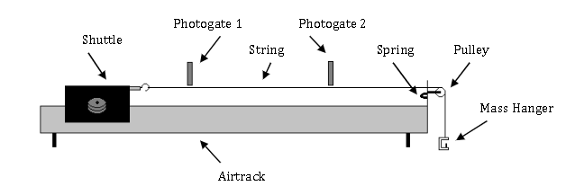
4)Main results:
Part two (A):
a(theoretically)= M’|g|/(M+M’)=1.63 m/s²
a₁ (experimentally)= 1.63667 =1.64 m/s²
Δa₁=1. m/s².
→ a₁= 1.6±1.0 m/s².
a₂(experimentally)⁼ .87 m/s²
Δa₂=1.03 m/s²
→ a₂= 0.9±1.0 m/s².
Part two (B):
M+M’(theoretically)=.300 kg
M+M’(experimentally)=.476 kg
Δ M+M’=.057 kg.
→ M+M’=0.48±.06 kg
Theory:
Newton's First Law states that an object will remain at rest or in uniform motion in a straight line unless acted upon by an external force. It is also called the law of inertia, which means objects will remain in their state of motion unless a force acts to change the motion. So, any change in motion involves an acceleration, and then Newton's Second Law applies, which can be represented in the form:
F=ma.
This experiment is divided into two parts . In the first, you will attempt to verify Newton’s first law by recording two velocities of moving cart to prove they are equal. While in the second part ,you will consider Newton’s second law by using a known force to accelerate a “frictionless” object. A mass hanging from a string over a pulley will act as the accelerating mass (M’) applying a force to accelerate the cart(M) as shown in the figure below:
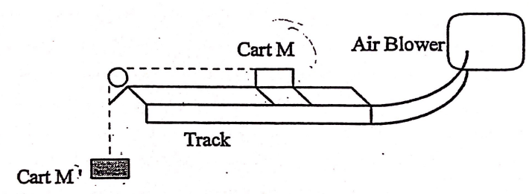
The acceleration, then, can be calculated from the equation:
|F|=M’|g|=(M+M’)|a|.
|a|= M’|g|/(M+M’).
and thus :
v(t)= M’|g|/(M+M’)×t.
d(t)= M’ |g|/2(M+M’)×t².
Notice that:
For part one :
There are three regions of time measurement. The first time, t₁, is the time it takes for the barrier of the cart to pass through the first photocell, beginning when the front of the barrier blocks the beam and stopping when the back of the barrier clears the beam. t₂is a similar measurement; it is the time it takes for the barrier of the cart to pass through the second photocell. The final time, t, is the time
between the other two; it begins when the back of the barrier clears the first photocell and stops when the barrier enters the second photocell.
The average velocity of the barrier of the cart passing through each photocell can be calculated by dividing the length, Δx , by the time it takes to pass through the photocell, giving:
v=Δx/ Δt.
For part two :
t , is the time that the cart spend from the moment of its moving until it reaches the first photocell. Δt is the time through the first photocell.
Procedure:
part one :
1. The air track was started .
2 .Both timers were set up both timers to measure Δt of each photocell.
3. One cart was launched along the track to record Δt of each photocell.
4. The needed calculations were obtained from the recorded data.
part two (A):
1. One timer was set up to measure t and the other to measure Δt.
2. Some mass (M’) was hanged with the cart(M) to exert external force.
3. The position of the first photocell(d) has been changed five times.
4. t and Δt were obtained of each time (d) is changed.
part two (B):
1. By keeping (d) and (M’+M) constant , t and Δt were obtained of each time (M) is decreased and (M’) is increased so to have constant sum of them.
Data And Analysis:
Part one:
Δt₁(sec) | Δt₂(sec) | V₁(m/s) | V₂(m/s) | V₂- V₁(m/s) | V_{AVG}(m/s) | (V₂- V₁)/  V_{AVG}
0.031 | 0.02 | 0.580645 | 0.9 | 0.319355 | 0.740323 | 0.431373
0.03 | 0.019 | 0.6 | 0.947368 | 0.347368 | 0.773684 | 0.44898
0.031 | 0.02 | 0.580645 | 0.9 | 0.319355 | 0.740323 | 0.431373
0.031 | 0.019 | 0.580645 | 0.947368 | 0.366723 | 0.764007 | 0.48
0.028 | 0.019 | 0.642857 | 0.947368 | 0.304511 | 0.795113 | 0.382979
0.031 | 0.02 | 0.580645 | 0.9 | 0.319355 | 0.740323 | 0.431373
0.03 | 0.019 | 0.6 | 0.947368 | 0.347368 | 0.773684 | 0.44898
*As Newton’s first law suggests, v₁ and v₂ must be roughly equal ,but , here we found significant difference between the two recorded velocities . This happened because the set up of the experiment was not that much accurate .I mean, there was an accelerating force due to the hanger of the mass, even though it has small mass ,nearly 10 g , but when we also consider the mass of the used string we gain an acceptable explaining of the error in the result ,the deviation of the velocity .
Part two(A):
M=250.00±.01 g M’=50.00±.01 g Δx=1.8±.1 cm
Δt(sec) | t(sec) | v(m/s) | d (m)
0.018 | 1.48 | 2.422267 | 0.545
0.018 | 1.101 | 1.80197 | 0.495
0.016 | 0.966 | 1.58102 | 0.445
0.016 | 0.927 | 1.51719 | 0.395
0.018 | 0.729 | 1.19313 | 0.345
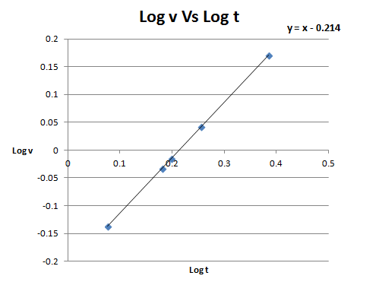

*Since V(t)= V₀+a t , V₀= 0.
V(t)=at.
by taking the log to both sides, the equation becomes:
Log v=Log a +Log t.
the above graph (Log v Vs Log t) has theoretically slope =1 and Y-intercept=Log a.
so:
a (experimentally)=10 ^{y-intercept}= 10^{.21396}=1.63667 m/s²
with error= 10^{3.91E-05}=1 m/s²
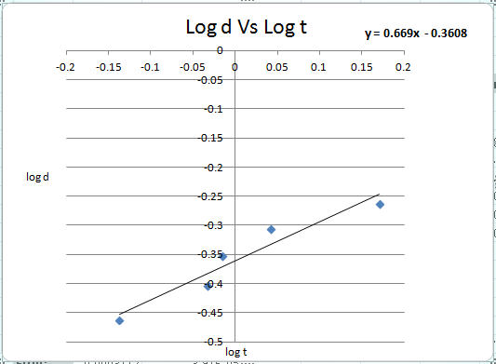

*Since d(t)= V_{0t}+1/2a t² , V₀= 0.
d(t)= 1/2a t².
By taking the log to both sides the equation becomes:
Log d= Log1/2 a +2 Log t.
The above graph(Log d Vs Log t) has theoretically slope=2 and Y-intercept=Log 1/2a.
So:
a (experimentally)=2×10 ^{y-intercept}= 2×10^{.-.3608349}=.87155 m/s²
with error= 10^{.0113188}=1.0264 m/s²
Part two(B):
Δt(sec) | t(sec) | M(kg) | M’(kg) | a(m/s²)
0.014 | 0.792 | 0.24 | 0.06 | 1.41886
0.013 | 0.772 | 0.23 | 0.07 | 1.493329
0.012 | 0.694 | 0.22 | 0.08 | 1.847869
0.012 | 0.68 | 0.21 | 0.09 | 1.92474
0.011 | 0.637 | 0.2 | 0.1 | 2.193366
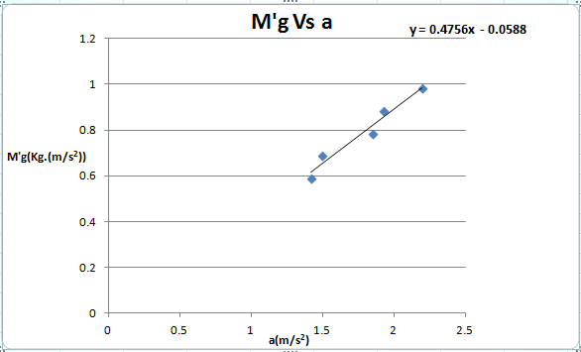

* Since a= M’|g|/(M+M’).
M’g= (M+M’)×a.
the above graph (M’g Vs a) has theoretically slope = (M+M’)=.300 kg
and Y-intercept=0
The slope here gives us an experimental value of (M+M’)=.475571 kg
with error =.05670261 kg.
Conclusion:
Part two (A):
a(theoretically)=1.63 m/s²
a₁= 1.6±1.0 m/s².
a₂= 0.9±1.0 m/s².
|a_{theo}-a₁|≤2× Δa₁ (the result is accepted).
|a_{theo}-a₂|≤2× Δa₂ (the result is accepted).
Part two (B):
M+M’(theoretically)=.300 kg
→ M+M’=0.48±.06 kg
|( M+M’)_{theo}- (M+M’)_{exp}| is not ≤2× Δ (M+M’) (the result is not accepted).
* The benefit of using air track method is to provide low friction environment .
*Such systematic errors have happened while doing the experiment and so, the results have been influenced :
1) The presence of friction
2) The used electrical equipment was not that reliable , the recoded t was larger because the timer started to count time in the moment of releasing the magnet not in the moment of the cart started to move.
3) In the previous equations we considered v₀=0 . However , v₀= had a value due to the impulse force caused by returning magnet.

By considering significant figures rules.
Edit from : https://studylib.net/doc/18745412/force-and-acceleration-on-an-airtrack-objectives--%E2%80%A2-exper...
V(t)= M’|g|/(M+M’)×t. it’s true v can be found by Δx/ Δt , but, we omitted this way because it will cause huge experimental error.

