
Physics Department
Physics 211

Experiment No.4
Moment of Inertia of a Flywheel.

Student’s Name: Remah Dahdoul Student’s No.: 1181771
Partner’s Name: Nadea Jamal Partner’s No.: 1181623
Partner’s Name: Ameed Mahajna Partner’s No.: 1180279
Section: 1

Date: 25\09\2019.
Instructor: Mr. Nihad Abu-Awwad .
Abstract:
1)The aim of the experiment: To determine the moment of inertia of a flywheel .
2)The method used: by setting up a system of a flywheel apparatus that contains both translating and rotational motion ,and , applying the principle of conservation of energy in our analysis.

3)Apparatus: flywheel , cord, micrometer, stop-watch, and meter stick. Notice the figure below:
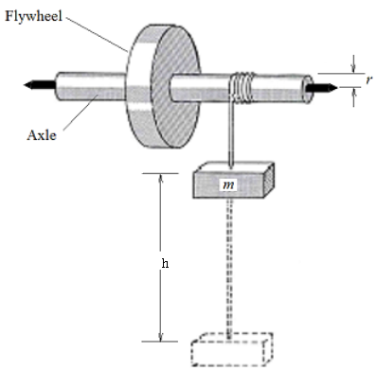
4)Main result:
I(theoretically)=0.033496 kg.m²
I(experimentally)= 0.032121kg.m²
ΔI=3×10⁻³kg.m²
→ I± ΔI= 0.032±0.003 kg.m²
Theory:
By considering the figure above ↑ :
The suspended object with mass (m) has a certain potential energy when it is at height ℎ, and some of that potential energy is converted as the mass moves down through distance ℎ. The change in potential energy, mgh , is converted into the kinetic energy of the falling mass, ½ mv² , and the rotational kinetic energy of the flywheel, ½ I ω², with some of the energy being dissipated through friction, producing thermal energy, in equivalent to the quantity nW.
The defined system of the flywheel and the falling mass assume that all energy is being conserved; any non-conservative forces will contribute to the nW term. The resulting energy conservation equation is:
mgh=½ mv²+½ I ω²+ nW. →(1)
Back to W, W is equal to amount of work done against friction per one rotation , so after the mass is released the wheel makes a further N revolutions before being brought to rest. The work done against friction during these N revolutions is equal to kinetic energy of the wheel :
NW=½ I ω²
W= I ω²/2N→(2)
Now , Consider the relationship between the angular velocity ω , and the instantaneous linear velocity (V) of a point on the circumference of the rotating axle. The linear velocity (V) of a point on the circumference of the axle will depend on the angular velocity(ω) , and the distance of the point from the centre of rotation, the radius (r) of the axle . The relationship between the angular velocity ω and the linear velocity V is:
ω = V/r→(3)
Furthermore,
V=2×(average velocity of fall)
V=2h/t →(4) , where t = the time of fall.
By substituting (2) ,(3)and (4) into (1) , and after some rearrangement , we gain the following formula :
where ,
m mass of the falling object
g gravitational acceleration
h change in height until
n the number of turns the wheel makes until the weight hits the ground
N the number of turns the wheel makes until the weight stops
I moment of inertia of the flywheel .
Notice that :
The moment of inertia, I, of an object, around some given axis of rotation, is a proportionality constant between the applied torque (τ) and the angular acceleration (α)of the object around that axis. (In a sense it is the equivalent of mass m in linear motion, which is a proportionality constant between the applied force, F and the acceleration a of the mass, i.e., F = ma.)
So, in general, τ = I α . The moment of inertia of an object, around some given axis, depends on the mass of the object, as well as the way in which that mass is arranged around the axis of rotation; more specifically, I depends on the sum of the mass of each particle in the object, multiplied by the square of the radius of rotation of each particle around the given axis, i.e. I=∑mr² .
Procedure:
1) The values of m , r and h were measured using the electronic balance , micrometer and meter stick respectively.
2) The object was allowed to fall through a fixed distance (h) to the ground, and the time of descent (t) was taken by a stop-watch. The number of revolutions (n) of the wheel during this time was taken by observing a mark made on the circumferences of the wheel. The further revolutions (N) made by the wheel before coming to rest were also counted by reference to mark P.
3) The previous step was repeated four times for the same distance (h) .
4) The needed calculations were obtained from the recorded data.
Data and Calculations:
m=0.99±0.01 kg r=0.01060±.00001 m h= 0.795±0.001m
M= 7.12±0.01 kg R= 0.0960±0.0001m
Attempt | t (s) | n (rev) | N (rev) | I(kg.m²)
1 | 8.00 | 10 | 25.5 | 0.031292626
2 | 8.77 | 12 | 24.5 | 0.035156683
3 | 7.87 | 11 | 28.5 | 0.030416601
4 | 8.04 | 12 | 32 | 0.032001517
5 | 8.02 | 12 | 30.5 | 0.031420664
Average | 8.14 | 11.4 | 28.2 | 0.032121113
δ^{m} | 0.160281 | 0.4 | 1.428286
Notice that: the average of N , n and t is used in the following calculations.
=0.032121113kg.m²
=2.98047×10⁻³kg.m²
kindly, see the last page, the mathematical steps are shown in detail.
Conclusion:
I(theoretically)=1/2 MR²= .033496 kg.m²
I(experimentally) =0.032121113 kg.m²
ΔI=2.98047×10⁻³kg.m²
|I_{theo}-I_{exp}|≤2× ΔI (the result is accepted).
* The benefit of using flywheel apparatus is to apply the concepts of energy conservation to cases where both translating and rotational motion are effective.
* In this experiment we used the technique of repetition , because it’s a way to minimize the error .However, such systematic and random errors have happened while doing the experiment and so, the results have been influenced :
1) the presence of friction , which causes energy to dissipate significantly into thermal form.
2) The recoded t was dependent in human precision so we expect to have some error on its values.
3) In the previous equations we ignored the rotational kinetic energy of the axel. However, it has a value equals to½ I _{axle} ω² . Where I _{axle}=1/2 mr².
Further, we assumed v =2h/t .However, the real value is shown in figure-2 below.
Notice the two uploaded figures for the details of computing the value ΔI.
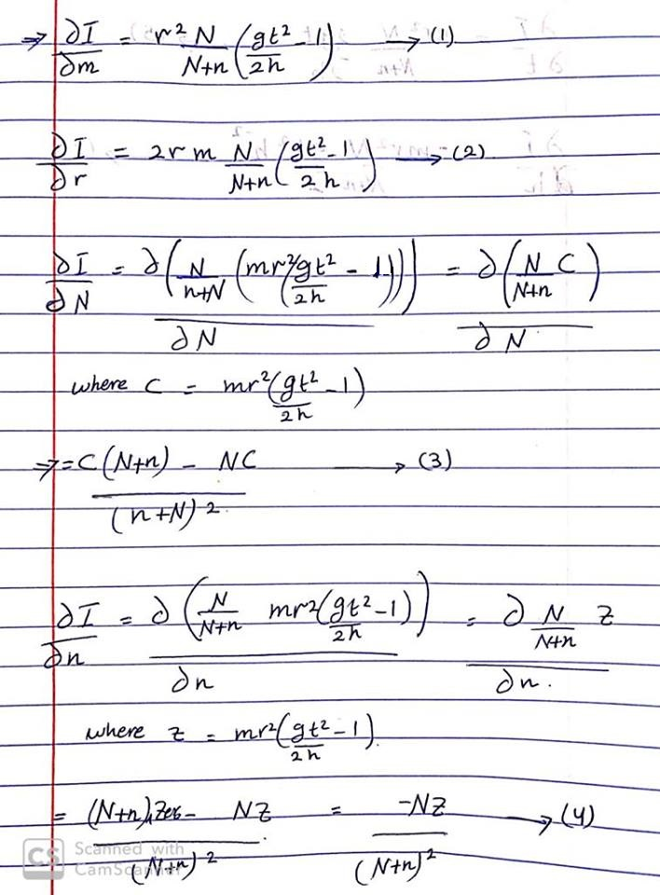
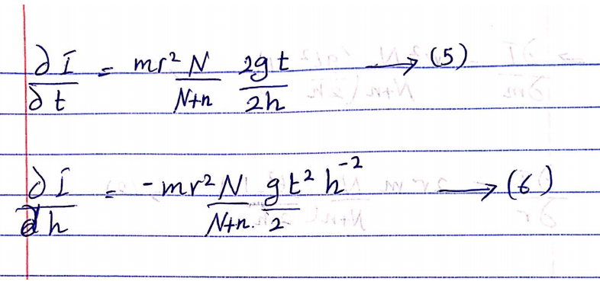
Notice the real value of v:
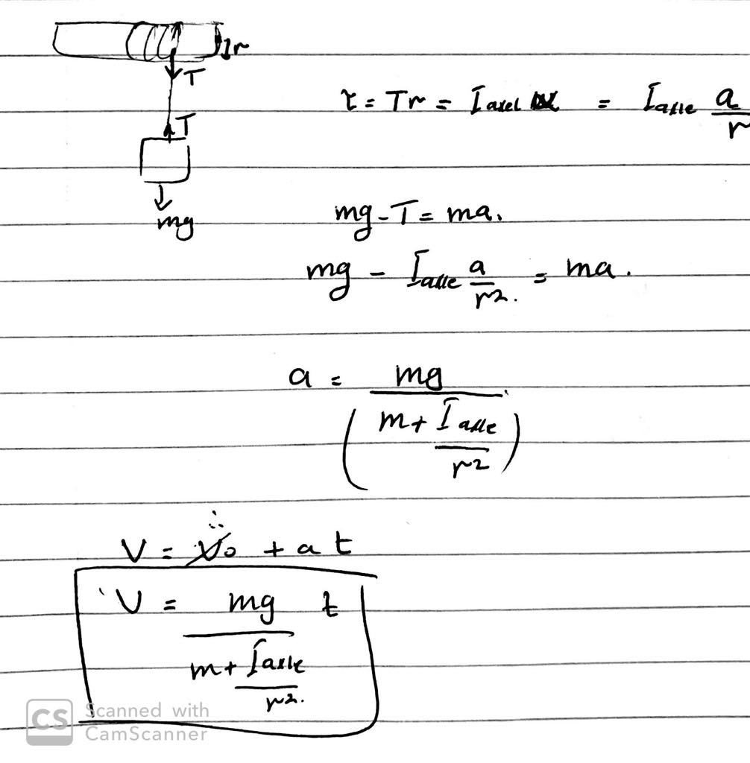

Edit from : http://www.phy.uct.ac.za/sites/default/files/image_tool/images/281/courses/phylab1/PHY1025F_Lab_Manual.pdf

