
Physics Department
Physics 211

Experiment No.5
The Helical Spring.

Student’s Name: Remah Dahdoul Student’s No.: 1181771
Partner’s Name: Nadea Jamal Partner’s No.: 1180433
Partner’s Name: Ameed Mahajna Partner’s No.: 1181623

Section: 1

Date: 2\10\2019.
Instructor: Mr. Nihad Abu-Awwad .
Abstract:
1)The aim of the experiment: to determine the value of the force constant of a soft spring set to oscillate vertically.
2)The method used: by using static(Load-Extension) and dynamic (spring mass oscillations) method .
3)Apparatus: a long helical spring, weight hanger , meter stick and stop watch. Notice the figure below:
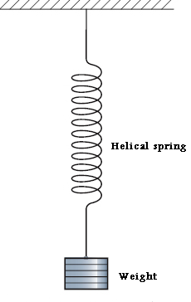
4)Main results:
Part one :
K=25.3593264 N/m. Δk =0.49745523 N/m.
→ K₁=25.4±0.5 N/m.
Part two :
K=28.59114 N/m. Δk =2.1711173 N/m.
→ K₂=29±2 N/m.
m_{eff} =0.0248133 kg Δm_{eff} =0.0144053 kg
→m_{eff} =0.025±0.014 kg .
Theory:
Robert Hooke, a 17th century physicist studied the behavior of springs under different loads. He established an equation, which is now known as Hooke’s law of elasticity .This law states that the amount by which a material body is deformed (the strain) is linearly proportional to the force causing the deformation (the stress). Thus, when applied to a spring, Hooke’s law implies that the restoring force is linearly proportional to the equilibrium extension.
, where F is the restoring force exerted by the spring, x is the equilibrium extension and K is called the spring constant. (The negative sign indicates that the force F is opposite in direction to the extension x. Hence also the term “restoring force” comes.)
When a weight (m) is suspended vertically using a soft spring, it will be under the influence of two equal and opposite forces, its weight and the elastic force due the spring.
Here, y can be noted to be y₀ , the new equilibrium position. If the spring is stretched into further length y’, it will undergo a simple harmonic oscillation due to the new net force which equals:
the general solution of this differential equation for y is:
where. Hence, the period of oscillation is given by:
In the determination of the spring constant of a spring, we generally neglect the effect of the mass of the spring on the equilibrium extension or the time period of oscillation of the spring for a given mass attached. In the case of soft massive springs the mass of the spring cannot be neglected. These types of springs have extension under their own weight and therefore need a correction for the extension. Similarly, they oscillate without any attached mass, which implies that the standard formula for the time period of oscillations of a spring needs modification, which appears in the term.
.
Procedure:
part one :
1.The spring was placed vertically and the hanger was suspended to it.
2. The equilibrium length (y₀) was measured using the meter stick.
3. The loads were added step by step and the extension Δy for each step was measured.
4. The needed calculations and graphs were obtained from the recorded data.
Part two:
1. The spring was loaded with a given mass m.
2. By stretching slightly, the spring started to oscillate.
3. Using stop watch, the time for 10 period was measured.
4. The previous steps were repeated for extra load each time.
5. The needed calculations and graphs were obtained from the recorded data.
Data And Analysis:
Part one:
m(kg) | mg(kg.m/s²) | Δy(m)
0.04896 | 0.479808 | 0.016
0.09896 | 0.969808 | 0.034
0.14896 | 1.459808 | 0.052
0.19896 | 1.949808 | 0.073
0.24896 | 2.439808 | 0.093
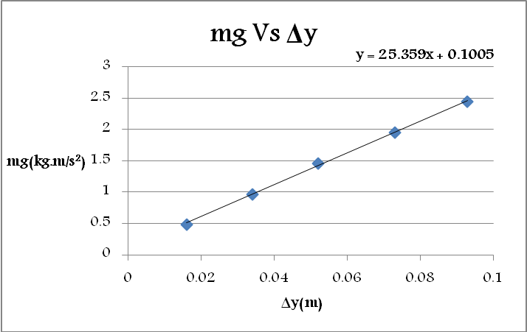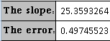
Since, |k Δy|=|mg|.
The graph of mg Vs Δy gives us a line with slope =k.
Here the experimental value of k =25.3593264 N/m.
with error=0.49745523 N/m.
Part two:
m(kg) | t(sec) | T(sec) | T²(sec²)
0.04896 | 3.30 | 0.330 | 0.1089
0.09896 | 4.00 | 0.400 | 0.16
0.14896 | 5.02 | 0.502 | 0.252004
0.19896 | 5.38 | 0.538 | 0.289444
0.24896 | 6.24 | 0.624 | 0.389376
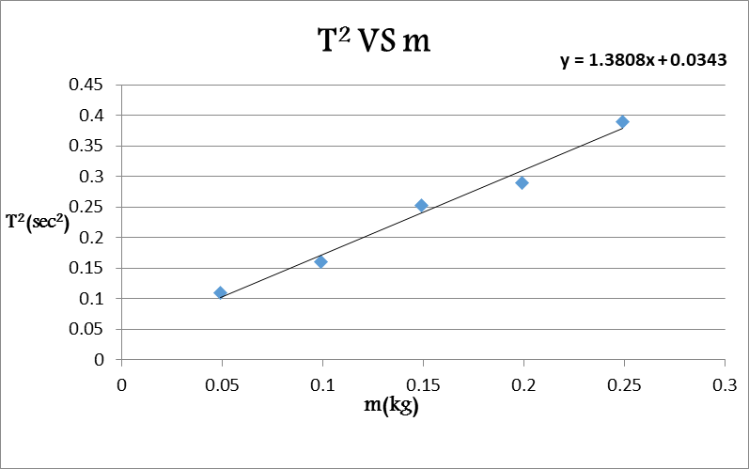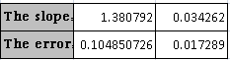
Since, . Hence,
The graph of (T²Vs m) gives us a line with slope =.
Here the experimental value of =28.59114 N/m.
with error= =2.1711173 N/m.
The y-intercept represents here the ratio.
So, =0.0248133 kg
with error =0.0144053 kg
Notice that :
m_{eff} =m_{s}/2(in static case) and m_{eff} =m_{s}/3 (in dynamic case)
in this part :
m_{eff}(theoretically)= m_{s}/3=.0143633 kg
Conclusion:
M_{s}=43.09±.01 g.
k(theoretically)=25 N/m.
m_{eff}(theoretically) =.0143633 kg.
Part one :
K₁=25.4±0.5 N/m.
|k_{theo}-k₁|≤2× Δk₁ (the result is accepted).
Part two:
K₂=29±2 N/m.
|k_{theo}-k₂|≤2× Δk₂ (the result is accepted).
m_{eff} =0.025±0.014 kg .
|m_{eff-theo}-m_{eff}|≤2× Δm_{eff} (the result is accepted).
*The effect of gravity on the spring is shifting the equilibrium point to cancel the effect of this constant force. So, T and f would not be affected.
*Such systematic errors have happened while doing the experiment and so, the results have been influenced:
1) The presence of friction and the spring was too old. So the recorded T was under the influence of energy dissipation. Further, we depended on our eyes in determining it. So, we expect to have error on its values.
2) The used spring was swinging a little bit. So, we expect that the motion was not fully simple harmonic.

Edit from : https://www.academia.edu/39000133/Experiment_6_-_Helical_Spring
Notice that |Δy| is taken here.
You can see the proof in the following link-exp5: https://www.academia.edu/11161518/Physics_P141_Lab_manual

