
Physics Department
Physics 211

Experiment No.6
Torsional Torque & Torsional Modulus.

Student’s Name: Remah Dahdoul Student’s No.: 1181771
Partner’s Name: Nadea Jamal Partner’s No.: 1180433
Partner’s Name: Ameed Mahajna Partner’s No.: 1181623

Section: 1

Date: 9\10\2019.
Instructor: Mr. Nihad Abu-Awwad .
Abstract:
1)The aims of the experiment: To study the elastic properties of Aluminum and to determine the torsional constant to analyze its dependence on Geometry. To find the Shear modulus of the Aluminum.
2)The method used: by using the torsional pendulum method. A torsional
pendulum consists of a disk (or some other object) suspended from a wire, which is then twisted and released, resulting in an oscillatory motion.
3)Apparatus: metallic rods ,rotating disk, stand ,dumbbell massive system , spring balance ,micrometer, meter stick and stop watch. Notice the figure below:
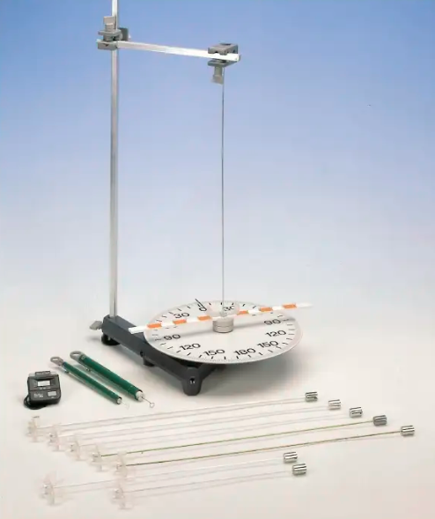
4)Main results:
Part one :
K=0.075±0.001 N.m/rad.
I= 9.37796×10⁻³kg.m².
Part two :
n= 3.9±0.2 N/m.
Part three :
m= -0.7±0.1
G_{avg}= (19.20±0.01)×10⁹ pa.
Theory:
In mechanics, torsion is defined as the twisting of an object due to the applied torque or moment which will produce rotation along the longitudinal axis of an object. When the applied torque is acted on a member, shear stress and deformation develop in response. Torsion is a concern in the designing stage of axles or shaft which is used in power generation and ultimately transmission.
In this experiment, a massive dumbbell shaped object was fixed to a thin metallic rod. Then, the system is twisted and start to oscillate. The oscillatory motion is caused by a restoring torque which is proportional to the angular displacement.
τ =-kθ .
Where, k is the torsional constant.
K depends on the geometry of the rod by .
Where , G :shear modulus
d : rod’s diameter
L : rod’s length
Notice that :
The period for small oscillations is given by 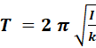
Where, T :period
I :moment of inertia
K : torsional constant
We can assume that I is constant for the whole experiment since the mass of the rod is very small compared to the dumbbell’s mass. So, I here is equal to I_{dumbbell.}
Procedure:
part one :
One rod was used , the system was twisted by a force (F) at five different angles , then, the period of oscillation for the system was measured.
Part two:
3 Aluminum rods of the same length were taken into study and then the diameter of each &the period were measured.
Part 3:
3 Aluminum rods of the same diameter and different lengths were taken and then the length of each &the period were measured.
* The needed calculations were obtained from the recorded data.
Data And Analysis:
Part one: r=17cm
θ (rad) | F(N) | τ(N.m)
0.174 | 0.1 | 0.017
0.349 | 0.2 | 0.03
0.524 | 0.29 | 0.044
0.698 | 0.38 | 0.057
0.873 | 0.46 | 0.069
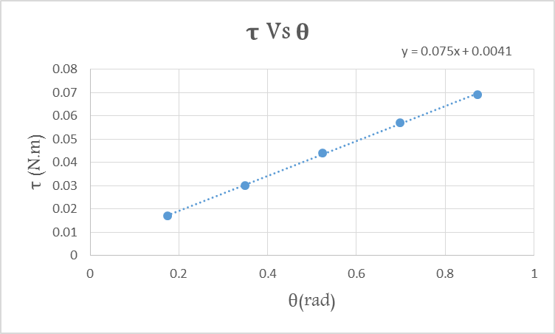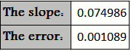
Since, τ=- ϰ θ.
The graph of τ Vs θ gives us a line with slope =k. Here the experimental value of k =0.074986 N.m/rad. with error=0.001089 N.m/rad.
=9.37796×10⁻³kg.m².
Part two:
Rod | d(m) | T(sec) | K(N.m/rad) | Log K | Log d
1 | 0.00194 | 2.222 | 0.074287224 | -1.12909 | -2.7122
2 | 0.00295 | 1.022 | 0.351156284 | -0.4545 | -2.53018
3 | 0.0039 | 0.56 | 1.169569898 | 0.068026 | -2.40894
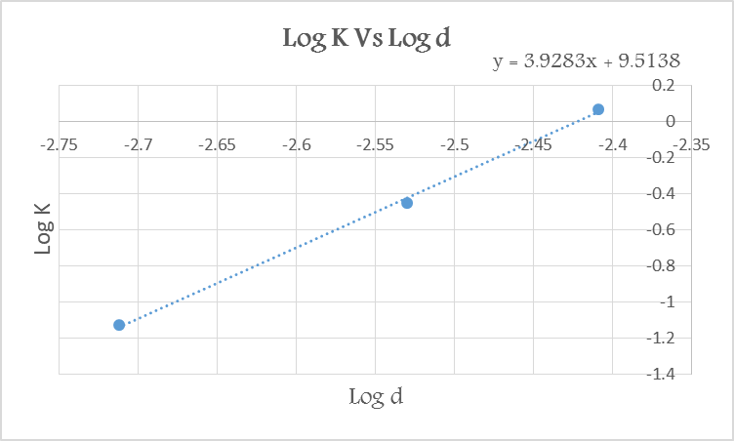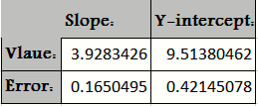
Since,
The graph of (Log K Vs Log d) gives us a line with slope =n.
Here the experimental value of n=3.92834.
with error=0.165049.
The y-intercept represents here the value =.
part three:
Rod | L(m) | T(sec) | K(N.m/rad) | Log L | Log k
1 | 0.477 | 2.222 | 0.074287 | -0.32148 | -1.12909
2 | 0.378 | 2.084 | 0.084451 | -0.42251 | -1.07339
3 | 0.27 | 1.818 | 0.110972 | -0.56864 | -0.95479
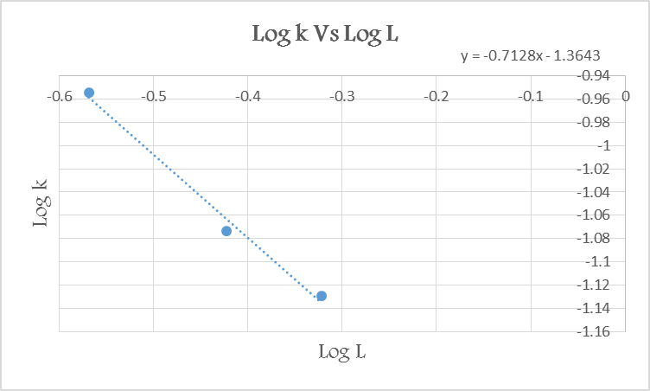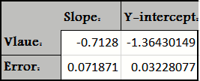
Since,
The graph of (Log K Vs Log L) gives us a line with slope =m.
Here the experimental value of n=3.92834.
with error=0.165049.
The y-intercept represents here the value =.
Conclusion:
To find the values of G , we substitute both n and m in the two formulas of y-int:
=19.19 ×10⁹pa.
=19.21 ×10⁹pa.
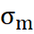=0.01 Gpa.
|G₁-G₂|=0.02 Gpa (the small deviation indicates to high precision in the results).
*Such systematic errors have happened while doing the experiment and so, the results have been influenced:
1) The used rods wasn’t straight so their shaped have affected the results .
2) The recorded T was under the influence of energy dissipation because of the presence of friction . Further, we depended on our eyes in determining it. So, we expect to have error on its values.
3) The used spring wasn’t completely perpendicular to the dumbbell .So, we expect that the calculated value of I wasn’t that accurate. Furthermore, in this experiment we ignored the inertia of rods .
4) The motion was not fully simple harmonic due to friction and the relatively large thetas we used.

