
Physics Department
Physics 211

Experiment No.7
Sound Waves
Student’s Name: Remah Dahdoul Student’s No.: 1181771
Partner’s Name: Nadea Jamal Partner’s No.: 1180433
Partner’s Name: Ameed Mahajna Partner’s No.: 1181623

Section: 1

Date: 16\10\2019.
Instructor: Mr. Nihad Abu-Awwad .
Abstract:
1)The aims of the experiment: to find the speed of sound waves in air and to find the end correction(e).
2)The method used: by using a single generator to produce audio signals with different frequencies and by changing the height of water surface in the used tube where the resonance occur.
3)Apparatus: Resonance tube, signal generator, oscilloscope, microphone, and
an amplifier. Notice the figure below:
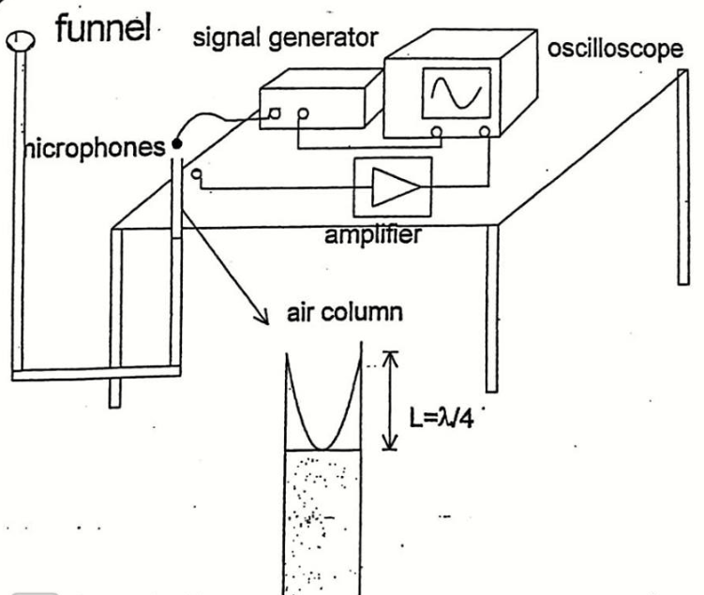
4)Main results:
V_{s(avg)}=353.5 m/s. =8.5 m/s.
→ v_{s}=(353±8) m/s
e_{(avg)}=0.01615 m . =0.00415 m.
→ e=(0.016±0.004)m.
Theory:
A sound wave is a longitudinal in which the individual particles of the medium oscillates along the direction of propagation. For a traveling sound wave of speed v_{s} , frequency f, and wavelength λ, the following relationship holds.
V_{s} = fλ → ( 1 )
Consider a sound wave traveling through a resonance tube as illustrated in the fig-1 below :
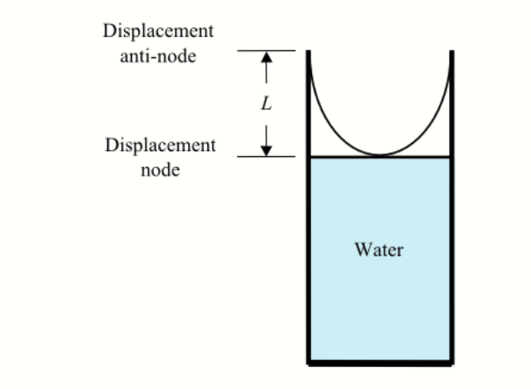

By using a signal generator connected to a microphone at the open end of the tube, sound waves are generated. These sound waves travel down the tube and are reflected upon reaching the surface of the water. The incoming and reflected waves interfere and form standing waves. The sound waves reflected from the water surface change their phase by 180° and therefore are completely out of phase with the incident sound waves. In other words, the amplitude of the standing waves must be zero at the water's surface. This point is a node. If a resonance condition is met, the open end of the tube has maximum amplitude of standing sound waves and is called an anti-node.
At constant temperature the speed of sound is fixed; in addition, for a given signal frequency is also fixed, then according to eq(1) , the wavelength of the sound wave should also is fixed. As a result the resonance conditions can only be satisfied when the length of the tube L is such that:
.
where n = 1, 2, 3, 4,..., and the length is defined to be the distance measured from the open end of the tube to the water surface. For the specific cases given in the fig-1 above , (n = 1), the length of the tube is .
Fig-2 below shows resonance conditions in which n = 2, 3and 4.
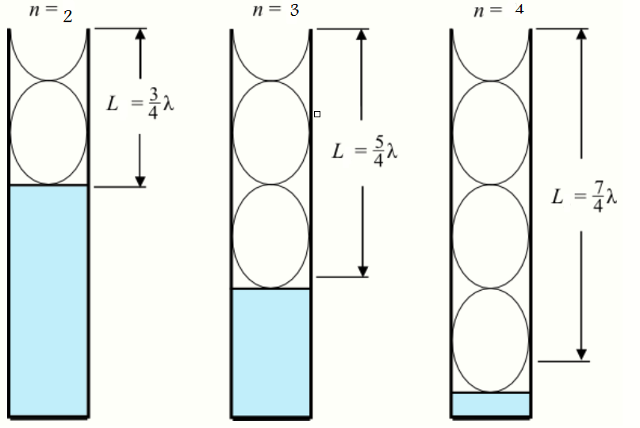
Here we must note that the antinode occrs outside the tube , so we need a corrector e to the formula to become :
and so on.
It is easy to notice that :
, .
This relationship between the two consecutive resonances will be used to find the wavelength of the standing sound waveand so the speed of sound .
.
Procedure:
A signal generator was used to give different frequencies. From 350 Hz up to 750 Hz . For each frequency L₁and L₂ at which resonance occurs have been recorded.
L₁and L₂ were determined by raising and lowering the funnel until the sound was as loud as possible.
Data And Analysis:
f(Hz) | 1/f(sec) | L₁(m) | L₂(m)
350 | 0.002857 | 0.240 | 0.720
400 | 0.0025 | 0.205 | 0.640
450 | 0.002222 | 0.180 | 0.580
500 | 0.002 | 0.160 | 0.500
550 | 0.001818 | 0.145 | 0.450
600 | 0.001667 | 0.130 | 0.410
650 | 0.001538 | 0.120 | 0.390
700 | 0.001429 | 0.110 | 0.360
750 | 0.001333 | 0.100 | 0.335
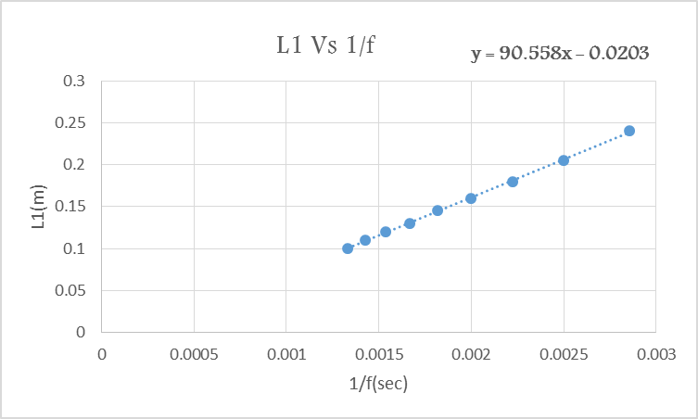
Since, and ,then:
→.

So, 4× Slope = .
v_{s}= 362.2332 m/s.
→ =2.944m/s
→ v_{s1}=362±3 m/s.
e =-Y_{intercept}=0.020278 m.
Y_{int}=e=0.001464 m.
→e₁= 0.0203±0.0015 m.

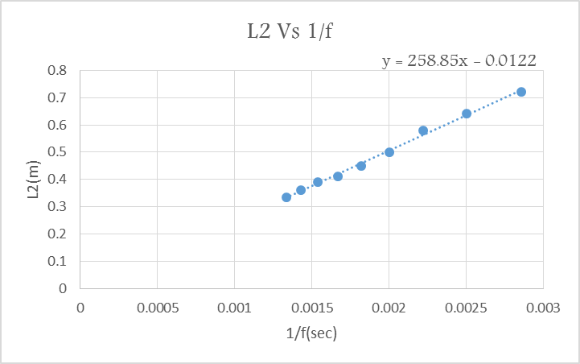
Since, and ,then:
→
So, Slope = .
v_{s}= 345.13733 m/s.
→ =8.344786m/s
→ v_{s2}=345±8 m/s.
e =-Y_{intercept}=0.01220898 m.
Y_{int}=e=0.01245036 m.
→e₂= 0.012±0.012 m.
Conclusion:
V_{s(avg)}=353.5 m/s . =8.5 m/s.
→ v_{s}=(353±8) m/s
e_{(avg)}=0.01615 m . =0.00415 m.
→ e=(0.016±0.004)m.
The theoretical values are :
V_{s}=343 m/s e=0.015 m
|V_{avg}-V_{theo}|≤2× (the result is accepted).
|e_{avg}-e_{theo}|≤2× (the result is accepted).
*Such systematic errors have happened while doing the experiment and so, the results have been influenced:
1) The level of water can never be straight
2) The frequency given by the used signal generator wasn’t fixed or either wasn’t showing the real value of the provided frequency.
3) The theoretical value of sound wave is taken to be at 20C not at our room temperature.
4) The readings of L₁and L₂ was dependent in our human precision , so they were not very accurate.

