
Physics Department
Physics 211

Experiment No.8
The thermal Expansion Coefficient of Brass.
Student’s Name: Remah Dahdoul Student’s No.: 1181771
Partner’s Name: Nadea Jamal Partner’s No.: 1180433
Partner’s Name: Ameed Mahajna Partner’s No.: 1181623

Section: 1

Date: 23\10\2019.
Instructor: Mr. Nihad Abu-Awwad .
Data And Analysis:
Part one :
Calibration Curve.
Scale (m) | T (m) | No. of slips
0.143 | 0 | 0 (zero point)
0.146 | 0.00075 | 1
0.149 | 0.00150 | 2
0.152 | 0.00225 | 3
0.155 | 0.00300 | 4
0.157 | 0.00375 | 5
0.160 | 0.00450 | 6
0.163 | 0.00525 | 7
0.166 | 0.00600 | 8
0.169 | 0.00675 | 9
0.172 | 0.00750 | 10
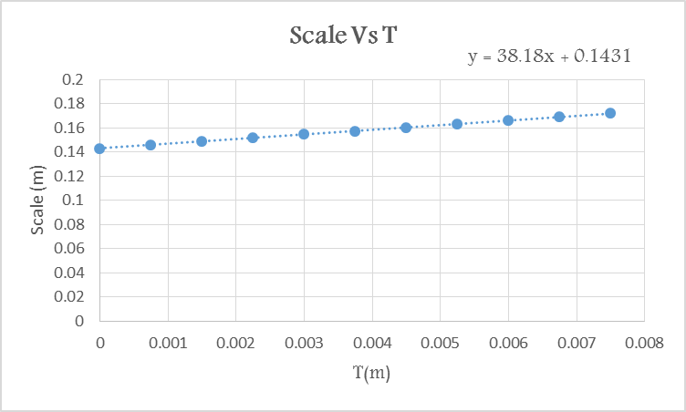
Part Two :
L Vs T
L₀ = 50.0±0.1 cm T₀ = 28 ˚C
T (˚C) | Heating |  | Cooling
T (˚C) | Scale(m) | L(cm) | Scale | L(cm)
27 | 0.143 | 50 | 0.143 | 50
30 | 0.147 | 50.01 | 0.144 | 50.0023
35 | 0.149 | 50.015 | 0.145 | 50.0049
40 | 0.151 | 50.02 | 0.147 | 50.01
45 | 0.152 | 50.023 | 0.148 | 50.013
50 | 0.154 | 50.028 | 0.15 | 50.018
55 | 0.157 | 50.036 | 0.152 | 50.023
60 | 0.158 | 50.039 | 0.154 | 50.028
62 | 0.159 | 50.042 | 0.156 | 50.034

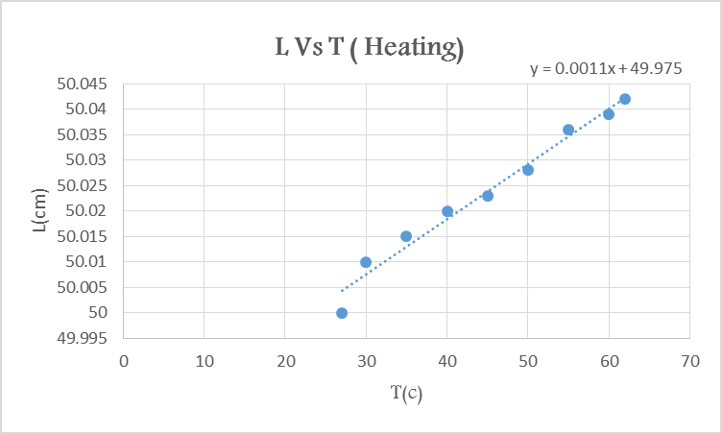
According to the graph above :
Slope = αL₀ = 0.0011 → α = 0.0011\50 = 2.2 × 10⁻⁵ ˚C⁻¹
Y-int. = L₀-αL₀T₀ = 49.975 → α = 1.79 × 10⁻⁵ ˚C⁻¹
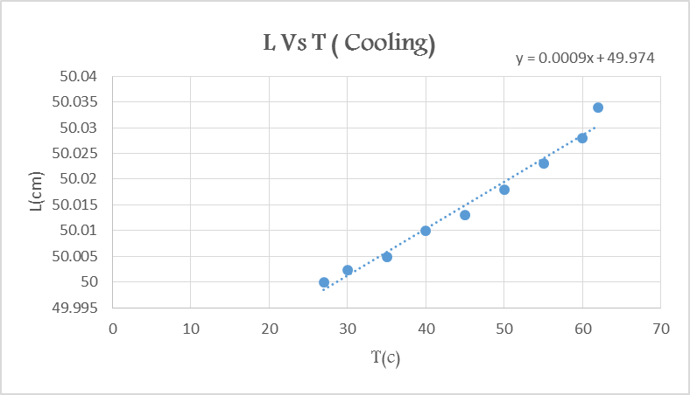
According to the graph above :
Slope = αL₀ = 0.000913 → α = 0.000913\50 = 1.8 × 10⁻⁵ ˚C⁻¹
Y-int. = L₀-αL₀T₀ = 49.9737 → α = 1.879 × 10⁻⁵ ˚C⁻¹
Main Results :
α_{avg}=1.91725 ˚C⁻¹ =0.09633 ˚C⁻¹
→ α=(1.9±0.1) ˚C⁻¹
The theoretical value of α = 1.9 × 10⁻⁵ ˚C⁻¹
| α _{avg}- α _{theo}|≤2× (the result is accepted).

Notice that we used to determine the values of this column the formula obtained from the previous graph : y = 38.18x + 0.1431 So : L= L₀+((scale- 0.1431)/38.18)

