Ch.7

Q2.

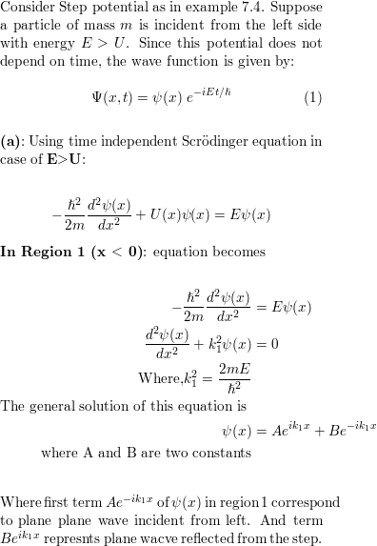 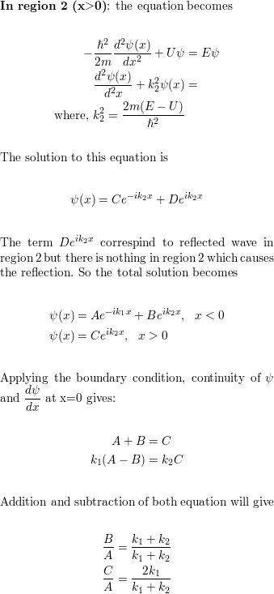

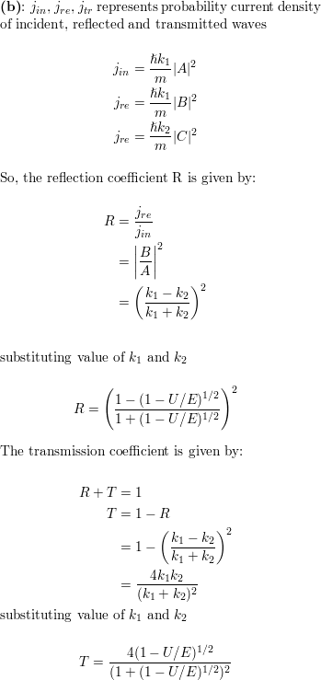

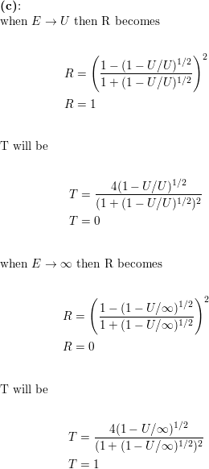

Q11:

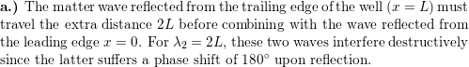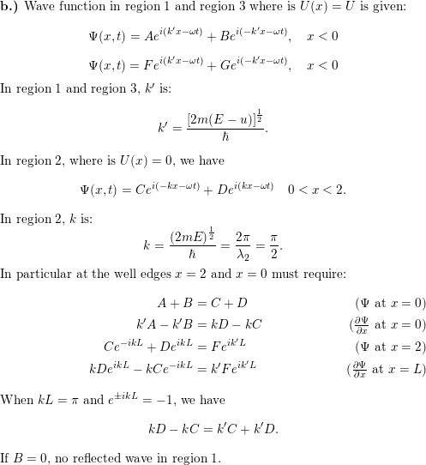https://d2nchlq0f2u6vy.cloudfront.net/19/11/13/60ab4753c9eec3ccb16949a191f681a6/25536272ade45ddafee29a36dcd5f948/lateximg.png?tcb=1621536769

Q12:

