Hw1

**12.**

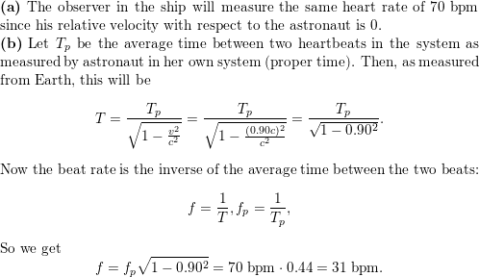Top of Form

https://d2nchlq0f2u6vy.cloudfront.net/19/10/31/b980309c2d114be2c32a98bf602869a5/8d83c6fe1b554e75d18ba0d1da3e32d3/lateximg.png?tcb=1615922698

18.

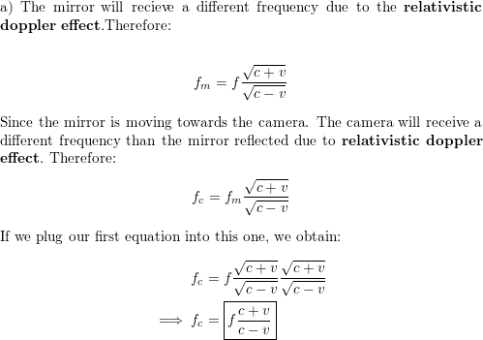

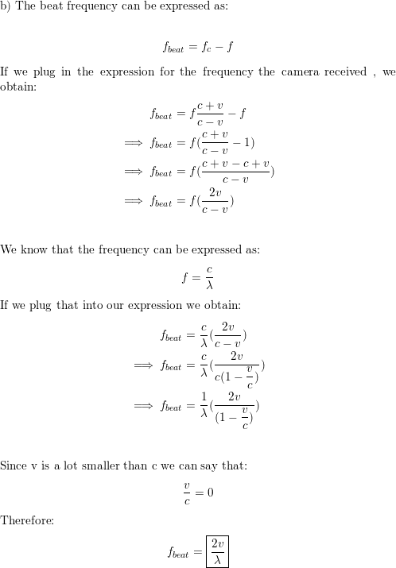

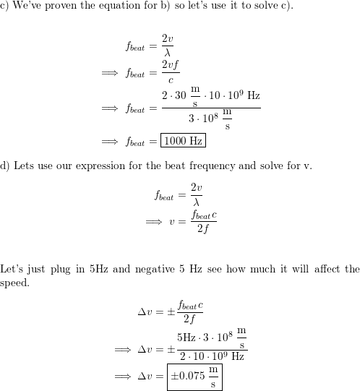

22

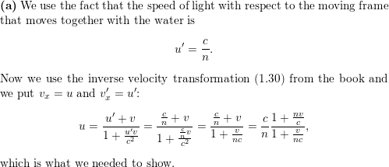

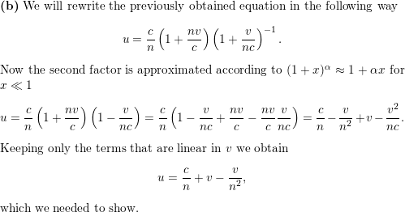

24

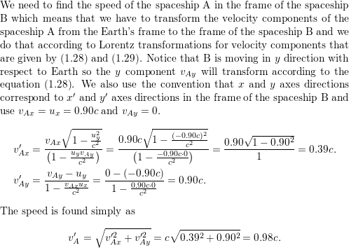

31

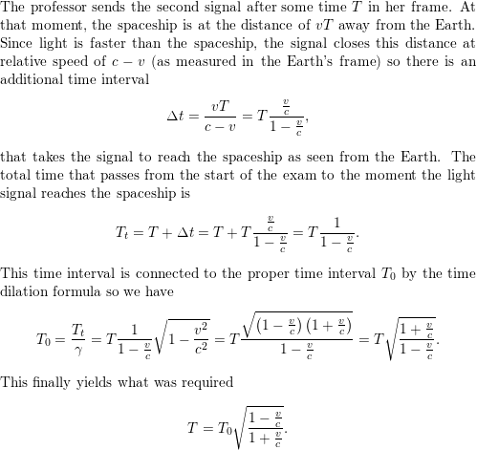

34.

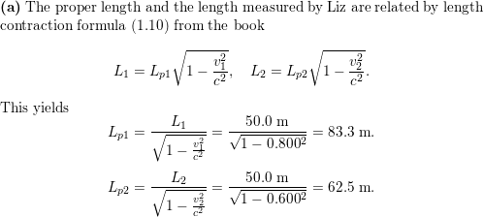

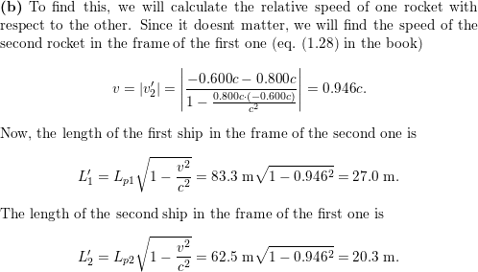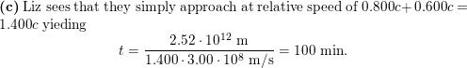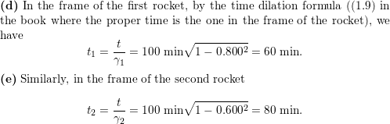https://d2nchlq0f2u6vy.cloudfront.net/19/11/13/ec0a52f209d0b74187a9fa5c22dcbabe/2f458e0544aeed2c5fe61e644a5e0c54/lateximg.png?tcb=1616185735

39.

