**Physics 112**

**Exp.#1: Linear and Nonlinear Elements**

**Preliminary Laboratory Questions**

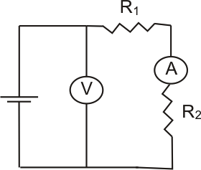

1) Find the value of the electric resistance of a carbon resistor from the four colors ordered on it as: yellow, black, red and silver.

2) How an ammeter is connected in an electric circuit and why?

3) How an voltmeter is connected in an electric circuit and why?

4) Consider the circuit shown: Find the value of R2

If R1=100 Ω , the reading of the voltmeter 10 V and the

reading of the ammeter 20 mA.

5) If the resistance of the tungsten wire in the light bulb is 2

Ω at 20 ˚C what would be its resistance at a temperature of 1320 ˚C, if the thermal

coefficient of o resistance of tungsten is 4.5 x 10-3 ˚C-1 .

6) Explain how you can measure the temperature of glow of the tungsten filament in the light bulb.

7) Explain how a current flows in a semiconducting diode in the two states of biasing

(forward and reverse) .