

**Physics 211**

**Experiment No.8**

**The Thermal Expansion Coefficient of Brass**

----------------------------------------------------------------------

**Student's Name:** Hamza AlHasan **Number: 1181636**

**Partner's Name:**

**Instructor: Dr.**Nihad Abu-Awwad  **Section No.:** 1

**Date:** 13\11\2019

**Abstract:**

This experiment aims to determine the coefficient of linear expansion of a brass rod and to learn how to calibrate an instrument which is done by indirect determination of very small distances. These aims are done using a brass rod, mirror/scale assembly, 12V power supply, this is used for heating the rod and lighting the lamp, meter stick, micrometer and a thermometer.

* Final result: αavg ± ∆αavg = (24 ± 2) * 10-6 ˚C-1

**Theory:**

When heating metals, most of them tends to expand and their expansion is linear over wide ranges of temperatures. At T=T0 (room temperature) the length of a metallic rod is L0 and that length could be found at temperature T>T0 by using the following formula:

**L(T) = L0 [1 + α (T-T0)]**

Where:

α: the linear coefficient of thermal expansion.

**Procedure:**

In this experiment, a brass rod is fixed at one end while it's allowed to expand and pushed against the back of a mirror from the other one. The mirror is held with a rubber band. The light that comes out from the lamp reflects from the mirror onto a meter scale and its position changes with expansion of the brass rod. To build the length versus temperature data and compute the coefficient of thermal expansion, two main steps are required:

1 Between the rod length and scale reading, a calibration curve have to be crated.

2 The scale reading must be recorded, first when the temperature increases and, second when it decreases.

**Step 1:** Calibration Curve:-

First things first is to measure the thickness of 10 identical pieces of plastic. The pieces are inserted one-by-one between the brass rod and the mirror while the total thickness of the inserted papers versus scale reading is being recorded. Finally, a graph of scale reading vs. thickness inserted is plotted and that is the calibration curve.

**Step 2:** L vs. T data:-

All plastic slips are removed, then the length of the rod is measured from the point of clamping to the point where it touches the mirror and that length is recorded as L0. Heating transformer is turned on (12 V a.c.). Through this, the thermometer is watched and the scale reading vs. temp. is recorded. When the temp. stops rising, the heater is turned off and the same process is repeated while cooling down.

**Data & Calculations:**

* **Step 1: Calibration Curve:-**

|  |  |  |
| --- | --- | --- |
| Scale (cm) | T (cm) | No. of slips |
| 12.8 | 0.0000 | 0 (zero point) |
| 13.1 | 0.0067 | 1 |
| 13.4 | 0.0134 | 2 |
| 13.5 | 0.0201 | 3 |
| 13.8 | 0.0268 | 4 |
| 14.0 | 0.0335 | 5 |
| 14.1 | 0.0402 | 6 |
| 14.3 | 0.0469 | 7 |
| 14.5 | 0.0536 | 8 |
| 14.6 | 0.0603 | 9 |
| 14.7 | 0.0670 | 10 |

* Thickness for 10 identical slips = 0.67 mm
* Thickness for one slip = 0.67\10 = 0.067 mm
* T = (0.067 ± 0.01) mm

|  |  |
| --- | --- |
| Slope ± ∆slope | Y-intercept ± ∆Y-intercept |
| 26.5943 | 13.02 |
| 1.172454 | 0.048742 |

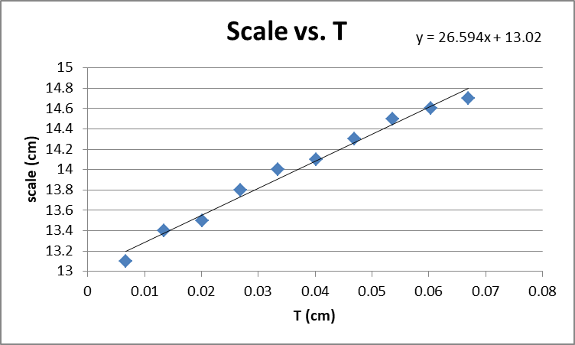

* **Step 2: L vs. T:-**
* L0 = 50 cm
* T0 = 28 ˚C

|  |  |  |  |  |
| --- | --- | --- | --- | --- |
| T (˚C) | Heating | | Cooling | |
| Scale | L(cm) | Scale | L(cm) |
| 30 | 12.5 | 49.98 | 12.7 | 49.99 |
| 32 | 12.7 | 49.99 | 12.9 | 50.00 |
| 34 | 12.8 | 49.99 | 13.0 | 50.00 |
| 39 | 12.9 | 50.00 | 13.1 | 50.00 |
| 41 | 13.0 | 50.00 | 13.2 | 50.01 |
| 47 | 13.1 | 50.00 | 13.3 | 50.01 |
| 57 | 13.5 | 50.02 | 13.5 | 50.02 |
| 59 | 13.6 | 50.02 | 13.6 | 50.02 |
| 60 | 13.7 | 50.03 | 13.7 | 50.03 |
| 62 | 13.9 | 50.03 | 13.9 | 50.03 |

|  |  |
| --- | --- |
| Slope ± ∆slope | Y-intercept ± ∆Y-intercept |
| 0.0013 | 49.94 |
| 0.00011 | 0.00487 |

* From graph (1): Heating:-

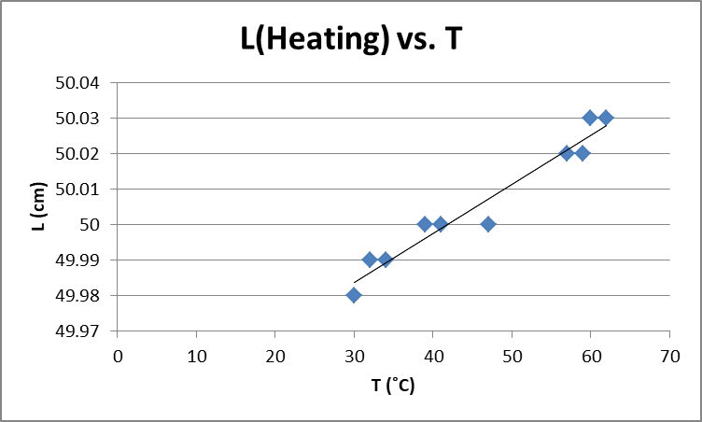

* Slope = αL0 = 0.0013 → α = 0.0013\50 = 26 * 10-6 ˚C-1
* Y-int. = L0-αL0T0 = 49.94 → α = 36 * 10-6 ˚C-1
* Slope ± ∆Slope = (26.0000 ± 0.0001) * 10-6 ˚C-1
* From graph (2): Cooling:-

|  |  |
| --- | --- |
| Slope ± ∆slope | Y-intercept ± ∆Y-intercept |
| 0.0011 | 49.96 |
| 0.0001 | 0.004922 |

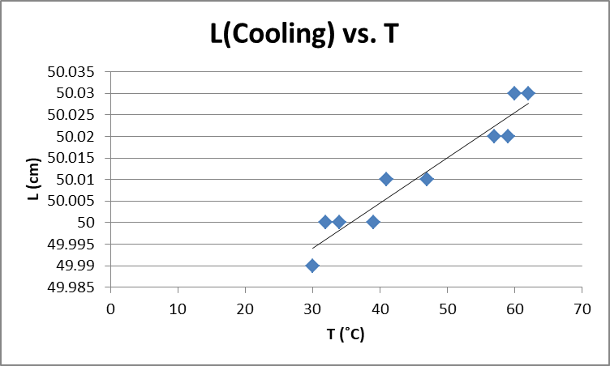

* Slope = αL0 = 0.0011 → α = 0.0011\50 = 22 * 10-6 ˚C-1
* Y-int. = L0-αL0T0 = 49.96 → α = 29 * 10-6 ˚C-1
* Slope ± ∆Slope = (22.0000 ± 0.0001) * 10-6 ˚C-1
* αavg = (26.0000+ 22.0000) * 10-6 \2 = 24.0000 * 10-6 ˚C-1
* σs = 2 * 10-6 ˚C-1 (From the calculator)
* αavg ± ∆αavg = (24 ± 2) * 10-6 ˚C-1

**Conclusion:**

* Discrepancy test:

Theoretical value of α = 19 * 10-6 ˚C-1 [1]

|Exp. – Theo.|≤ 2(error)

|24 – 19|* 10-6 ≤ 2 (2* 10-6)

5 * 10-6 ≤ 4 * 10-6 >>>>>>>>>>>>>> (The value is not accepted)

* The value has not been accepted because of several errors that have been done during the experiment. First error was in using the mirror, to reflect the light, while it is not fixed so it gave somehow wrong readings for the scale which has later affected the value of thermal coefficient. Another error was in the thermometer that gave different values of T0, in addition to that it didn't give somewhat a constant difference when reading the temperature during both, heating and cooling, and that gave a noticeable difference when measuring the value of α (for illustration, the difference between 30 ˚C& 32 ˚C[two degrees] is too small in comparison to the difference between 47 ˚C& 57 ˚C[ten degrees]).

**References:**

[1] Appendix C in physics 211 lab manual.