[](https://www.google.ps/url?sa=i&rct=j&q=&esrc=s&source=images&cd=&cad=rja&uact=8&ved=0ahUKEwiXkvOBo6HSAhXMtBoKHbRWCLEQjRwIBw&url=https://en.wikipedia.org/wiki/File:Birzeit_University_logo.svg&psig=AFQjCNFpnpXtrjWTp_fTkxvhtGLlIhXMOw&ust=1487769385132017)

**Physics Lab 211**

**Experiment No. 7**

# **Sound Waves**

**Name:** Abdallah Zatare **ID:** 1151769

**Partner’s: Hamza & Ibrahim**

**Abstract:**

**-Aims:** To detect the generation of resonance phenomenon in sound waves in air, and to calculate their speed.

**-Methods:** By measuring the heights where resonance takes place at different frequencies.

**-Main Result:**

$$\overline{v_{s}}=\left(348±6\right) m/s$$

**Theoretical Background:**

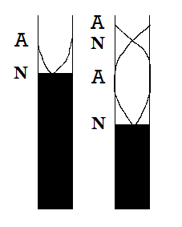 Resonance results from the formation of a node at the closed end and an antinode at the open end in a tube closed at one end.

This leads to the following resonance conditions:

$L_{1}+e=\frac{λ}{4}$ ­ …………… (eq.1)

$L_{2}+e=\frac{3λ}{4}$…………… (eq.2)

Where $e$ is called the end correction (the antinode occurs outside the tube).

By substituting $=\frac{v_{s}}{f}$, and rearranging the equations above we get:

$L_{1}=\frac{v_{s}}{4}\frac{1}{f}-e$…………… (eq.3)

$L_{2}=\frac{3v_{s}}{4}\frac{1}{f}-e$…………… (eq.4)

By plotting ( $L vs\frac{1}{f}$), we obtain ( $\frac{v}{4}$) as a slope for (eq.3), ( $\frac{3}{4}v$) as a slope for (eq.4), and the end correction from y-intercept.

**Procedure:**

A signal generator is connected to one microphone producing audio signal. A second microphone is connected for picking up weak signals. The resonance occurs when the height of the air column is an integer multiple of a quarter wavelength on the first order, and three quarters of a wavelength on the second order. So by lowering and rising the funnel, different heights of the water column is produced, and resonance can be detected then by hearing a loud distinct audio signal.

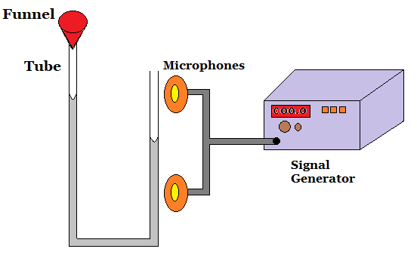

**Data Sheet:**

|  |  |  |  |
| --- | --- | --- | --- |
| $$Frequency (Hz)$$ | $$\frac{1}{f} (s)$$ | $$L_{1} (m)$$ | $$L_{2}(m)$$ |
| 349.9 | $$2.86 ×{10}^{-3}$$ | 0.235 | 0.735 |
| 399.7 | $$2.50×{10}^{-3}$$ | 0.205 | 0.635 |
| 450.0 | $$2.22×{10}^{-3}$$ | 0.180 | 0.565 |
| 500.0 | $$2.00×{10}^{-3}$$ | 0.160 | 0.505 |
| 550.0 | $$1.82×{10}^{-3}$$ | 0.145 | 0.450 |
| 600.0 | $$1.67×{10}^{-3}$$ | 0.135 | 0.415 |
| 650.0 | $$1.54×{10}^{-3}$$ | 0.120 | 0.385 |
| 700.0 | $$1.43×{10}^{-3}$$ | 0.113 | 0.360 |

**Calculations:**

**First Order (at L1):**

…………… (eq.3)

From the first graph ($L_{1}vs\frac{1}{f}$), we obtain:

$$1: Slope=\frac{v_{1}}{4}=85.82 →v_{1}=343.28 m/s$$

$$\frac{Δv_{1}}{v_{1}}=\frac{Δslope}{slope}→\frac{{Δv}_{1}}{343.28}=\frac{1.05}{85.82} →Δv_{1}=4.2 m/s$$

$$→v_{1}=\left(343.3±4.2\right) m/s$$

$$2: y_{-}intecept=-e_{1}= -0.01 →e_{1}=0.01 m$$

$$\frac{Δe_{1}}{e_{1}}=\frac{Δy_{-}intercept}{y_{-}intercept} →\frac{Δe_{1}}{0.01}=\frac{0.002}{0.01} →Δe_{1}=0.002 m$$

$$→e_{1}=\left(0.010±0.002\right)m$$

**First Order (at L2):**

…………… (eq.4)

From the second graph ($L_{2}vs\frac{1}{f}$), we obtain:

$$1: Slope=\frac{3v_{2}}{4}=263.87 →v_{2}=351.83 m/s$$

$$\frac{Δv_{2}}{v_{2}}=\frac{Δslope}{slope}→\frac{{Δv}_{2}}{351.83}=\frac{3.28}{263.87} →Δv_{2}=4.4 m/s$$

$$→v_{2}=\left(351.8±4.4\right) m/s$$

$$2: y_{-}intecept=-e_{2}= -0.02 →e_{2}=0.02 m$$

$$\frac{Δe_{2}}{e_{2}}=\frac{Δy_{-}intercept}{y_{-}intercept} →\frac{Δe_{2}}{0.02}=\frac{0.007}{0.02} →Δe_{2}=0.007 m$$

$$→e_{2}=\left(0.020±0.007\right)m$$

----------------------------------------------------

The Average value of the speed of sound:

$$\overline{v_{s}}=\frac{{v_{1}+v}_{2}}{2}=\frac{343.3+351.8}{2}=347.55 m/s$$

The error is obtained from σ­­­m:

The average value of $e$:

$$\overline{e}=\frac{{(e}_{1}+e_{2})}{2}=\frac{0.01+0.02}{2}=0.015 m$$

The error is obtained from σ­­­m:

----------------------------------------------------

**Results & Conclusion:**

$$\overline{v_{s}}=\left(348±6\right) m/s$$

$$\overline{e}=\left(0.015±0.007\right) m$$

The accepted value of the speed of sound at 30ο:

It is clear that our result is accepted since: $2×Δ\overline{v_{s}}>Discrepancy$

Normally, the speed of sound is 343 m/s, but this is at temperature 20o, and since it was hot today –around 30o-, the true value of the speed of sound is around 349 m/s.

We remark that the distance between the microphones and the tube must equal zero but since it is not, we took the end correction $(e$) into consideration which is about (1.5 cm). That is why the heights of the resonance lengths were the actual height plus ($e$).

Besides the end correction, another errors might have occurred, such as calibrating the signal generator on the desired frequency because it is not stable. As well as, reading from the ruler on the resonance tube was not accurate, since it is hard to keep the water on a specific spot to take a good reading.

**Graph I**

|  |  |  |
| --- | --- | --- |
|  | **slope** | **y-intercept** |
|  | 85.825655 | -0.010390 |
| **error** | 1.052023 | 0.002164 |

**Graph II**

|  |  |  |
| --- | --- | --- |
|  | **slope** | **y-intercept** |
|  | 263.873124 | -0.022616 |
| **error** | 3.275722 | 0.006739 |