

## Physics 211

**Experiment No. 8**

**The thermal expansion coefficient of brass**

………………………………………………………………………………………

Student’s Name: **يوسف محمود اغريب** Student’s No.: 1181326

Partner’s Name: **معتز الطويل**

Instructor: **نهاد أبو عواد**

Date: 18.9.2019

* **Abstract:**

1) The objects of the experiment:

a. To determine the coefficient of linear expansion of brass rod.

b. To learn how to calibrate an instrument.

2) The method used:

By the calibration and by using the determination of the thermal expansion of a brass.

3) The main results are:

Aaverege(coefficient of linear of expansion of brass rod

) = 26.8*10^-6 (°C)-1

**Theory:**

In general, metals expand when heated and their expansion is linear over wide ranges of temperature.

The added of heat increases the average amplitude of vibration of the atoms in the material, which increases the average separation between the atoms. The length of a metallic rod whose length at a temperature T=T.(room temperature) is L. can be found at temperature T >T. c by the following relationship:

L(T)=L.(1+ a(T-T.)) .

Where (a) is called the linear coefficient of thermal expansion.

We use the calibration curve by measuring the thickness of the pieces of plastic and reading the scale for everyone, and using the graph that containing of the scale reading versus thickness and this is ***the calibration curve.***

We heating the rod slowly and then cool it, and use the temperature versus the scale that we can find the length of the rod from the scale.

**Procedure:**

* The brass rod was fixed at one end as shown in the fig1.The other end is allowed to expand and pushed against the back of a mirror.The mirror is held with arubber band and the light is reflect from the mirror to ameter scale and the position of the light on the scale changes upon expansion of the brass . 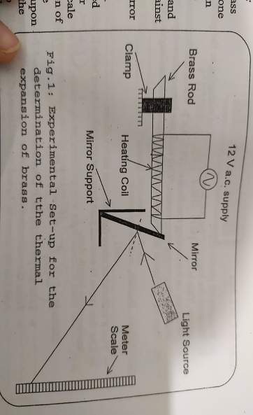
* At part 1: the calibration curve was found and graphed.BY measuring the thickness of the identical plastic and using 10 pieses by starting to insertig the pieses one by one between the brass rod and the mirror and record the thickness of the inserted pieses versus the scale reading .
* At part 2: the all of plastic pieces was removed and the length of the rod was measured (from the point of clamping to the point where it touches the mirror and this length is L. .
* The rood was heating by transformer(12v a.c.) and the scale was reading versus the temperature until the reaches of temperature stops .and the heater was turning off and repeat the same process we doing at heating with the cooling down .

* **Calculation and graphs:**

**Data:**

Part1; L. =46.2 cm

|  |  |  |
| --- | --- | --- |
| # of pices | Thickness(cm) | Scale (cm) |
| 1 | 0.0073+46.2 | 12.7 |
| 2 | 0.0146+46.2 | 12.9 |
| 3 | 0.0219+46.2 | 13.1 |
| 4 | 0.0292+46.2 | 13.4 |
| 5 | 0.0365+46.2 | 13.6 |
| 6 | 0.0438+46.2 | 13.7 |
| 7 | 0.0511+46.2 | 13.9 |
| 8 | 0.0584+46.2 | 14.0 |
| 9 | 0.0657+46.2 | 14.1 |
| 10 | 0.073+46.2 | 14.2 |

**Slope =**22.2757

- Part 2:

L.=46.2 cm

|  |  |  |  |  |  |
| --- | --- | --- | --- | --- | --- |
| T(c) | Scall of heating | | | Scall of cooling | |
| Scale(cm) | Lenght)cm) | | Scale(cm) | Lenght)cm) |
| 25 | 12.5 | | 46.2000 | 12.5 | 46.2000 |
| 30 | 12.7 | | 46.20730 | 12.7 | 46.20730 |
| 35 | 13 | | 46.21825 | 12.9 | 46.2146 |
| 40 | 13.2 | | 46.2263 | 12.9 | 46.2146 |
| 45 | 13.3 | | 46.2281 | 13 | 46.21825 |
| 50 | 13.5 | | 46.2329 | 13.2 | 46.2263 |
| 55 | 13.6 | | 46.2365 | 13.3 | 46.2281 |
| 60 | 13.8 | | 46.2464 | 13.5 | 46.2329 |
| 63 | 13.9 | | 46.2511 | 13.9 | 46.2511 |

Slope = 835.9965*100= 1/slope = a*L.

*a=25.8 *10^-6(°C)-1

Slope = 780.6265*100 1/slope =a*L.

a= 27.7 *10^-6 (°C)-1

aaverege=26.8*10^-6 (°C)-1

* **The conclusion:**

**The actiual valu of a=19*10^-6**

The discrepancy= {(26.8-19) *10^-6/19*10^-6}*100%

= 40%

* My result is not accepted .

There is some error in my result because of many reasons:

)Some of systematic ,and random error):

*Do not install the right way the pieces of the plastic between the mirror and the rood.

*The error in reading the meter scale.

* The error of converting the scale to length.

*Inaccuracies in temperature reading with the scale in form balanced.

*There is some error (in accuracy) in the reading of the temperature of the thermometer .

* there is some error when we use the scale graphing for the converting.