**PHYS 232 Assignment 8 due Wednesday April 29*,* 2020 at 10 am**

1. Submit your solutions of the following 2 problems on Ritaj by **Wednesday April 29*,* 2020 at 10 am**
2. Submit maximum 2 pages (one page per problem)
3. Label the files by your name + problem number:

For example: SamirSalim1.jpg …etc….

1. The figure below shows the results of an experiment to measure the mass of an unstable particle. Use the red Gaussian fit to estimate the mass of the particle and its lifetime. The horizontal axis is in units of MeV/c2. (35%)

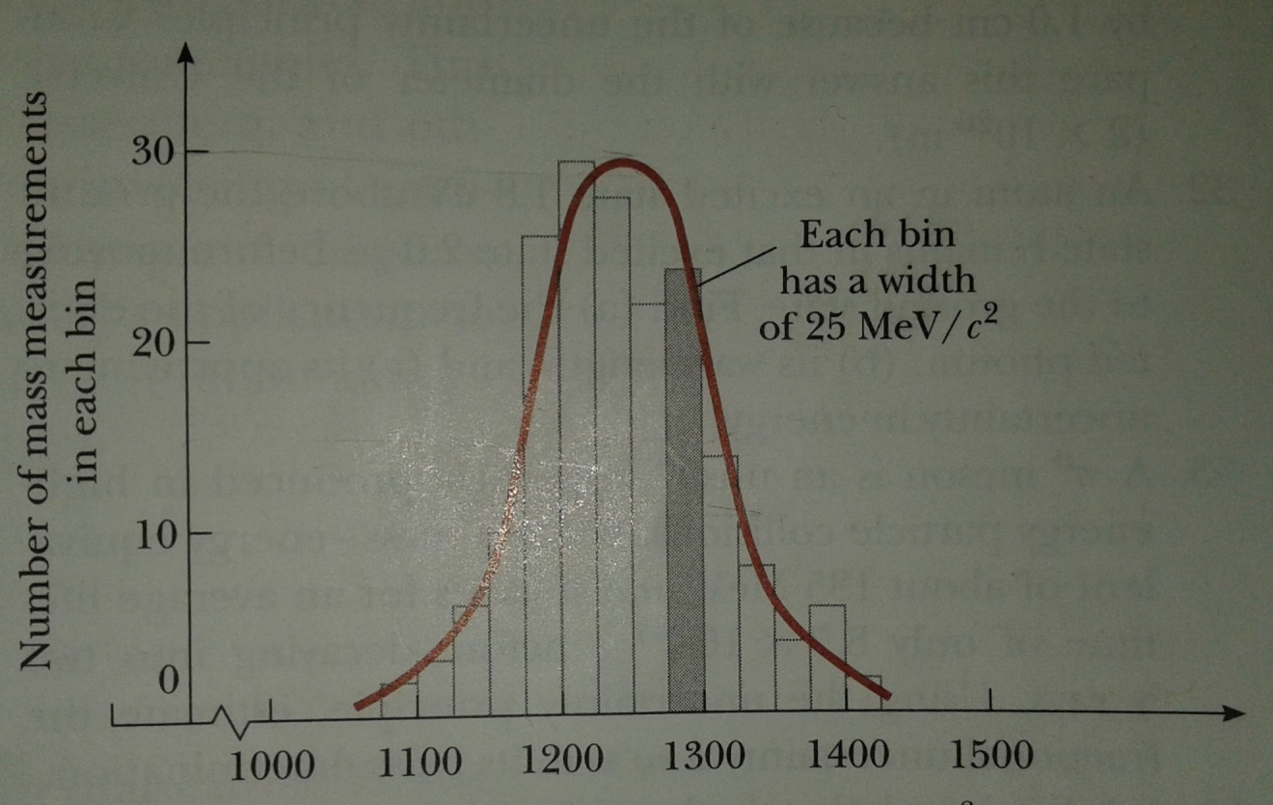

1. Consider an atom of the element Tungsten (W).
2. Use the Bohr model to estimate the energy of a K electron (n = 1) in a Tungsten atom. (35%)
3. The figure below shows the experimental X-ray spectra produced by various metals when bombarded with electrons. Each result gives the voltage difference used to accelerate the bombarding electrons that produce the x-rays. Use your result in a) to explain why there are no Kα X-rays for all the Tungsten cases shown in the figure. (20%)

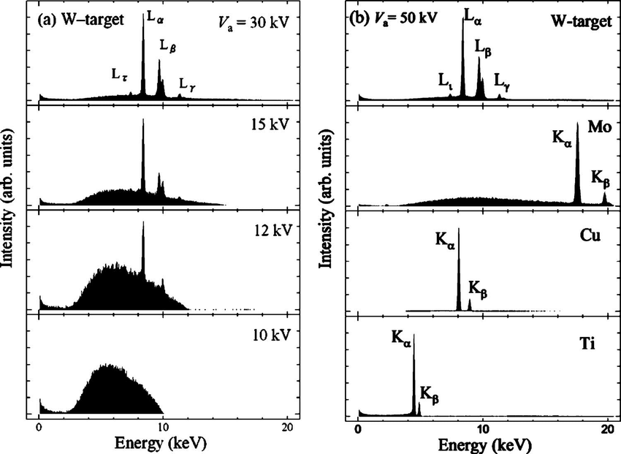

**+10%** for good hand-writing and clear and well-organized solutions.

**You are expected to work alone. Academic honesty is very important. Cheating will make you lose grades.**