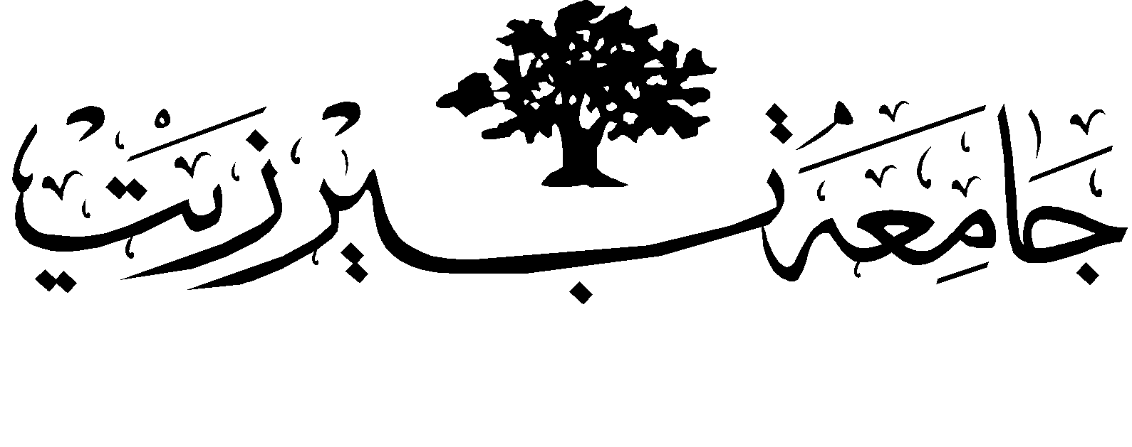

# *Chemistry Department*

General Chemistry: CHEM 133

**First Hour Exam 1st Sem. 2017-2018**

**Time: 75 min.**

**Student Name:______________________ Student No:_______________**

**Please circle:**

**Dr. Saleh Rayyan Section: 01**

**Dr. Imtiaz Khalid Section: 02**

**Dr. Jack Mustaklem Section:03**

**G*☺*☺ ☺*☺*☺D LUCK**

**Select the best fit answer in each of the following questions:**

**1. Which one of the following molecules can be represented by the general formula AX4E0?**

a. CCl4 b. PH3

c. SF4 d. XeF4

**2. Rank the elements C, Si, O, Na in order of decreasing electronegativity, the most electronegative atom first.**

a. O > C > Si > Na b. Na > Si > C > O

c. C > O > Na > Si d. O > Si > C > Na

**3. Which of the following electron configurations represents an excited state for an element (not ground state)?**

a. [Ar]4*s*23d104*p*1 b. [Ar]4*s*23*d*104*p*6

c. [Ne]3*s*23*p*3  d. [Ne]3*s*23*p*54*d*1

**4. Which of the following compounds is expected to have the strongest ionic bonds?**

a. RbF b. NaI

c. NaF d. CsBr

**5. Which of the following resonance structures is contributes least to SCO?**

a. I b. III 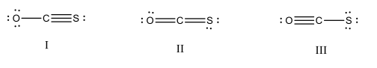

c. II d. all are equally stable.

**6. Which of the following molecules has trigonal pyramidal molecular geometry?**

a. CCl4 b. PH3

c. XeF4 d. SF4

**7. The F–O–F bond angle in oxygen difluoride, OF2, is expected to be.**

1. ≈ 104.5° b. > 109.5°

c. > 120°d. = 120°

**8. Electrons are always placed in the lowest energy sublevel available is the statement of ……?**

a. Aufbau principle b. Exclusion principle

c. Hund’s rule d. Dalton low

**9. Which of the following represent metallic bond?**

a. CCl4  b. SF2

c. RbCa  d. KCl

**10. Consider the molecule PCl5. How many lone pairs are on the central atom?**

a. 2 b. 3

c. 4 d. 0

**11. Which molecule is an exception to the octet rule?**

a. NaCl b. SO3

c. SiCl4  d. AsI3

**12. Rank the bonds in the following set in order of decreasing bond strength (the strongest first): C–F, C–Br, C–Cl**

a. C–F > C–Br> C–Clb. C–F > C–Cl > C–Br

c. C–Br > C–Cl > C–Fd. S–Cl> S–F > S–Br

**13. Which of the following has the shortest bond?**

a. NH4+1 b. NH3

c. CH4 d. H2O

**14. Methylene (C2H4), is the smallest hormone (ripen hormone). The CC bond in the molecule C2H4 is best described as a:**

a. single bond b. double bond

c. ionic bond d. triple bond

**15. What is the molecular geometry of the poly atomic NO3-1 ion?**

a. trigonal planer b. linear

c. tetrahedral d. octahedral

**16. The average bond order for the bonds in carbonate ion CO3**-2**resonance hybrid is.**

a. 3 b. 4

c. 4/3 d. 3/4

**17. Which of the following has the smallest atomic size?**

a. K b. Na

c. Na +1 d. F-1

**18. The formal charge of N in nitrogen dioxide (NO2) is?**

a. - 1 b. + 3 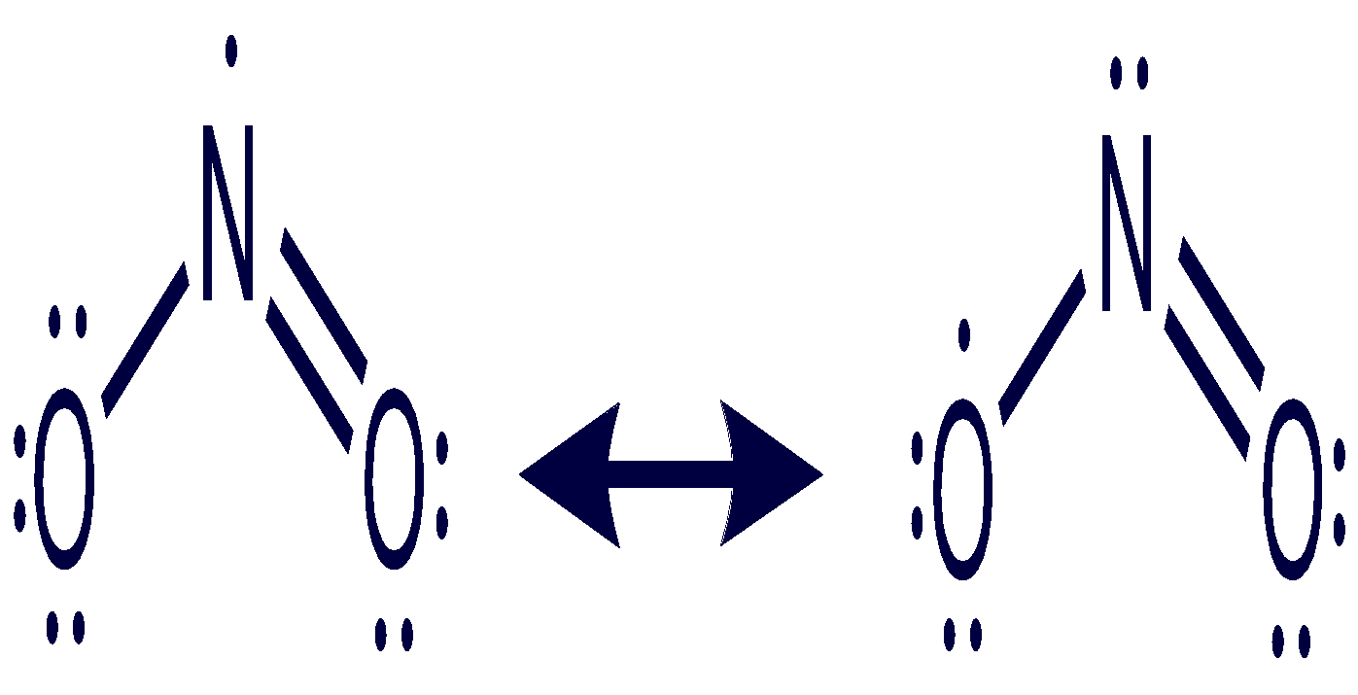

c. - 3 d. + 1

**19. Given that the average bond energies of O=O bond is 498 kJ/mol, C─H bond is 413 kJ/mol, C=O bond is 799 KJ/mol and O─H bond is 467 kJ/mol, What will be the ∆H° rxn for the oxidation of methane to form CO2 and H2O?** **CH4 + 2O2 → CO2 + 2H2O**

a. 618 KJ/mol b. 514 KJ/mol

c. 715 KJ/mol d. - 818 KJ/mol

**20. Which of the following is the correct Lewis structures of CO3-2?**



a. A

b. B

c. C

d. D

**21. Which of the following does not contribute in the resonance structures for nitrite ion, NO2–?**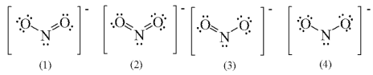

a. 1 and 2 b. 2 and 4

c. 1 and 3 d. 2, 3, and 4

**22. The** **following are the 3 possible resonance forms for the ion NCO−, the formal charge for the oxygen (O) in form I is.**



a. 0 b. +1

c. 2 d. -1

**G*☺*☺ ☺*☺*☺D LUCK**

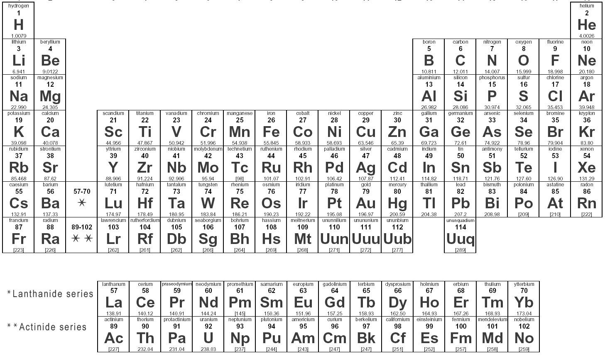17/12-2017