**CHEM 141**

**HOMEWORK**

**CHAPTER 5**

**Second Semester 2019/2020**

**Student Name …………………………………. Student ID Number……………………..**

**Instructions:**

* **Choose 10 questions of the first 15 question, solve them and write the final answers in the table below. You need to show your solution or explanation to 5 of these questions on a separate page(s).**
* **Answer all the questions numbered 16 to 20.**
* **Your answers should be submitted in a file with your name being the file name.**
* **The answers should be submitted no later than May 2nd, 2020.**

**Answer Sheet**

|  |  |  |  |  |
| --- | --- | --- | --- | --- |
| **Q#** | **Answer** | **Q#** | **T or F** | |
| **1** |  | **16** |  | |
| **2** |  | **17** |  | |
| **3** |  | **18** |  | |
| **4** |  | **19** |  | |
| **5** |  | **20** |  | |
| **6** |  |  | |
| **7** |  |
| **8** |  |
| **9** |  |
| **10** |  |
| **11** |  |
| **12** |  |
| **13** |  |
| **14** |  |
| **15** |  |

1. A sample of oxygen occupies 47.2 liters under a pressure of 1240 torr at 25oC. What volume would it occupy at 25oC if the pressure was decreased to 730 torr?

2. Calculate the density of chlorine gas at STP, in grams per liter.

3. What pressure (in atm) would be exerted by 76 g of fluorine gas in a 1.50 liter vessel at -37oC?

4. What is the molecular weight of a pure gaseous compound having a density of 4.95 g/L at atemperature of -35oC and pressure of 1020 torr?

5. A 0.580 g sample of a compound containing only carbon and hydrogen contains 0.480 g of carbon and 0.100 g of hydrogen. At STP, 33.6 mL of the gas has a mass of 0.087 g. What is the molecular formula for the compound?

6. A mixture of 90.0 grams of CH4 and 10.0 grams of argon has a pressure of 250 torr under conditions of constant temperature and volume. What is the partial pressure of CH4 in torr?

7. A sample of hydrogen gas collected by displacement of water occupied 30.0 mL at 24oC and a total pressure of 736 torr. What volume would the hydrogen occupy if it were dry and at STP? The vapor pressure of water at 24.0oC is 22.4 torr.

8. If helium effuses through a porous barrier at a rate of 4.0 moles per minute, at what rate (in moles per minute) would oxygen gas diffuse?

9. Calculate the weight of KClO3 that would be required to produce 29.5 L of oxygen measured at 127oC and 760 torr.

2KClO3(s) ⇒ 2KCl(s) + 3O2(g)

10. Which of the lines on the figure below is the best representation of the relationship between the volume of a gas and its Celsius temperature, other factors remaining constant?

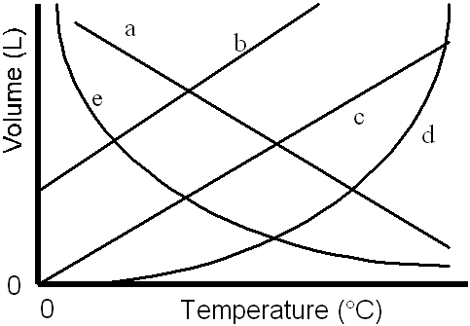

11. A 250.0-mL sample of ammonia, NH3(*g*), exerts a pressure of 833 torr at 42.4°C. What mass of ammonia is in the container?

12. Magnesium metal (0.100 mol) and a volume of aqueous hydrochloric acid that contains 0.500 mol of HCl are combined and react to completion. How many liters of hydrogen gas, measured at STP, are produced?

Mg(*s*) + 2HCl(*aq*)  MgCl2(*aq*) + H2(*g*)

13. Methane, CH4(*g*), reacts with steam to give *synthesis gas,* a mixture of carbon monoxide and hydrogen, which is used as starting material for the synthesis of a number of organic and inorganic compounds. What mass of hydrogen is formed if 275 L of methane (measured at STP) is converted to synthesis gas?

CH4(*g*) + H2O(*g*)  CO(*g*) + H2(*g*) [unbalanced]

14. Arrange the following gases in order of increasing rate of effusion.

|  |  |  |  |  |
| --- | --- | --- | --- | --- |
| C2H6 | Ar | HCl | PH3 |  |

15. Use the van der Waals equation for real gases to calculate the pressure exerted by 1.00 mole of ammonia at 27°C in a 750-mL container. (*a* = 4.17 L2·atm/mol2, *b* = 0.0371 L/mol)

**TRUE or FALSE**

16. Three 1.0 liter flasks are filled with H2, O2 and Ne, respectively. At STP, each flask has the same number of gas molecules.

17. From the postulates of kinetic-molecular theory, it follows that the molecules of all gases at a given temperature have the same average speed.

18. A real gas most closely approaches the behavior of an ideal gas under conditions of high P and low T.

19. A mixture of 0.50 mol H2(g) and 0.50 mol N2(g) is introduced into a 15.0 liter container having a pinhole leak at 30oC. After a period of time, the partial pressure of H2 exceeds that of N2 in the container.

20. At a temperature of absolute zero, the volume of an ideal gas is zero.