

**Birzeit University**

Chemistry Department

Chemistry 141

1st hour Exam 2nd Sem. 2017/2018

Time: 1:30 Hours.

**Instructors:**

**Dr. Saleh Rayyan**

**Student Name: _________________________**

**Student No: ____________________________**

**Lecture No: ____________________________**

G*☺*☺ ☺*☺*☺d Luck

*Chem141 1st hour*

*Student name: ------------------------ student no: ------------------------- Section:---------------*

|  |  |  |  |  |
| --- | --- | --- | --- | --- |
|  | **A** | **B** | **C** | **D** |
| ***1*** | A | B | *C* | D |
| **2** | A | B | C | D |
| **3** | A | B | C | D |
| **4** | A | B | C | D |
| **5** | A | B | C | D |
| **6** | A | B | C | D |
| **7** | A | B | C | D |
| **8** | A | B | C | D |
| **9** | A | B | C | D |
| **10** | A | B | C | D |
| ***11*** | A | B | C | D |
| **12** | A | B | C | D |
| **13** | A | B | C | D |
| **14** | A | B | C | D |
| **15** | A | B | C | D |
| **16** | A | B | C | D |
| **17** | A | B | C | D |
| **18** | A | B | C | D |
| **19** | A | B | C | D |
| **20** | A | B | *C* | D |

**Please read the questions carfully and choose the best fit answer (1 point each):**

**1) Select the best statement.**

A) Physical properties are mostly extensive in nature.

B) Physical changes alter the composition of the substances involved.

C) Physical properties are not valid characteristics for identifying a substance.

D) Physical changes may be reversed by changing the temperature.

**2) The speed needed to escape the pull of Earth's gravity is** 253 × 102 mi/h**. What is this speed in km/s?**

A) 655 × 102 km/s B) 109 km/s

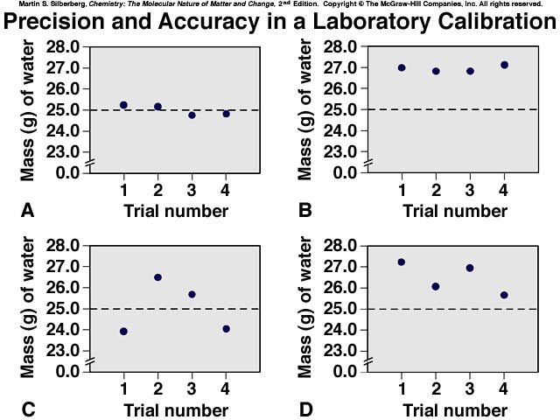C) 11.3 km/s D) 5.02 km/h

**3) The measurements shown in the figure below are?**

A) Precise. B) Precise but not accurate.

C) Accurate. D) Accurate but not Precise.

**4) Which measurement is expressed to 4 significant figures?**

A) 0.0423 kg B) 24.04 cm

C) 1300 K D) 62.040 g

**5) The result of (3.8621 × 1.5630) - 5.980 is properly written as**

A) 0.06 B) 0.056

C) 0.0565 D) 0.05646

**6) Compound 1 has a composition of 50.00 mass % of element A and 50.00 mass % of element B. A and B also form a second binary compound (compound 2). If the compositions of the two compounds are consistent with the law of multiple proportions, which of the following compositions could be that of compound 2?**

A) 50 mass % A, 100 mass % B B) 75 mass % A, 25 mass % B

C) 33.33 mass % A, 66.67 mass % B D) 73.3 mass % A, 26.7 mass % B

**7) Which scientist is credited for finding the mass/charge ratio of the electron?**

A) Thomson B) Millikan

C) Dalton D) Rutherford

**8) Isotopes are atoms of the same element that differ in the?**

A) Atomic number B) Mass number

C) Number of neutrons D) Both B and C.

**9) Mixtures differ from compounds in three major ways, which of the following is not one of them?**

A) The proportions of the components can vary.

B) The individual properties of the components are observable.

C) The components can be separated by physical means

D) The composition of the different components in any mixture must follow the law of multiple proportions.

**10) The substance, HNO3, is a strong acid, What is its name?**

A) Nitrous acid B) nitrite acid

C) hyponitrous acid D) nitric acid

**11) Platinum is used in jewelry and electronics. How many grams of Pt are in 0.040 mol of Pt?**

A) 7.8 g B) 3.9 g

C) 195.08g D) 1.9 g

**12) Lithium is a key element in mobiles, computers and other electronic device batteries, how many Li atoms are in 1 x 10-4 mol of Lithium?**

A) 6 x 1020 atoms. B) 2 x 1020 atoms.

C) 2 x 10-26 atoms D) 6 x 1019 atoms.

**13) Elemental analysis of organic compound (M = 90.08 g/mol) shows it contains 36.03 g C, 6.06 g H, and 47.97 g O. Determine the molecular formula for this organic compound.**

A) C3H6O3 B) C1H2O1

C) CH3O D) C3.33H6.66O3.33

**14) Copper is obtained from copper(I) sulfide by roasting it in the presence of oxygen gas to form powdered copper(I) oxide and gaseous sulfur dioxide. The correct value of** *m***,** *n***,** *x* **and** *y* **to obtain a balanced equation is?** *m* **Cu2S (*s*) +** *n* **O2 (*g*) →** *x* **Cu2O (*s*) +** *y* **SO2 (*g*)**

A) *m*=2, *n*=3, *x*=2 and *y*=2 B) *m*=1, *n*=1.5, *x*=1 and *y*=1

C) *m*=4, *n*=6, *x*=4 and *y*=4 D) *m*=1, *n*=1, *x*=1 and *y*=1

**15) In a simulation of mercury removal from industrial wastewater, 0.200 L of 0.010 *M* mercury(II) nitrate reacts with 0.010 L of 0.10 *M* sodium sulfide. How many grams of mercury(II) sulfide form?**

A) 0.53 g B) 0.12g

C) 0.23g D)0.93g

**16) How many different ions are in (NH4)3PO4?**

A) 12H+1, 3 N-3, 1 P-3 and 4 O-2 ions B) 3 NH4+1 and 1 PO4-2 ions

C) 3 NH4+1 and 1 PO4-3 ions D) 1 NH4+1 and 3 PO4-3 ions

**17) What is the net ionic equation when Ba(OH)2 react with H2SO4 in water?**

A) Ba2+ (*aq*) + 2OH− (*aq*) + 2H+ (*aq*) + SO42− (*aq*) → BaSO4 (*s*) + H2O (*l*)

B) 2OH− (*aq*) + 2H+ (*aq*) → H2O (*l*)

C) Ba2+ (*aq*) + SO42− (*aq*) → BaSO4 (*s*)

D) There is no net ionic equation in this case

**18) A 50.00 mL sample of H2SO4 is titrated with 0.1524 *M* NaOH. The buret reads 0.55 mL at the start and 33.87 mL at the end-point. Find the molarity of the H2SO4 solution.**

A) 0.051 B) 0.100

C) 0.20 D) 0.033

**19) What is the oxidation number of sulfur in H2SO4?**

A) **̶** 2 B) **+** 2

C) **+** 6 D) **̶** 6

**20)** **In the following reaction, which of the following is spectator ions:**

**3 Ba(NO3)2 + 2 K3PO4 → Ba3(PO4)2 + 6 KNO3**

A)Ba +2 and PO4 -3 B) K +1 and PO4 -3

C) K +1 and NO3 -1 D) Ba+2 and NO3 -1

G*☺*☺ ☺*☺*☺d Luck

**Soluble Ionic Compounds:**

1. All common compounds of Group 1A(1) ions (Li+, Na+, K+, etc.) and ammonium ion (NH4+) are soluble.

2. All common nitrates (NO3−), acetates (CH3COO− or C2H3O2−) and most perchlorates (ClO4−) are soluble

3. All common chlorides (Cl-), bromides (Br-) and iodides (I-) are soluble, *except* those of Ag+, Pb2+, Cu+, and Hg22+. All common fluorides (F−) are soluble *except* those of Pb2+ and Group 2A(2).

4. All common sulfates (SO42−) are soluble, *except* those of Ca2+, Sr2+, Ba2+, Ag+, and Pb2+.

**Insoluble Ionic Compounds:**

1. All common metal hydroxides are insoluble, *except* those of Group 1A(1) and the larger members of Group 2A(2)(beginning with Ca2+).

2. All common carbonates (CO32−) and phosphates (PO43−) are insoluble, *except* those of Group 1A(1) and NH4+.

3. All common sulfides are insoluble except those of Group 1A(1), Group 2A(2) and NH4+.

