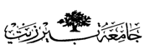

**Birzeit University**

Chemistry Department

Chemistry 141

1st hour Exam 2nd Sem. 2017/2018

Time: 75 minutes.

**Instructors:**

**Dr. Saleh Rayyan**

**Student Name: _________________________**

**Student No: ____________________________**

**Lecture No: ____________________________**

G*☺*☺ ☺*☺*☺d Luck

*Chem141 1st hour*

*Student name: ------------------------ student no: ------------------------- Section:---------------*

|  |  |  |  |  |
| --- | --- | --- | --- | --- |
|  | **A** | **B** | **C** | **D** |
| ***1*** | A | B | *C* | D |
| **2** | A | B | C | D |
| **3** | A | B | C | D |
| **4** | A | B | C | D |
| **5** | A | B | C | D |
| **6** | A | B | C | D |
| **7** | A | B | C | D |
| **8** | A | B | C | D |
| **9** | A | B | C | D |
| **10** | A | B | C | D |
| ***11*** | A | B | C | D |
| **12** | A | B | C | D |
| **13** | A | B | C | D |
| **14** | A | B | C | D |
| **15** | A | B | C | D |
| **16** | A | B | C | D |
| **17** | A | B | C | D |
| **18** | A | B | C | D |
| **19** | A | B | C | D |
| **20** | A | B | *C* | D |

**Please read the questions carfully and choose the best fit answer (1 point each):**

**1) Select the best statement.**

A) Physical properties are mostly extensive in nature.

B) Physical changes alter the composition of the substances involved.

C) Physical properties are not valid characteristics for identifying a substance.

D) Chemical changes cannot simply be reversed by changing the temperature.

**2) The density of iron is** 7874 kg/dm3**. Express this amount in lb/cm3?**

A) 655 lb/cm3 B) 109 lb/cm3

C) 17.36 lb/cm3 D) 5.02 lb/cm3

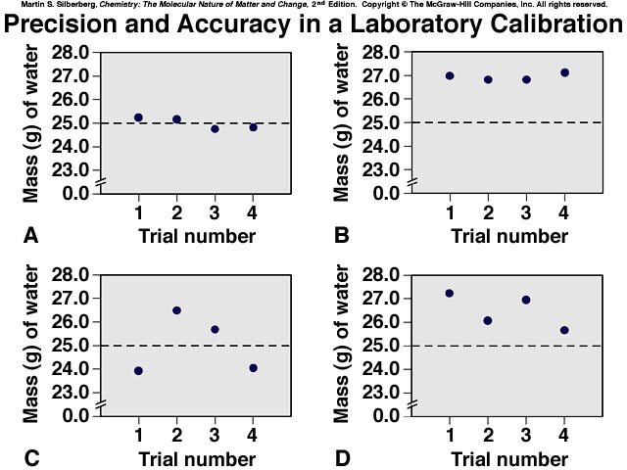 **3) The measurements shown in the figure below are?**

A) Precise. B) Precise and accurate.

C) Accurate. D) Accurate but not Precise.

**4) Which measurement is expressed to 5 significant figures?**

A) 0.04230 kg B) 24.040 cm

C) 13000 K D) 62.04 g

**5) The result of (3.8621 × 1.5630) - 5.9800 is properly written as**

A) 0.06 B) 0.0565

C) 0.056 D) 0.05646

**6) Element A and B form three compounds, AB, AB2 and AB3. This is an illustration of?**

A) Law of multiple proportions B) Low of definite composition

C) Both A and B is correct D) None of the above.

**7) Which scientist is credited for finding the mass and the charge of the electron?**

A) Millikan B) Thomson

C) Dalton D) Rutherford

**8) Carbon has 3 isotopes 12C, 13C and 14C, these isotopes have the same?**

A) Number of protons B) Number of electrons

C) Number of neutrons D) Both A and B.

**9) Compounds differ from mixtures in three major ways, which of the following is not one of them?**

A) The proportions of the components (elements) of a compound is definite.

B) The individual properties of the components are not observable.

C) The components of a compound cannot be separated by physical means

D) The composition of the different components in a compound can vary.

**10) The substance, H2SO3, is an acid, what is its name?**

A) Sulfuric acid B) Sulfarite acid

C) hyposulfrous acid D) Sulfurous acid

**11) Silver is used in jewelry and electronics. How many grams of Ag are in 0.040 mol of Ag?**

A) 4.3 g B) 3.9 g

C) 195.08g D) 1.9 g

**12) Gallium is a key element in solar energy cells, how many Ga atoms are in 1 x 10-4 mol of Gallium?**

A) 6 x 1020 atoms. B) 2 x 1020 atoms.

C) 2 x 10-26 atoms D) 6 x 1019 atoms.

**13) Elemental analysis of organic compound (M = 180.16 g/mol) shows it contains 36.03 g C, 6.06 g H, and 47.97 g O. Determine the molecular formula for this organic compound.**

A) C6H12O6 B) C3H6O3

C) CH2O D) C36.03H6.06O47.97

**14) Propane reacts with oxygen according to the following equation. The correct value of** *m***,** *n***,** *x* **and** *y* **to obtain a balanced equation is?** *m* **C3H8 (*g*) +** *n* **O2 (*g*) →** *x* **CO 2 (*g*) +** *y* **H2O (*g*)**

A) *m*=1, *n*=5, *x*=3 and *y*=4 B) *m*=1, *n*=1.5, *x*=1 and *y*=1

C) *m*=2, *n*=10, *x*=6 and *y*=8 D) *m*=1, *n*=1, *x*=1 and *y*=1

**15) In a simulation of mercury removal from industrial wastewater, 0.200 L of 0.010 *M* mercury(II) nitrate reacts with 0.010 L of 0.10 *M* sodium sulfide. How many grams of Sodium nitrate form?**

A) 0.34 g B) 0.12g

C) 0.17g D)0.93g

**16) How many different ions are in Fe2(CO3)3?**

A) 3C+4, 2 Fe+3 and 9 O-2 ions B) 2 Fe+2 and 2 CO3-2 ions

C) 2 Fe+3 and 3 CO3-2 ions D) 1 Fe+3 and 3 CO3-2 ions

**17) What is the net ionic equation when Ca(OH)2 react with HF in water?**

A) Ca2+ (*aq*) + 2OH− (*aq*) + 2H+ (*aq*) + 2F1− (*aq*) → CaF2 (*s*) + 2H2O (*l*)

B) 2OH− (*aq*) + 2H+ (*aq*) → H2O (*l*)

C) Ca2+ (*aq*) + 2F1− (*aq*) → CaF2 (*s*)

D) There is no net ionic equation in this case

**18) A 50.00 mL sample of H3PO4 is titrated with 0.1524 *M* NaOH. The buret reads 1.55 mL at the start and 34.87 mL at the end-point. Find the molarity of the H3PO4 solution.**

A) 0.0338 B) 0.100

C) 0.200 D) 0.0400

**19) What is the oxidation number of phosphorus in H3PO4?**

A) **̶** 3 B) **+** 3

C) **+** 5 D) **̶** 5

**20)** **In the following reaction, which of the following is spectator ions?**

**Ca(NO3)2 + Na2SO4 → CaSO4 + 2 NaNO3**

A)Ca +2 and SO4 -2 B) Na +1 and SO4 -2

C) Na +1 and NO3 -1 D) Ca+2 and NO3 -1

G*☺*☺ ☺*☺*☺d Luck

**Soluble Ionic Compounds:**

1. All common compounds of Group 1A(1) ions (Li+, Na+, K+, etc.) and ammonium ion (NH4+) are soluble.

2. All common nitrates (NO3−), acetates (CH3COO− or C2H3O2−) and most perchlorates (ClO4−) are soluble

3. All common chlorides (Cl-), bromides (Br-) and iodides (I-) are soluble, *except* those of Ag+, Pb2+, Cu+, and Hg22+. All common fluorides (F−) are soluble *except* those of Pb2+ and Group 2A(2).

4. All common sulfates (SO42−) are soluble, *except* those of Ca2+, Sr2+, Ba2+, Ag+, and Pb2+.

**Insoluble Ionic Compounds:**

1. All common metal hydroxides are insoluble, *except* those of Group 1A(1) and the larger members of Group 2A(2)(beginning with Ca2+).

2. All common carbonates (CO32−) and phosphates (PO43−) are insoluble, *except* those of Group 1A(1) and NH4+.

3. All common sulfides are insoluble except those of Group 1A(1), Group 2A(2) and NH4+.

