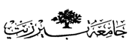

**Birzeit University**

Chemistry Department

Chemistry 141

2nd hour Exam 2nd Sem. 2017/2018

Time: 1:30 Hours.

**Instructors:**

**Dr. Saleh Rayyan**

**Student Name: _________________________**

**Student No: ____________________________**

**Lecture No: ____________________________**

G*☺*☺ ☺*☺*☺d Luck

*Chem141 2nd hour*

*Student name: ------------------------ student no: ------------------------- Section:---------------*

|  |  |  |  |  |
| --- | --- | --- | --- | --- |
|  | **A** | **B** | **C** | **D** |
| ***1*** | A | B | *C* | D |
| **2** | A | B | C | D |
| **3** | A | B | C | D |
| **4** | A | B | C | D |
| **5** | A | B | C | D |
| **6** | A | B | C | D |
| **7** | A | B | C | D |
| **8** | A | B | C | D |
| **9** | A | B | C | D |
| **10** | A | B | C | D |
| ***11*** | A | B | C | D |
| **12** | A | B | C | D |
| **13** | A | B | C | D |
| **14** | A | B | C | D |
| **15** | A | B | C | D |
| **16** | A | B | C | D |
| **17** | A | B | C | D |
| **18** | A | B | C | D |
| **19** | A | B | C | D |
| **20** | A | B | *C* | D |

**Please read the questions carfully and choose the best fit answer (1 point each):**

**1. Mineral oil (density = 1.35 g/mL) can be used in place of mercury (density = 13.5 g/mL) in certain pressure-measuring instruments. What is the pressure of an oxygen sample in mm of Hg if its pressure is 460 mm mineral oil?**

A) 155 mm B) 4600 mm

C) 460 mm D) 46 mm

**2.** **The total pressure in a mixture is the sum of the partial pressures of the component gases, this statement is of ____________** **Law of partial pressures.**

A) Charles' B) Boyle's C) Avogadro's D) Dalton's

**3**. **What is the partial pressure of oxygen O2 in****a 10-L flask if 0.2 mol of ozone O3 is added to 0.40 mol of oxygen? The temperature of the mixture is 0°C.**

A) 0.90 atm B) 1.35 atm

C) 0.11 atm D) 0.0 atm

**4. A flask with a volume of 3.00 L contains 9.33 grams of an unknown gas at 30.0°C and 1.00 atm. What is the molar mass of the gas?**

A) 77.4 g/mol B) 81.4 g/mol

C) 7.76 g/mol D) 66.1 g/mol

**5. Zinc metal (0.200 mol) and a volume of aqueous hydrochloric acid that contains 0.500 mol of HCl are combined and react to completion at STP. How many liters of hydrogen gas are produced at STP?**  Zn(*s*) + 2HCl(*aq*)  ZnCl2(*aq*) + H2(*g*)

A) 4.49 L B) 22.4 L

C) 2.24 L D) 11.2 L

**6. Hydrogen peroxide was catalytically decomposed and 80.0 mL of oxygen gas was collected over water at 25.0°C and 784 torr. What mass of oxygen was collected? (Pwater = 24.0 torr at 25°C)**

A) 0.0962 g B) 105 g

C) 0.105 g D) 0.108 g

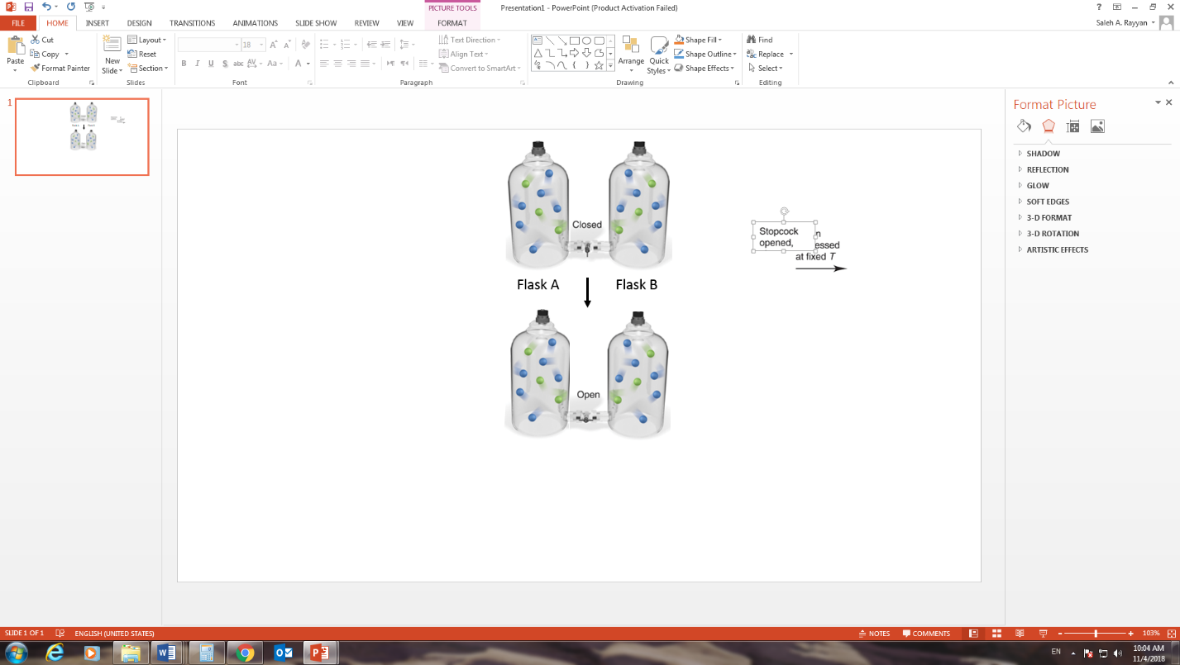**7. In the scene depicted to the right, flask A contains He gas and the total pressure is 2 atm and flask B contains Ne gas and the total pressure is 4 atm. What will be the total pressure in the two flasks if the valve between them is opened given that both flasks have the same volume and each particle represent 0.1 mol in flask A and 0.2 mol in flask B and the process was done at constant temperature?**

A) 2 atm

B) 4 atm

C) 3 atm

D) 6 atm

1. **A system that receives some work and does not transfer heat to the surroundings has**

A) *w* ˃ 0, ∆*E* < 0 B) *w* > 0, ∆*E* > 0

C) *w* < 0, ∆*E* = 0 D) *w* ˂ 0, ∆*E* < 0

**9. A system receives 225 J of heat and delivers 125 J of work. Calculate the change in the internal energy, ∆E, of the system.**

A) -l00 J B) 100 J

C) -350 J D) 350 J

**10.** **A system initially has an internal energy E of 945 J. It undergoes a process during which it releases 111 J of heat energy to the surroundings, and does work of 222 J. What is the final energy of the system, in J?**

A) 834 J B) 612 J

C) 168 J D) 390 J

**11. When NaOH aqueous solution is mixed with HCl aqueous solution. The temperature of the resultant solution increase, which of the following is true for this reaction?**

A) ∆*H* > 0, process is exothermic B) ∆*H* = 0, since cold packs are sealed

C) ∆*H* ˂ 0, process is exothermicD) ∆*H* > 0, process is endothermic

**12. Ali baba candy bar contains 280 *Calories*, of which the sugar content accounts for 110 *Calories*. What is the energy of the sugar content?**

A) 460 J B) 4.6 × 10 2 kJ

C) 4.6 × 10-1 kJ D) 0.460 × 103 J

**13. How much heat is gained when 20.0 g of H2O is heated from 22.0 to 80.0°C. c for H2O is 4.184 J/g.K.**

A) 1.61 kJ B) 9.37 kJ

C) 4.9 kJ D) -4.9 kJ

**14. A 10.0 g sample of an unknown mineral was heated to 99.9°C and placed into a calorimeter containing 10.0 g of water at 19.9°C. The heat capacity of the calorimeter was 10.0 J/K. The final temperature in the calorimeter was 29.9°C. What is the specific heat capacity of the mineral?**

A) 0.598 J/(g·K) B) - 0.598 J/(g·K)

C) 0.741 J/(g·K) D) - 0.741 J/(g·K)

**15. Any object (including atoms) can absorb or emit only certain quantities of energy, this statement was proposed by?**

A) Planck B) Rydberg

C) Compton D) Einstein

**16. If the energy of a photon is 2.32 × 10-18 J, what is its wavelength in nm?**

A) 85.7 nm B) 0.857 × 10-7 m

C) 8.57 × 10-8 nm D) 8.57 × 10-8 m

**17. Use the Rydberg equation to calculate the wavelength of a photon released when the hydrogen atom undergoes a transition from n = 4 to n = 2. (R = 1.097 × 107 m-1)**

A) 4.862 × 10-7 nm B) > 1019 nm

C) 4.862 × 10-7 m D) 0.2057 × 107 nm

**18. The Bohr Theory predicts the energy difference (in J) for the lithium ion (Li+2) between the n = 3 and the n = 5 state to be**

A) 1.36 ×10-19 J B) 3.68 × 10-18 J

C) 1.40 × 10-18 J D) 1.55 × 10-19 J

**19. What is the correct combinations between the following quantum numbers designations and/or sublevel names?**

|  |  |  |  |  |
| --- | --- | --- | --- | --- |
|  | *n* | *l* | m*l* | Name |
| A) | 2 | 1 | 0 | 2*p* |
| B) | 4 | 3 | +1 | 4*d* |
| C) | 3 | 2 | -1 | 3*p* |
| D) | 5 | 2 | +3 | 5*d* |

**20. Which of the following is a correct set of quantum numbers for an electron in a 4*p* orbital?**

A) *n* = 4, *l* = 1, *ml* = +1 B) *n* = 4, *l* = 4, *ml* = 3

C) *n* = 6, *l* = 2, *ml* = +*1* D) *n = 4, l = 2, ml = +1*

