Chemistry 133

Quiz #8 Form A 18.12.2015

Student name:------------------------------- Student #-----------------------------

2. Which one of the following quantities is generally not obtainable from a single heating or cooling curve of a substance, measured at atmospheric pressure?

A) melting point D) heat of fusion

B) boiling point E) heat of vaporization

C) triple point

Ans:  C

3. Examine the following phase diagram and identify the feature represented by point A.

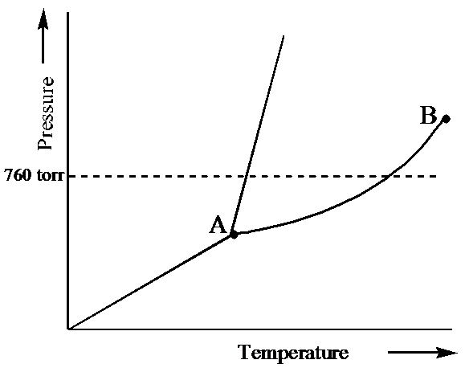

A) melting point D)sublimation point

B) critical point E) boiling point

C) triple point

Ans:  C

4. When the electron cloud of a molecule is easily distorted, the molecule has a high

A) polarity. D) van der Waals radius.

B) polarizability. E) compressibility.

C) dipole moment.

5. Examine the phase diagram for the substance Bogusium (Bo) and select the correct statement.

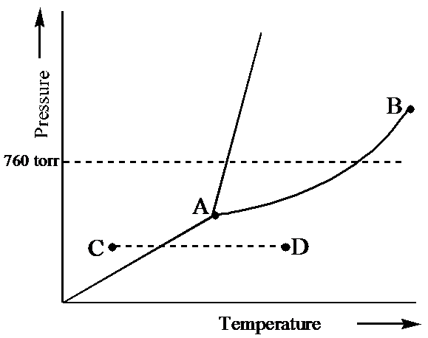 A) Bo(*s*) has a lower density than Bo(*l*).

B) The triple point for Bo is at a higher temperature than the melting point for Bo.

C) Bo changes from a solid to a liquid as one follows the line from C to D.

D) Bo changes from a liquid to a gas as one follows the line from C to D.

E) Point B represents the critical temperature and pressure for Bo.

Ans:  E

6. Ammonia's unusually high melting point is the result of

A) dipole-dipole forces. D) covalent bonding.

B) London dispersion forces. E) ionic bonding.

C) hydrogen bonding.

Ans:  C

7. Octane has a vapor pressure of 40. torr at 45.1°C and 400. torr at 104.0°C. What is its heat of vaporization?

A) 39.0 kJ/mol D) 710 kJ/mol

B) 46.0 kJ/mol E) None of these choices is correct.

C) 590 kJ/mol

Ans:  A