***Drying Agents***

The most common way to ***dry*** (remove the water from) an organic liquid is to add an ***anhydrous*** (dry) drying agent that binds with water. Anhydrous drying agents react with water to form ***crystalline hydrates,*** which are insoluble in the organic phase and can be removed by filtration.



Drying agents for organic liquids are usually anhydrous inorganic salts.

Following are the factors that need to be considered in selecting a drying agent:

• Capacity • Efficiency • Speed • Chemical inertness

***Capacity for removing water.*** The maximum number of moles of water bound in the hydrated form of the salt is called its ***capacity;*** the capacity is the amount of water that can be taken up per unit weight of drying agent.

***Efficiency.*** The ***efficiency*** expresses how much water the drying agent *leaves behind* in the organic liquid. The lower the efficiency value, the smaller the amount of water left in the organic liquid; thus, the drying agent is more efficient.

***Speed.*** The ***speed*** with which the hydrate forms determines how long the drying agent needs to be in contact with the organic solution. A good general drying agent, such as MgSO4, usually requires 5–10 minutes to remove water from an organic liquid. CaCl2 and Na2SO4 usually require 15–30 minutes.

***Chemical inertness.*** Drying agents must be ***chemically inert*** (unreactive) to both the organic solvent and any organic compound dissolved in the solvent. For example, bases such as K2CO3 and KOH are not suitable for drying acidic organic compounds because they undergo chemical reactions with these compounds. MgSO4 is generally considered to be a neutral salt, but in the presence of water it is slightly acidic. Therefore, MgSO4 is not suitable for drying solutions containing compounds that are especially acid sensitive.

*Table 1. Suitable drying agents to use with various classes of organic compounds.*

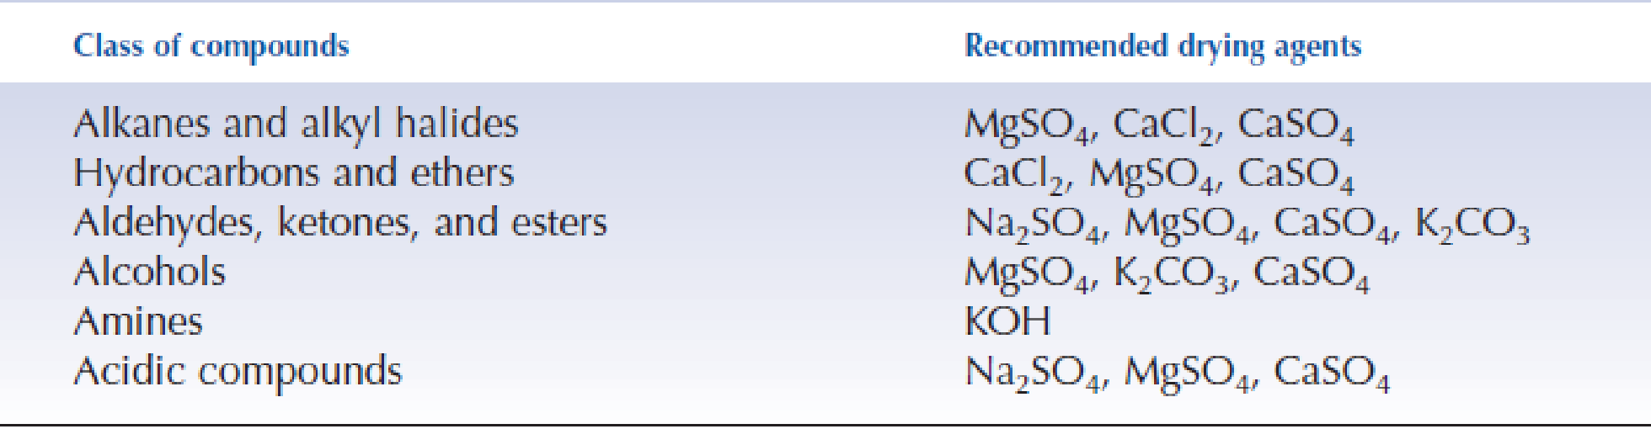

*Table 2. Common Drying Agents, Their Properties, and Their Uses*

