

**Organic –Chem. 221 Lab**

**Experiment No: #1**

**Melting point**

**Exp. date: 14-2-2018**

**Submission date: 7- 3 -2018**

**Student Name:** **Aleen Nasser**

**Student No: 1160792**

**Partner Name: Rawan hamyle**

**Partner No: 1161783**

**Instructor name: Adi Qamhia**

**Abstract:**

The melting point of a pure compound is an intensive property, like density and boiling point. Intensive properties are independent of the amount of substance present. The melting point of a compound is the temperature at which it changes from a solid to a liquid. Experimentally, melting point is actually recorded as the range of temperatures in which the first crystal starts to melt until the temperature at which the last crystal just disappears a melting point apparatus was used to measure the melting point of pure substances such as Pure Urea and Pure sailysalic Acid. The data collected is compared to the melting point theory to prove if the melting ranges of the pure substances and the mixtures stayed consistent with the theory. The main objective of this experiment is to determine the melting points of various organic compounds and a mixture of compound and to determine the eutectic point which is The point in a phase diagram indicating the chemical composition and temperature corresponding to the lowest melting point of a mixture of components and to identify unknowns by a mixture melting point is useful in determining the identity of an unknown compound. A small portion of a known compound, whose melting point is known, is mixed with the unknown compound. If the melting point of the mixture is the same as that of the known compound, then the known and the unknown are most likely identical. A decrease in melting point of the mixture and a broadening of the melting point range indicates that the compounds are different. As the result show the melting point range was between 159-160℃ which was nearly the salicylic acid which is melting point is 154-160℃.

**Chemicals and Glassware:**

1. Thermometer
2. clamp
3. Rubber
4. Thiele tube
5. Oil
6. Capillary tube

**Procedure**:

1. A capillary melting point tube and a known compound. Were obtained.

2. A small amount of the compound on a clean surface was placed. The open end of the tube was pushed into the compound.  Some of the sample will now be in the top of the tube.

3. Hold the closed end of the capillary tube was holden over a dropping tube; the dropping tube should be held perpendicular to the table and a couple of inches above the table surface. The capillary tube was dropped into the dropping tube; the capillary tube will bounce on the table, packing the powder into the bottom.

4. The capillary melting point tube place in the Mel-temp apparatus chamber. With a setting of two to two and a half was start; the temperature should slowly rise.  The sample should be observed continuously, so that the melting point of the sample is not missed.  Heat slowly to acquire the most accurate results.  Record the melting range, which was begins when the sample first starts to melt and ends when the sample is completely melted.

5. An unknown sample was obtained and determines its melting range. The unknown was identified by comparing the data on the known the class has obtained.

6.     Time permitting, pulverize a mixture of two known substances used for practice with a mortar and pestle, and determine the melting point of the mixture.

**Data:**

**The thermometer correction curve :**

**table 1 thermometer correction**

| Average | correction |
| --- | --- |
| 0 | 0 |
| 53 | -1.5 |
| 114 | 2 |
| 125.5 | 2 |
| 133 | 0.5 |
| 157 | 3.5 |

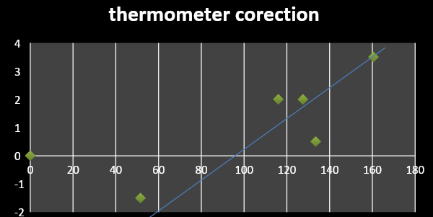

**Melting point results:**

1. Single compound :

| Compound | Observe melting point | Average | Literature melting point |
| --- | --- | --- | --- |
| Ice water system | 0 | 0 | 0 |
| 1,4-dichlorobenzene | 50-53 | 51.5 | 52-54 |
| 160Acetanilide | 114-118 | 116 | 114 |
| Benzamide | 125-130 | 127.5 | 124-127 |
| Urea | 133-134 | 133.5 | 132-134 |
| Salicylic Acid | 159-162 | 160.5 | 154-160 |

Table 2

1. Mixture :

| Compound | Melting point | Literature m.p | Average |
| --- | --- | --- | --- |
| Pure Urea | 133.5 | 132-134 | 113.5 |
| Pure Benz amide | 127.5 | 124-127 | 127 |
| 75%urea:25%benzamide | 106-126 | -------------------- | 116 |
| 50%urea:50%benzamide | 100-107 | -------------------- | 103.5 |
| 25%urea:75%benzamide | 107-114 | -------------------- | 110.5 |
| Eutectic m.p of urea-Benz amide | 105 |  |  |

Table3 m.p for compound

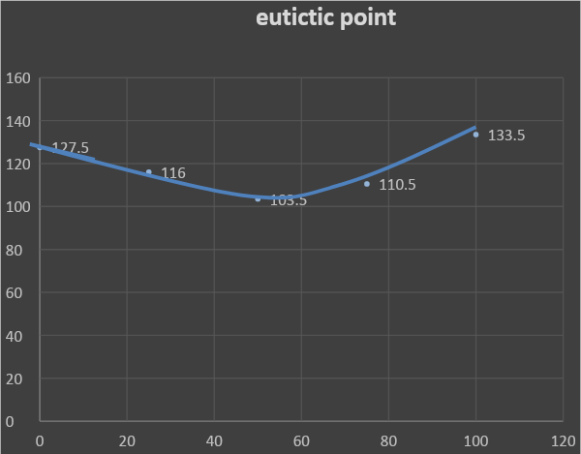 Graph #2 eutectic point

1. Unknown compound:

| Unknown number | m.p range of unknown | m.p of the correct compund |
| --- | --- | --- |
| 16 | 159-160 | 154-160 |

Table 4

* The unknown is Salicylic Acid

**Dissuasion**:

Based on the observations of the melting points of combined substances, the conclusion can be made that the melting point of combined, impure substances is lower than the melting point of either of the substances in their pure form. This because the melting point of a substance decreases with increase in presence of impurities in it. The melting point of ice as example decreases from 0 °C to -22 °C on mixing salt in it in proper proportion. That is why salt is added to make freezing mixtures to keep ice creams frozen, pure substances would increase. The lower melting point of the new substance is due to the disruption of the crystal structures when they are mixed, resulting in a lower lattice energy and a lower overall melting point. However when we mixed the Urea with the benzineamide in different concentration The result show that the melting point for the mixture is below the melting point of the each compound as pure which was 103.5 when the ratio was 50%:50% this which called the eutectic point and this is the point in a phase diagram indicating the chemical composition and temperature corresponding to the lowest melting point of a mixture of components then in the identification of an unknown we take a small portion of it and observed the melting point range which was nearly the salicylic acid 159-160 so we mix a proximately the same amount of unknown and salicylic acid and observed each melting point and the two result was approximately the same the unknown identify

**CONCLUSION:**

The objective of this lab was to accurately measure melting points of different compounds. The melting point can be used to determine the identity of a substance or the purity of a substance. However, the mixing of the two substances resulted in a much lower melting point; therefore, . The mixing of urea combined with benzineamide also resulted in a lower melting point than that of pure urea. These results show that impure substances have lower melting points and wider ranges of melting point temperature than pure substances.

**Question:**

1. It will melting rapidly before the true value so the average will be incorrect and below the true.
2. A small portion of a known compound (Salicylic Acid), whose melting point is known, is mixed with the unknown compound. If the melting point of the mixture is the same as that of the known compound, then the known and the unknown are most likely identical. A decrease in melting point of the mixture and a broadening of the melting point range indicates that the compounds are different.
3. Yes the freezing of ice decreases from 0 °C to -22 °C on mixing salt in it in proper proportion. That is why salt is added to make freezing mixtures to keep ice creams frozen, and because the impurities.