

**Organic –Chem. 221 Lab**

**Instructor name: Adi Qamhieh Exp. date: 19.2.2018**

**Student Name: Muhammad Ibrahim Musleh**

**Student No:** **1162595**  
  
  
**Partner Name: Fairouz Zayed**

**Partner No: 1160750**

**Experiment No: 1**

**Experiment title:** **Melting Points**

**Submission date: 12.3.2018**

**Abstract:-** (including objectives, chemical reactions, methods used and main results)

The purpose of this experiment is to determine the melting point of pure and impure compounds, and determine the melting point and identify an unknown . The method of Thiele Apparatus is used. Shows the different between Observed melting point and Literature melting point and to identify the Eutectic point of Urea-Benz amide.

**Chemicals:-**1) p-Dichlorobezene (1,4-dichlorobenzene)  
2) Acetanilide.  
3) Salicylic acid (2-hydroxybenzoic acid).  
4) Ice-water system  
5) Urea  
6) Benzamide

**Glassware:-**

1-Bunsen Burner.  
2- Mercury Thermometer.  
3- Thiele tube.  
4- Thermometer adapter

**Experimental Procedure:-** (Brief and in clear items and use the passive voice form)

| **Step** | **#** |
| --- | --- |
| The thiele apparatus is prepared. | 1 |
| A small pile of sample compound is placed onto a piece of paper, a powder is crushed with a spatula if necessary. | 2 |
| The powder is scraped into a mound and the open end of the capillary tube is pushed downward into the sample. | 3 |
| The capillary tube is turned right side up and the bottom is tapped gently against the bench top in order to move the powder down to the bottom of the tube. | 4 |
| The capillary tube is attached to the thermometer with a small rubber, made by cutting a small piece off the end of a piece of tuning, for accurate readings the sample compound is held close to and at the level of the thermometer bulb, which is fully submerged and centered in the oil bath, the rubber band is kept well above the level of oil to prevent the melting of rubber by the hot liquid. Finally, the apparatus is heated up. | 5 |

**Data and Results:-** Fill in the chart below with appropriate structures, and physical propertiesof reagents needed to complete the reaction. In addition calculate the moles and mass or volume of the reagents. Experimental results are to be filled in during completion of the experiment.

| **Name and structure** | **Observed M.P. Range °C** | **Average °C** | **Literature M.P. °C** | **Thermometer Correction Necessary** |
| --- | --- | --- | --- | --- |
| Ice-water system | 2 | 2 | 0 | 2 |
| 1,4-Dichlorobenzene | 58-60 | 59 | 54 | 5 |
| Acetanilide | 120-123 | 121.5 | 114 | 7.5 |
| Benzamide | 130-133 | 131.5 | 124-127 | 6 |
| Urea | 136-138 | 137 | 133-134 | 3.5 |
| Salicylic acid | 162-165 | 163.5 | 154-160 | 6.5 |

**Table 1 : M.P. for severl compunds  
  
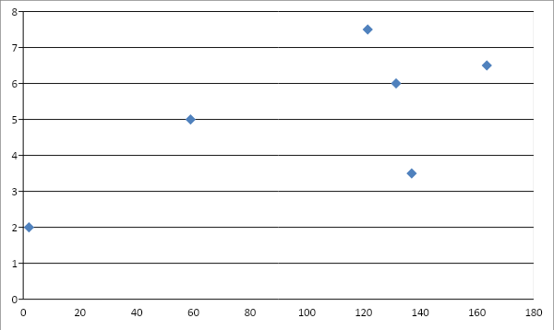**

**Graph 1 : Correction for thermometer**

| **Name and structure** | **Melting Point** | **Literature M.P.** | **Average** |
| --- | --- | --- | --- |
| Pure Urea | 136-138 | 133-134 | 137 |
| Pure Benzamide | 130-133 | 124-127 | 132 |
| 75% Urea , 25% Benzamide | 106-120 | ------- | 113 |
| 50% Urea , 50% Benzamide | 110-114 | ------- | 112 |
| 25% Urea , 75% Benzamide | 112-120 | ------- | 116 |
| Eutectic M.P. of Urea- Bezamide | **112** | | |

**Table 2 : Eutectic Point**

**Unknown:-  
  
 Number 90 is Benzoic acid   
  
The Observed temperature is 130-132**

**Discussion & Comments:-** Provide a summary of the experiment including observations, analysis of all data and results, and methods to correct errors or optimize the experiment.   
  
From this experiment we observed the melting point for several compounds and mixtures.  
  
Part 1 of this experiment we found the melting point for many pure compounds by thermometer and compare them with literature melting point, then sketch the correction curve for my thermometer.  
  
Part 2 of this experiment we found the melting point for different mixtures and observed that an impure compound has low temperature than pure compounds.  
  
Part 3 of this experiment is to determine what is unknown. When I measure the temperature of my unknown number 90 I see that my temperature is range between 130-132 I cross-eyed that this unknown is Benzoic acid and try to know it and observed that is correct

**Questions:-**

**Q1.** Error in melting point, temperature will be less than the actual, and the range would be great.

**Q2.** Firstly we mix this substance with the suspected compound(Salicylic acid), the same amount of two compounds, put this in one capillary tube and another capillary tube with pure Salicylic acid, and put it with thermometer if two compounds in two capillary melt together so the substance is salicylic acid.

**Q3.** Ice cream, because we add salt to ice cream so decrease the freezing point. On the other hand, pure ice has not salt in it.

**Good Luck**