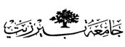

**Organic –Chem. 221 Lab**

**Instructor name: Adi Qamhieh Exp. date: 26.2.2018**

**Student Name: Muhammad Ibrahim Musleh**

**Student No:** **1162595**  
  
  
**Partner Name: Fairouz Zayed**

**Partner No: 1160750**

**Experiment No: 2**

**Experiment title:** **Distillation-Fractional Distillation**

**Submission date: 5.3.2018**

**Abstract:- (including objectives, chemical reactions, methods used and main results)**

The purpose of this experiment is to compare the efficiency of simple distillation and Fractional distillation for separation and purification of a mixture of Water and Acetone. We mix water (50ml) and acetone (50ml) then separate them by two methods mention above. The main result is to understand the difference between Simple and Fractional distillation.

**Chemicals:-**

1-Water (H2O)  
2-Acetone(CH3COCH3)

**Glassware:-**

1-Thermometer.  
2-Thermometer Adapter.  
3-Distillation head.  
4-Condenser.  
5-Distillation flask.  
6-Fractional distillation column.  
7-Graduated cylinder.

**Experimental Procedure:-(Brief and in clear items and use the passive voice form)**

| **Step** | **#** |
| --- | --- |
| **The setup of fractional distillation was prepared.** | **1** |
| **A 50ml of water and acetone was added and mixed in distillation flask then an amount of boiling chips were added.** | **2** |
| **The mixture is heated by Bunsen burner ,then the temperature is read every 5 ml of the distillate.** | **3** |
| **The distillation flask had not to dryness of it would broke.** (This creates a potential risk of explosion) | **4** |
| **Sketch** | **5** |

**Data:-**

Fill in the chart below with appropriate structures, and physical propertiesof reagents needed to complete the reaction. In addition calculate the moles and mass or volume of the reagents. Experimental results are to be filled in during completion of the experiment.

1. **Simple Distillation:-**

| T | 60 | 61.2 | 62.2 | 64 | 65.7 | 67.8 | 70 | 72.4 | 78.2 | 86 | 92 | 95 | 95.2 | 95.9 | 96 | 96 | 96.1 |
| --- | --- | --- | --- | --- | --- | --- | --- | --- | --- | --- | --- | --- | --- | --- | --- | --- | --- |
| V | 5 | 10 | 15 | 20 | 25 | 30 | 35 | 40 | 45 | 50 | 55 | 60 | 65 | 70 | 75 | 80 | 85 |

**T:Teperature(Co) V:Volume(ml)**

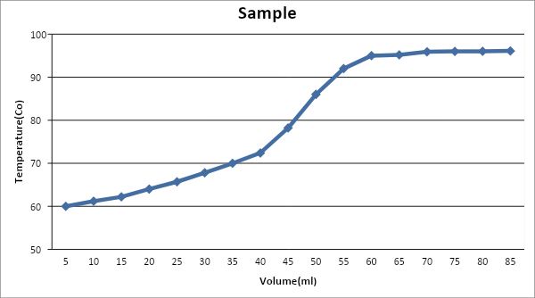

2- **Fractional Distillation:-**

| T | 54 | 55 | 56 | 57 | 58 | 58.7 | 59 | 61 | 62 | 85 | 92 | 92.5 | 92.5 | 92.5 | 92.5 | 92.5 | 92.7 |
| --- | --- | --- | --- | --- | --- | --- | --- | --- | --- | --- | --- | --- | --- | --- | --- | --- | --- |
| V | 5 | 10 | 15 | 20 | 25 | 30 | 35 | 40 | 45 | 50 | 55 | 60 | 65 | 70 | 75 | 80 | 85 |

**T:Teperature(Co) V:Volume(ml)**

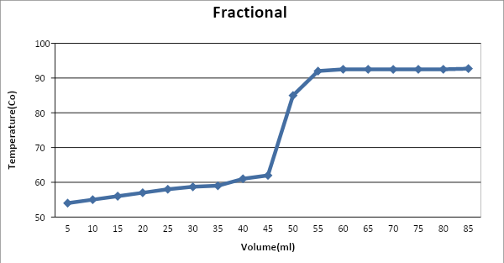

**Results:-**

As we see from two charts above we conclude that there is a noticeable difference between Simple and Fractional Distillation. Simple distillation is a continuous method that separate water and acetone. On the other hand, Fractional distillation has a noticeable step between separate of water and acetone.

**Discussion & Comments:-**

Provide a summary of the experiment including observations, analysis of all data and results, and methods to correct errors or optimize the experiment.

It appears that the fractional distillation was more efficient than the simple distillation. The simple distillation graphed basically as a straight line, but the graph of the fractional distillation actually somewhat shows the rise where mostly Acetone is being condensed and then the rise and second plateau where mostly Water is being condensed. This cannot be really seen in the graph of simple distillation. This may be due in part that the simple distillation was heated too fast. I know that for the fractional distillation it seemed like we heated it at a very steady rate, but the simple distillation was harder to control.

In simple distillation, two substances were collected would not be very pure and separation was not complete. After collected the acetone(Distillate) the temperature should rise sharply in order to boil water.

Both simple and fractional distillation assemble each other in the first and the end but a difference is observed in the middle region-Jump region-.

**Questions:-**

**Q1.** **(3) :** Yes, because boiling point of liquid equal to temperature of vapor, also pure substance has special temperature so it will remain constant throughout distillation.

**Q2.** **(4)** No, I cannot conclude that they are identical, because I cannot call two identical ,identical on basis of their physical property such as boiling point. It would however show that they have similar structures. Still they would have differences that would prevent us from calling them identical. For instance if they both have same boiling points, it is not necessary that they would have the same melting point as well. Thus just on the basis of boiling point we cannot call two liquids identical. Also, we only call two substances identical if they have similar chemical properties as well as physical properties. (Azeotropic Mixture)  
**OR**

Boiling point is a physical property. Same boiling temperature indicates same van der waal's force between molecules in the liquid. Other properties like absorption spectra of spectrophotometer, refractive index, density, dipole moment are also required to match.

**Q3.** **(6) :** Actually the vapor pressure of the liquid would not change that depends only the substance and its temperature. The boiling point decreases because it depends on the overall (atmospheric) pressure. As you indicated, a liquid boils when the vapor pressure equals the atmospheric pressure. As you increase the liquid's vapor pressure by heating it, and the overall pressure is lowered, you reach boiling more quickly (at a lower temperature).

**Good Luck**