**Abstract:-**The objectives form this experiment are to produce acetanilide and purify acetanilide by crystallization, the acetanilide is got by reaction of aniline and acetic anhydride. There are eight methods used like dissolving the solid, depolarization, filtration, cooling and crystallization, etc. The main result from this experiment is to get a pure acetanilide and weight it.

**Chemicals:-**

| Anline | Acetic anhydride | Acetanilide | Acetic acie | Zinc | Water(Good Solvent) | Decolorizing carbon |
| --- | --- | --- | --- | --- | --- | --- |

**Glassware: -**

| Suction(Buchner, or sidearm) flask | Buchner funnel | Bunsen burner | Graduated cylinder | Erlenmeyer flask |
| --- | --- | --- | --- | --- |

**Reactions and Mechanisms:-**

C6H5NH2+CH3COOCOCH3 C6H5NHCOCH3 +CH3COOH

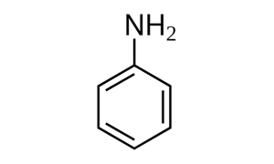 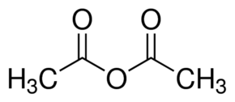 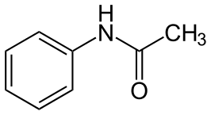 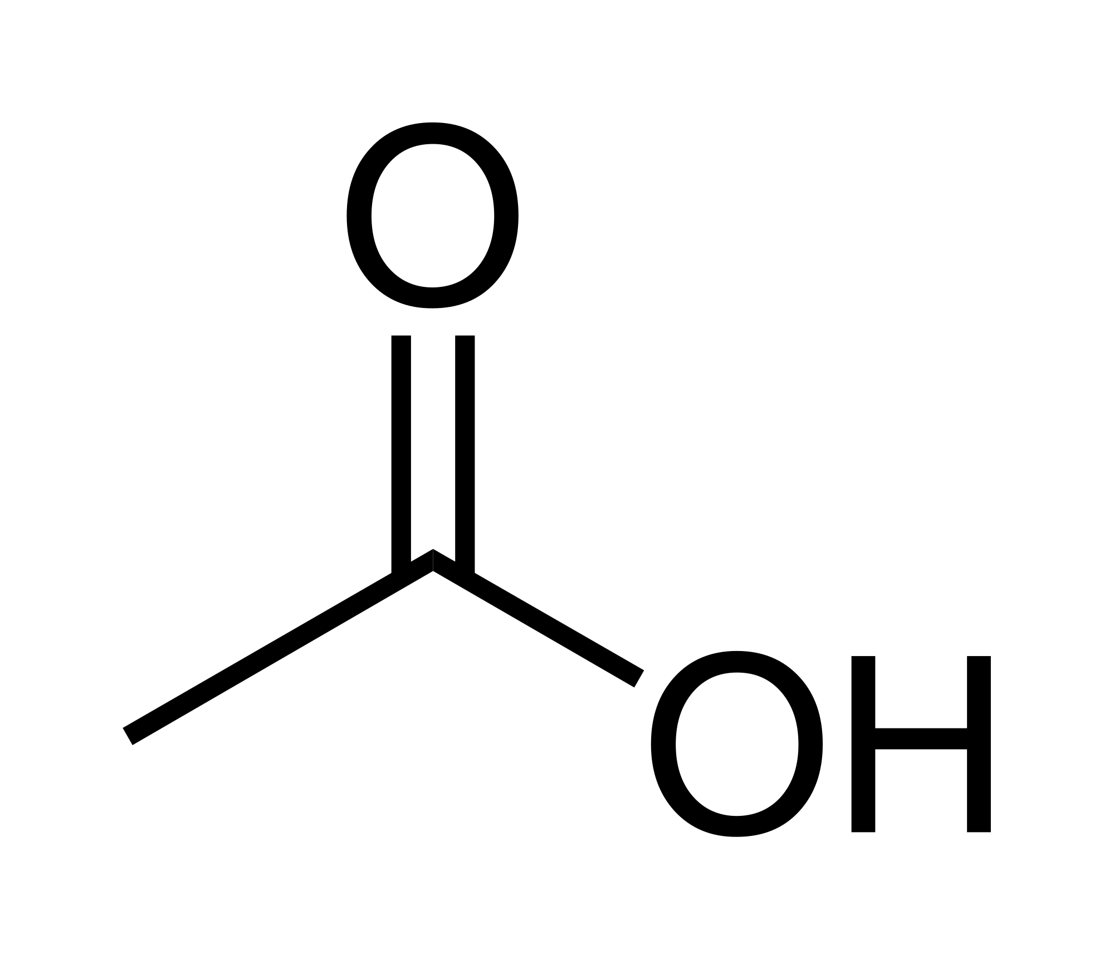

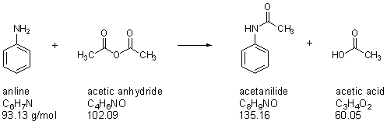

**Experimental Procedure:-**

| **Step** | **#** |
| --- | --- |
| 5ml of Aniline is added to Erlenmeyer flask | 1 |
| Little amount of zinc is added to the Aniline | 2 |
| Approximately 30 ml of water is added to Aniline | 3 |
| 5ml of Acetic anhydride is added to the Erlenmeyer flask | 4 |
| The mixture is heated with added droplet of water until the mixture is cleared. | 5 |
| Little amount of decolorizing carbon is added to the mixture then boil it. | 6 |
| The mixture is filtered by suction filtration(Zinc and decolorizing carbon is precipitated) | 7 |
| The mixture obtained is heated, then cool it, then the mixture is filtered by suction filtration, and the crystal is taken and dry it then weight. | 8 |

**Data and Results:-**

| **Name** | **Weight** | **Molecular weight** | **Density** |
| --- | --- | --- | --- |
| Anline | 5.11g | 93.13g/mol | 1.022g/ml |
| Acetic anhydride | 5.41g | 102.1g/mol | 1.082g/ml |
| Acetanilide | 5.15g | 135.16 g/mol | ــــــــــــــ |

Actual Yield = 5.15 g  
  
Theoretical yield =

Actual yield  
Percent Yield(% yield) = ـــــــــــــــــــــــــــــــــــــــ **\*** 100%   
 Theoretical Yield

**Discussion & Comments:-**

Percentage yield equal 72% of Acetanilide, why is not 100 ?, there are several reasons that caused loss of products.  
  
**a-** The volume of solvent (Water) added to the mixture is high so the mixture not able to produce the maximum amount of Acetanilide after cooling, more solvent added will dissolve the product more.

**b-** Decolorizing charcoal is important to removes the unwanted colored impurities, like zinc. On the other hand, if a lot of decolorizing charcoal are added to the mixture this will cause loss of some products, because some of Acetanilide would be adsorbed on the surface of charcoal. As a rule, a little amount of charcoal is sufficiently to remove the colored impurities.  
  
Boiling chips are small, porous stones made of calcium carbonate, and insoluble. The adding of boiling chips must be before boiling of mixture, because if boiling chips are added to the mixture near its boiling point it will induce flash boiling.   
  
How to determine the impurity of sample ? By found its melting point.

**Questions:-**

**Q1.** Three reasons for this to happen:-  
a- The charcoal is fine, so it passes from filter paper ;  
b- The charcoal added is not enough to remove all the impurities and ; c- The suction filtration did not perform in the correct way.

I will repeat the suction filtration with finer filter paper, or add an amount of charcoal to the mixture.

**Q2.** **(3)**

**Q3.** **(5)**

**Good Luck**