**Recrystallization of Acetanilide**

Earl Cedric Dalamacio, Angelica S. Duenas, Ryan S. Esquibil, Estevez M. Evangelista * and Richard G. Ferrer

*Department of Pharmacy, Faculty of Pharmacy*

*University of Santo Tomas, Espana Street, Manila 1008*

**Abstract**

Recrystallization is a common method of purifying organic substances through the difference in solubility at different temperature. In this experiment, three samples of acetanilide put in 3 different test tubes were dissolved in a given solvent (water, methanol, and hexane, respectively) and placed in a heating water bath setup (37 oC –40 oC) for 1-5 minutes. The solution was cooled slowly as crystals form out. Crude acetanilide is obtained by mixing aniline and distilled water with acetic anhydride. This mixture is cooled with an ice bath which hastens the formation of crystals. The mixture is filtered then dried to finally obtain the crude acetanilide. Recrystallizing solvent was added to the crude acetanilide and was heated on a water bath until the solid dissolves. The mixture is filtered while hot, and crystals were collected then washed with distilled water. As the compound crystallizes from the solution, molecules of other compounds dissolved in solution are excluded from growing crystal lattice, yielding pure acetanilide.

**Introduction**

Organic compounds that are solid at room temperature are usually purified by crystallization. Crystallization is the deposition of crystals from a solution. During the process of crystal formation, a molecule have the tendency to be attached to a growing crystal composed with the same type of molecules because of a better fit in a crystal lattice of a molecule of the same structure than for other molecule.[2] Lattice is a fixed and rigid arrangement of atoms, molecules or ions.[1]

Recrystallization is a method in which two crystallization processes was performed. It is referred to the second crystallization.[3] It depends on the difference of solubility of a substance in a hot and in a cold solvent. Solubility is another property of substances which is given importance in the experiment. It is a main factor which affects crystallization. A recrystallizing solvent has to be identified first before performing crystallization. The substance is expected to show an ideal solubility behavior in a given solvent in which both the desired substance and its impurities have similar solubilities and boiling points, and when the impurities represent only a small fraction of the whole substance. With this, the desired substance will crystallize on cooling while the impurities would not. [3]

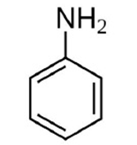

Fig. 2.1, Structural formula of Aniline

Aniline, C6H5NH2, is an organic base used to make dyes, drugs, explosives, plastics, and photographic and rubber chemicals. Aniline was first obtained in 1826by the destructive distillation of indigo. Its name is taken from the specific name of the indigo-yielding plant Indigofera anil (Indigofera suffruticosa) Aniline is prepared commercially by the catalytic hydrogenation of nitrobenzene or by the action of ammonia on chlorobenzene. The reduction of nitrobenzene cans also be carried out with iron borings in aqueous acid. When aniline is heated with organic acids, it gives amides, called anilides, such as acetanilide from aniline and acetic acid. Pure aniline is a highly poisonous, oily, colorless substance with a pleasant odor. [5]

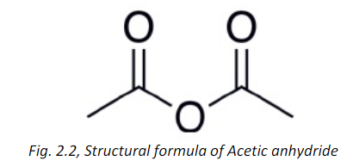

Acetic anhydride, (CH3CO)2O, is a colorless liquid with a pungent vinegar-like odor when it reacts with water to form acetic acid. The boiling point if acetic anhydride 10oC and 140oCand the melting point is 73°C. It is soluble in ether, chloroform and benzene. It is soluble in water when acetic anhydride decomposes. The density of acetic anhydride is 1.082 g/ml in liquid state and its molecular weight is102.09 g/mol. acetic anhydride is most widely used for the conversion of cellulose to cellulose acetate, which is a component of photographic film and other coated materials. It plays an important role in the acetylation of aniline to form acetanilide.

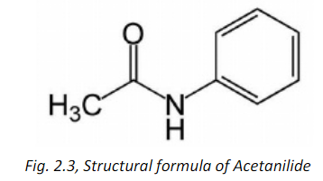

Acetanilide, C6H5NH(COCH3), is the product of acetylation of aniline with acetic anhydride at low temperature. It is a white, odorless flake solid or crystals that boils at 304°C and melts in the range of 114-116°C. The density of acetanilide is 1.219 g/ml. Acetanilide is soluble in hot water, alcohol, ether, chloroform, acetone, glycerol and benzene. It is stable under normal condition and can undergo self- ignite at 545oC. Acetanilide (N- Phenyl acetamide) used as a precursor in penicillin synthesis and other pharmaceuticals including painkillers and intermediates. In medicine, it is a pro drug with analgesic and antipyretic, or fever-reducing properties which is in the same class of drugs as acetaminophen, in generic, paracetamol. However, direct application of acetanilide may cause methemoglobinemia and damage liver and kidneys. The objectives of the experiment are as follows:

1. to synthesize acetanilide by acetylation of aniline

2. to purify crude acetanilide by Recrystallization

3. to calculate the percentage yield of pure acetanilide

**Experimental:**

**A. Sample Used**

 The samples used in the experiment were pure acetanilide, aniline & acetic anhydride which were used to produce crude acetanilide, and different solvents like water, hexane, and methanol.

**B. Procedure**

1. Production of Crude Acetanilide

2 ml of aniline and 20 ml of distilled water were mixed in an Erlenmeyer flask. 3 ml of acetic anhydride was slowly added to this mixture. This was cooled with an ice bath to hasten crystallization. After which, the mixture is filtered with a wet filter paper. The filter paper with the residue is dried. Crude acetanilide is obtained and weighed.

2. Recrystallizing solvent Determination

 Corn-gain amount of pure acetanilide was placed in three different test tubes. 1 ml of water was added to the first test tube. It was shaken and placed on a water bath (37- 40oC) for 1-5 minutes. Then, it was cooled. Observations were recorded. Same procedure is repeated for the second and third test tubes with the two remaining solvents, hexane, and methanol respectively.

3. Recrsytallization Process

20 ml of the recrystallizing solvent was added to the preciously obtained crude acetanilide. This mixture was heated on a water bath until all of the solid dissolves. Activated charcoal is added if the solution is colored. (The flask has to be removed from the bath first before adding the activated charcoal.) The solution is quickly filtered while still hot using a fluted filter paper. The filtrate is allowed to cool down by placing the receiver on the beaker containing tap water. Crystals are collected and washed with distilled water, then pressed-in between filter papers to dry. The crystals are recrystallized pure acetanilide. Weigh and determine the melting point of pure acetanilide.

**Result and Discussion**

 A recrystallizing solvent is a solvent that shows the desired solubility behavior for the substance to be crystallized. It is necessary for us to identify the ideal recrystallizing solvent of a compound to purify the organic compound. In choosing the recrystallizing solvent, the compound should be insoluble at room temperature. While heating, the compound should be very soluble and upon cooling, it is insoluble. The unwanted impurities should be soluble at room temperature or insoluble during heating. The applied amount of heat energy associated with a given temperature in a given system is the heat capacity. (Mullin, 1961) It should not go beyond the melting point of the substance to be crystallized. If the boiling point of the solvent is high, the solid may melt in the solvent rather than dissolve. In such case, the solid may oil out. Oiling occurs when the solid substance melts and forms a liquid that is insoluble in the solvent. When cooling, the liquid refuses to crystallize; rather, it becomes a super cooled liquid, or oil. Oils may solidify if the temperature is lowered, yet will not crystallize. [3] In addition, volatility of the solvent is a factor in selecting the correct recrystallizing solvent. The solvent should be volatile enough to be easily removed from the solution after crystallization. Volatile solvents having low boiling point is preferable. [3] The chemical reactivity of recrystallizing solvent should be low. It should neither decompose nor oxidize the desired substance. The solvent should not react with the compound to be purified. Thus, the desired substance may be contaminated with impurities.[1] The melting point determination is the temperature at which the material changes from a solid to its liquid state. Determining the melting point is used to obtain a fresh impression of purity of a substance. This is because any quantities of impurities may change the Melting point of the substance.

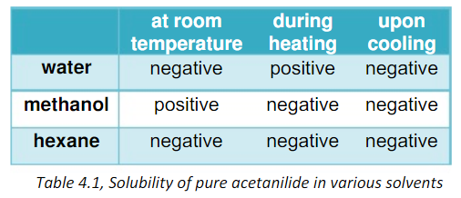

**Table 4.1**

The table shows the solubility of acetanilide in three different solvents namely water, methanol, and hexane. The pure acetanilide in water was insoluble at room temperature, but soluble when heated, and reverts back to its old insoluble state when cooled. On the other hand, methanol gave a positive result for solubility at room temperature, but negative both during heating and cooling. Lastly, hexane gave a negative or insoluble result for all three situated temperatures. Among the three solvents used, water is the most appropriate to be used as the recrystallization solvent because it exhibited the best results for solubility of pure acetanilide.

Filtration was a process used to eliminate unwanted substances or parts from the experimental samples or solutions. In the experiment, the group used a filter paper to filter the solutions. On the other hand, activated charcoals are decolorizing agents used to remove colored impurities in the solutions that appear during the water bath for recrystallization. In the group’s experiment process, there was no need to use the activated charcoal since the group had developed trace amounts of colored impurities only. Adding activated charcoal might even adsorb the desired substance when added.

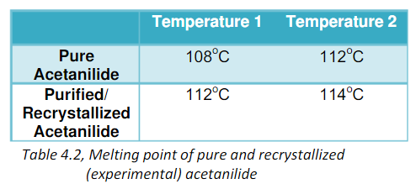

**Table 4.2**

Melting point is the temperature at which the solid and liquid phase or forms of a substance exist in equilibrium. Micro melting point was the method used in the experiment to determine the melting point of the 2 sample substances. Micro melting point is the strapping of capillary tubes on the tip of the thermometer and immersed into an oil bath. Oil was used rather than the usual water in the experiment because it has a higher boiling point than water (> 100oC), and it also does not evaporate easily when heated at a high temperature. Based on the data gathered, pure acetanilide still had traces of impurities because its melting point is not the same as the standard melting point of acetanilide which is 114-116 oC; however, the acquired data was still near or close to the standard.

The percentage yield is often obtained to describe the proportion of the actual yield and the theoretical yield of the experiment. The amount of limiting reagent present at the start of a reaction determines the theoretical yield or the maximum obtainable yield. The actual yield, or the amount of product actually obtained from the reaction, is almost always less than the theoretical yield. [4]

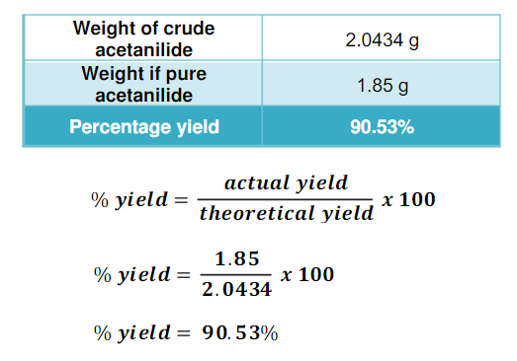

**Chemical equation for acetanilide:**

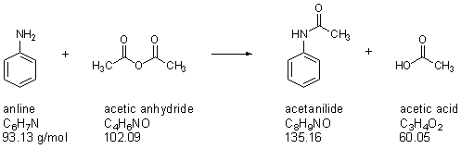

**Calculations:**

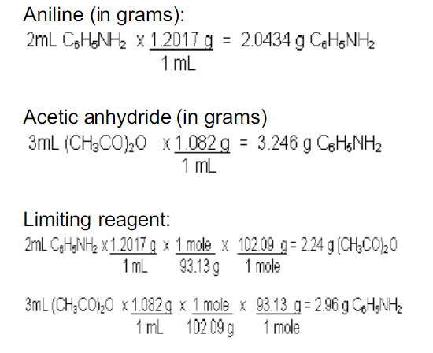

Therefore, the limiting reagent is aniline since 2.96 g C6H5NH2 was needed to make 3mL of (CH3CO)2O. The theoretical yield is equal to the limiting reagent.

**REFERENCES:**

[1] Mullin, J. W. (1961). Crystallization.London, England: Butterworth & Co.Pg.1, 21, 29-35, 39-55, 57-58, 62, 120-121, 140-14.

[2] Pastro, D. J., John, C. R., & Miller,M. S. (1998). Experiment andTechniquesin Organic Chemistry. NewJersey: Prentice Hall. Pg. 43-46.

[3] Pavia, D. L., Lampman, G. M., Kriz,G. S., & Engel, R. G. (1999).OrganicLaboratory Techniques: A Microscale Approarch (3rd Ed.).Harcourt CollegePubliser. Pg. 558-576.

[4] Chemistry 10th Edition by Chang (2010).

[5] Aniline (Chemical Compound),Retrieved July 26, 2012, from http://www.britannica.com/EBchecked/topic/25473/aniline.

[6] Acetanilide (n- phenylacetamide). (n.d.). Retrieved August 16, 2009,from <http://chemicalland21.com/lifescience/phar/ACETANILIDE.htm>.

[7] Acetic anhydride (acetyl ether). (n.d.). Retrieved August 16, 2009, from <http://chemicalland21.com/petrochemical/ACETIC%20ANHYDRIDE.htm>.

**Photos:**

<http://www.britannica.com/EBchecked/topic/25473/aniline>

<http://en.wikipedia.org/wiki/File:Acetic_anhydride-2D-skeletal.png>

<http://chemistry.about.com/od/factsstructures/ig/Chemical-Structures--->

A/Acetanilide.htm