**Abstract:-**The objective form this experiment is to extract desired compound from a mixture of three common household items: aspirin, B-naphthol, and naphthalene. Extraction is a process used in order to separate an organic product from its mixture. The extraction process can also be used to separate an organic substance from its natural source.(1)

**Chemicals:-**

| 5%NaHCO3 | Ether | 6M HCl | 10%NaOH | Decolorizing carbon | CaCl2 |
| --- | --- | --- | --- | --- | --- |

Table 1 : Chemicals’s Used

**Glassware:-**

| ErlenmeyerFlask | Beaker | Separatory Funnel | Buchner Funnel | Filter Flask |
| --- | --- | --- | --- | --- |

**Table 2 :Glassware’s Used**

**Reactions and Mechanisms:-**

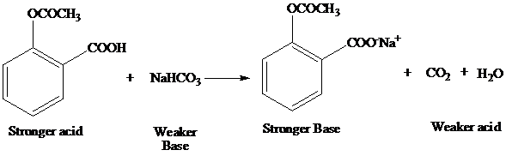

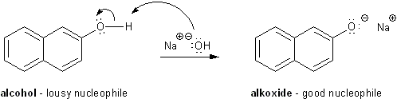

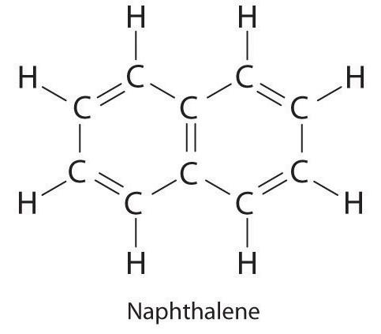

**Experimental Procedure:-**

| Step | # |
| --- | --- |
| 6.01 grams of the prepared mixture are weighed in a 125ml Erlenmeyer flask , then 50ml of ether is added, dissolve it by swirling and the solution is poured into a separatory funnel supported on a ring stand. A small amount of additional ether is added to the original solution. | 1 |
| 20ml of 5% sodium bicarbonate solution are added, the funnel is stopped, inverted, and held it with hand, briefly shake it. | 2 |
| With the funnel still inverted stopped and opened the stopcock to release any internal pressure, repeat this until judged that the reaction of the aspirin is complete and no substantial internal pressure continues to develop. | 3 |
| The separatory funnel placed back in the ring stand, the stopper is removed, and the lower aqueous layer is drawn off into a 125ml Erlenmeyer flask. To be certain that the aspirin has been removed, the above extraction is repeated with a second 20ml portion of 5% sodium bicarbonate solution(**NaHCO3**), and the two aqueous extracts are combined | 4 |
| The aqueous solution is gently heated on a warm water bath to cxpel any ether present. The solution is cooled and cautiously add 6M hydrochloric acid **(HCl)** with stirring until a PH of 1-2 is indicated by **litmus paper** and a precipitate has formed. The crystals are collected by suction filtration on a Buchner funnel. The crystals are washed with a small amount of cold water and allow them to thoroughly air dry. | 5 |
| Add 20 ml of 10% Sodium hydroxide(**NaOH**) to the remain solution in the separatory funnel to separate β-naphthol. Repeat the extraction technique, invert, shake, and relieve pressure until no further pressure is noted. The Sodium hydroxide is forming a sodium salt with the β-naphthol which is soluble in the aqueous phase. Draw off the lower aqueous portion into a 125 ml Erlenmeyer flask. | 6 |
| Add a second 20ml portion of 10% Sodium hydroxide(**NaOH**) to the funnel and extract, combine this second aqueous portion with the first. Carefully add 6M hydrochloric acid **(HCl)** to a pH of 1-2. The hydrochloric acid will convert the β-naphthol salt back into β-naphthol which is insoluble in water at the reduced ph. The β-naphthol will precipitate out. Collect the crystals by suction filtration on a Buchner funnel and use ice cold water to rinse. | 7 |
| Transfer the ether remaining in the funnel to a 125 ml Erlenmeyer flask. Add a small amount of anhydrous calcium chloride **(CaCl2)**, about 1/10 the volume of the ether solution, to the 125 ml flask containing the ether. Allow the ether solution to stand over the anhydrous calcium chloride for 15-20 minutes with occasional swirling. | 8 |
| Decant the ether solution off the anhydrous calcium chloride into a dried 125 ml Erlenmeyer flask. Evaporate the liquid on a hot water bath in the hood. After the ether has evaporated, naphthalene should remain behind. Weigh the three samples, and the percentage yield for each one of them. | 10 |

**Data, Calculation, and Results:-**

| **Compound** | **What is used to extract it** | **Amount** | **Percent yield** |
| --- | --- | --- | --- |
| Aspirin | 5%NaHCO3 | 1.49g | 24.8% |
| B-naphthol | 10%NaOH | 1.78g | 29.62% |
| Naphthalene | ـــــــــــــــــــــ | 1.89g | 31.45% |

Table 3 : Describe the compounds

Total amount Before extraction = 6.01g

Total amount After extraction = 5.16g

Total Percent yield = 85.87%

**Discussion & Comments:-**

Why total percent yield is not 100% ?  
  
As show above my total percent yield = 85.87% , so there is an error in my procedure, one of the error is lose some of the mixture during shake of the separatory funnel, also when the two layers are separated may some of the aqueous layer lost, and may be some of the upper layer drop out with aqueous and after heat it the upper layer vaporize(ether) with lose some of the mixtures. Another error, may be the mixture itself has an error in produce it.

**Questions: -**

**Q1.** The basic strengths of Sodium hydroxide (NaOH) is more than the Sodium bicarbonate(NaHCO3)

PKa of **NaOH** = 15.7

PKa of **NaHCO3**= 6.4

**Q2.** **(3)** Aspirin and B-naphthol would separate together.

**Q3.** **(4)** Aspirin has greater amount of internal pressure than B-naphthol , because of PKa values.  
PKa of **Aspirin** = 3.49(Strong acid)

PKa of **B-naphthol**= 9.51(Weak acid)

PKa of **NaHCO3** = 6.4  
  
**Aspirin(Water Insoluble) + NaHCO3  Aspirin(Water Soluble)+H2O+CO2**

So the reaction of aspirin with NaHCO3 will produce internal pressure. However, the reaction of B-naphthol will not produce internal pressure.

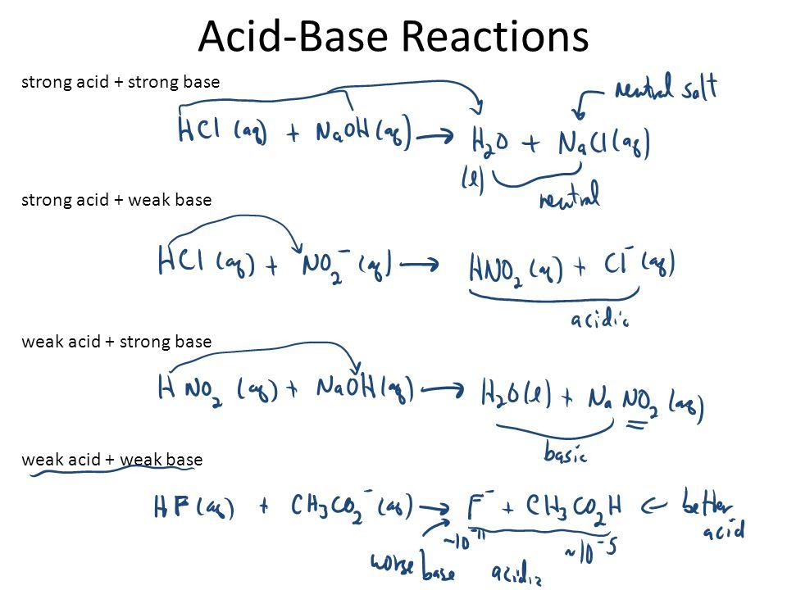

Figure 1 : Type of acid-base reactions

**Reference:-**   
  
https://www.coursehero.com/file/5803425/Extraction-lab-report/

**Good Luck**