# **EXPERIMENT 4 - Purification - Recrystallization of Benzoic acid**

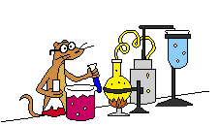

**Purpose:**

1. To purify samples of organic compounds that are solids at room temperature
2. To dissociate the impure sample in the minimum amount of an appropriate hot solvent

**Equipment / Materials:**

hot plate 125-mL Erlenmeyer flask ice stirring rod spatula

Büchner funnel impure benzoic acid weighing paper digital scales rubber tubing (hose) benzoic acid boiling stones (chips) filter paper

25 mL graguated cylinder 50 mL beaker Mel-temp apparatus

#### **Discussion:**

The products of chemical reactions can be impure. Purification of your products must be performed to remove by-products and impurities. Liquids are customarily purified by distillation, while solids are purified by recrystallization (sometimes called simply "**crystallization**").

Recrystallization is a method of purifying a solid.  There are two types of impurities:  those more soluble in a given solvent than the main component and those less soluble. (If there are any impurities that have the same solubility as the main component, then a different solvent needs to be chosen.)

When organic substances are synthesized in the laboratory or isolated from plants, they will obviously contain impurities. Several techniques for purifying these compounds have been developed. The most basic of these techniques for the purification of organic solids is recrystallization, which relies on the different solubilities of solutes in a solvent. Compounds, which are less soluble, will crystallize first. The crystallization process itself helps in the purification because as the crystals form, they select the correct molecules, which fit into the crystal lattice and ignore the wrong molecules. This is of course not a perfect process, but it does increase the purity of the final product.

The solubility of the compound in the solvent used for recrystallization is important. In the ideal case, the solvent would completely dissolve the compound to be purified at high temperature, usually the boiling point of the solvent, and the compound would be completely insoluble in that solvent at room temperature or at zero oC. In addition the impurity either would be completely insoluble in the particular solvent at the high temperature, or would be very soluble in the solvent at low temperature. In the former case, the impurity could be filtered off at high temperature, while in the latter case the impurity would completely stay in solution upon cooling. In the real world, this will never happen and recrystallization is a technique that has to be practiced and perfected.

Regardless of crystallization method, the purity of the solid can be verified by taking the melting point.

A good (suitable) recrystallization solvent will dissolve a large amount of the impure compound at temperatures near the boiling point of the solvent. Small amount of compound being purified should remain in solution at low temperatures, between approximately 25 and –5 oC. Low solubility at low temperatures minimizes the amount of purified compound that will lose during recrystallization.

A suitable recrystallization solvent should also be partially volatile in order to be easily removed from the purified crystals. The solvent should not react with the compound being purified and it should have the boiling point below the melting point of the compound being purified because solid melts before dissolves (oiling out). In selecting a good recrystallization solvent one should also consider flammability, toxicity, and expense.

In selecting a solvent consider that like likes like. Polar compounds dissolve polar compounds and non-polar compounds dissolve non-polar compounds. The most commonly used recrystallization solvents are presented in the following table.

| solvent | formula | polarity | boiling point (0C) |
| --- | --- | --- | --- |
| water | H2O | very polar | 100 |
| ethanol | CH3CH2OH | polar | 78 |
| methanol | CH3OH | polar | 65 |
| dichloromethane | CH2Cl2 | slightly polar | 40 |
| diethyl ether | (CH3CH2)2O | slightly polar | 35 |

Organic compounds with one polar functional group and a low number of carbon atoms such as methanol, ethanol, and n-propanol are highly soluble (miscible) in water. These alcohols form hydrogen bond with water due to the polar –OH functional group. As the number of carbons per polar functional group increase, solubility decreases. The solubility of alcohols with four to five carbons is given in the following table.

| alcohol | formula | Solubility (g/100 ml H2O) |
| --- | --- | --- |
| n-butanol | CH3CH2CH2CH2OH | 8 |
| n-pentanol | CH3CH2CH2CH2CH2OH | 2 |
| n-hexanol | CH3CH2CH2CH2CH2CH2OH | 0.5 |
| n-pentanol | CH3CH2CH2CH2CH2CH2CH2OH | 0.1 |

Compounds with six or more carbons for each polar group will not be very soluble in polar solvents but will be soluble in non-polar solvents such as benzene and cyclohexane.

If a single solvent cannot be found that is suitable for recrystallization, a solvent pair often used. The solvents must be miscible in one another. Some commonly used solvent pairs are water-ethanol, acetic acid – water, ether-acetone. Typically, the compound being recrystallized will be more soluble in one solvent than the other. The compound is dissolved in a minimum amount of the hot solvent in which it is more soluble.

The following formulas used in solubility problems.

**% lost in cold solvent** = (solubility in cold solvent/solubility in hot solvent) x100

**% recovery of solid**  = [g (solid ) – g (solid lost)] x 100 / g (solid)

**Example (1)**- The solubility of solid “X” in hot water (5.50 g/100 ml at 100 oC) is not very great, and its solubility in cold water (0.53 g/100ml at 0 oC) is significant. What would be the maximum theoretical percent recovery from crystallization of 5.00 g of solid “X” from 100 ml water? Assuming the solution is chilled at 0 oC.

Percent solid lost in cold water = (solubility in cold water/ solubility in hot water) x100

= (0.53/5.50) x100 = **9.64%**

grams solid lost in cold water = grams mass of original solid x percent lost = 5.00 g x 9.64% = **0.482 g**

g (solid recovered) = g (solid) – g (solid lost) = 5.00 – 0.482 = **4.52 g**

% recovery = g (solid recovered) x100 / g (solid) = (4.52/5.00) x100 = **90.4 %**

**Example (2)** – The solubility of compound “X” in ethanol is 0.80 g per 100 ml at 0 oC and 5.00 g per 100 ml at 78oC. What is the minimum amount of ethanol needed to recrystallize a 12.00 g sample of compound “X”? How much would be lost in the recrystallization, that is, would remain in the cold solvent?

amount of ethanol needed at 78 oC = (12.00 g)( 100 ml/5.00 g) = **240 ml**

amount of sample remaining in the cold solvent at 0 oC = (240 ml)(0.80 g/100 ml) = **1.9 g**

or % lost = (0.80/5.00) x100 = 16 % 🡺 12.00 x 16% = 1.92 g

The actual laboratory we will do is the recrystallization of benzoic acid from water using the temperature gradient method.  Benzoic acid is not very soluble in cold water, but it is soluble in hot water. The purpose of this experiment is to learn the technique of recrystallization by purifying benzoic acid.

**Experimental Procedures**

Using a weighing paper, weigh out about 1.00 g of “impure Benzoic acid for recrystallization” and transfer it to a 125-ml Erlenmeyer flask. Add about 20 ml distilled water, using a graduated cylinder, to the flask and bring the mixture to the boiling point by heating on a hot plate, while stirring the mixture and boiling gently to dissolve benzoic acid completely. (Fig 1)

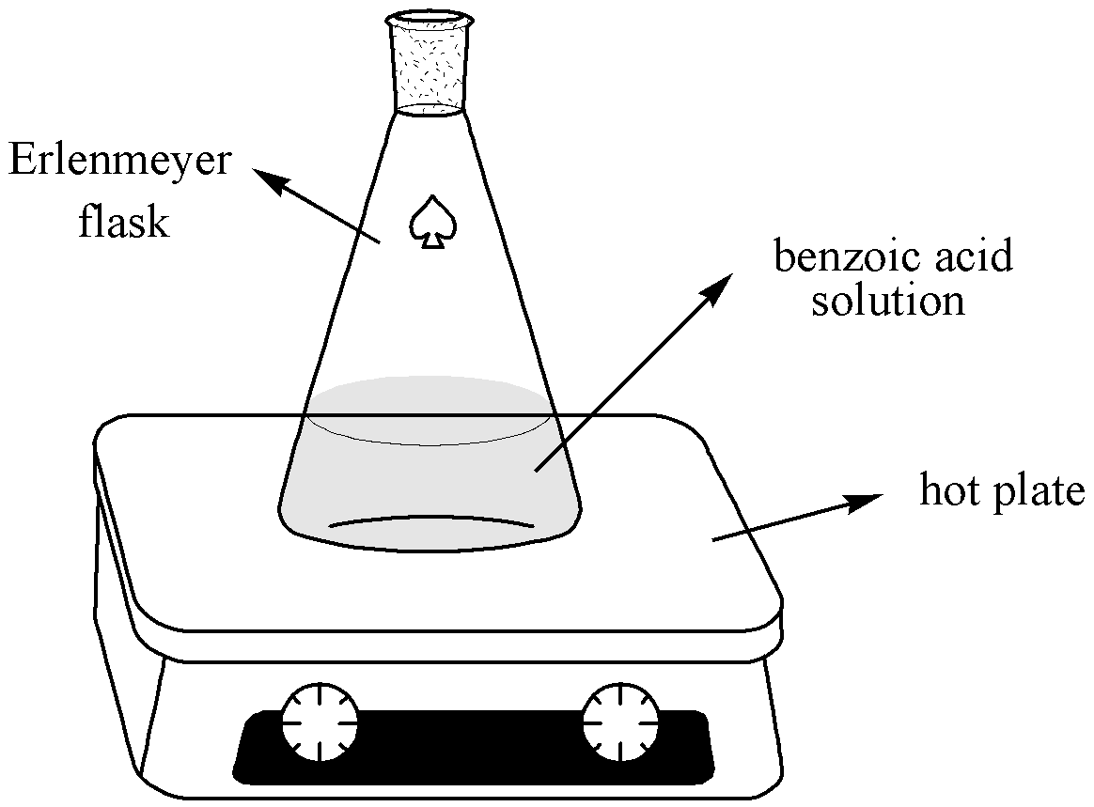

Fig 1- Dissolving benzoic acid

Remove the flask from the hot plate and examine the solution. If there are particles of benzoic acid still undissolved, then add an additional amount of hot or cold water in small increments and resume heating the solution. The objective is to dissolve the entire solid in only as much as hot or near boiling solvent (water) as is necessary. Do not add too much water or the solution will not be saturated and the yield of purified benzoic acid will be reduced. Keep adding water in small amounts (several drops at a time from a Pasteur pipette) until all of the benzoic acid is dissolved and the solution is boiling.

If the solution is completely clear (though not necessarily colorless) and no solid benzoic acid is visible, then add additional 10-15 ml water to the mixture and place the Erlenmeyer flask on a countertop where it will not be disturbed and cover with an upside-down small beaker (to prevent dust contamination). Allowing the flask to cool slowly will give the best-shaped crystals after about 5-10 minutes. If crystallization does not occur after 10 minutes, scrape the sides of the flask above the level of the solution with the sharp end of a glass rod hard enough to audibly scratch the interior surface of the flask. This may dislodge some undetectable, small crystals that will drop into the solution and "seed" the solution, helping to induce crystallization. A seed crystal can serve as a nucleation point for the crystallization process. Cooling the solution in an ice bath may also help at this point.

When the crystals have formed completely (may required ice bath), collect your solid chemical by setting up a vacuum (suction) filtration on a properly fitted filter paper in a clean Büchner funnel apparatus as described by your instructor. (Fig 2)

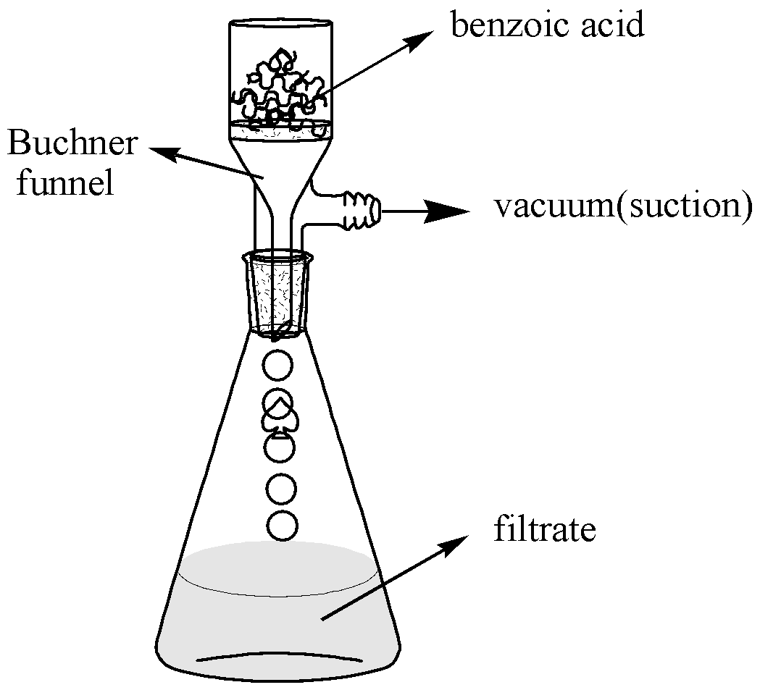

Fig. 2 – Büchner funnel and suction flask

Pour the chilled mixture into the Buchner funnel. The water should filter quickly - if not, check for vacuum leaks.  Get all the crystals out of the flask using a spatula or stirring rod.  Rinsing with 1 or 2 mLs of **cold** water helps get the crystals out of the flask, and rinsing helps remove impurities.

Let the aspirator run for a few minutes to start air-drying the crystals.  Then use a spatula to lift the filter paper and crystals out of the Buchner funnel, then press them as dry as possible on a large clean paper towel (hand dry), allow them to dry completely, and transfer the dry sample to a pre-weigh weighing paper. Determine the weigh the DRY crystals of recovered benzoic acid.

Calculate the percent recovered using the following *written* formula and determine the melting point of your recrystallized benzoic acid.

**Weight of benzoic acid obtained after recrystallization**

**% Recovered = x100**

**Weight of benzoic acid before recrystallization**

**Note: Submit product to the instructor in a properly labeled container.**

# **EXPERIMENT 4 – Recrystallization of Benzoic Acid**

**Data and Results (Recrystallization)**

**REPORT FORM** **Name**  _______________________________

**Instructor ___________________________**

**Date ________________________________**

**1. Sample name ____________________________**

**2. Data on the impure Benzoic acid**

**a. Mass of the benzoic acid + weighing paper ________ g**

**b. Mass of weighing paper ________ g**

**c. Mass of impure benzoic acid ________ g**

**3. Data for recrystallized benzoic acid**

**a. Mass of recrystallized benzoic acid + weighing paper ________g**

**b. Mass of weighing paper ________ g**

**c. Mass of recrystallized benzoic acid ________g**

**d. Calculation of percentage recovery**

**(show calculation)**

**________%**

**d. Melting point of recrystallized benzoic acid ________ oC**

**e. Structural formula of the benzoic acid** 

# **Pre-Laboratory Questions–EXP 4 Name:**

**Due before lab begins. Answer in space provided.**

1. What is the ideal solvent for crystallization of a particular compound? What is the primary consideration in

choosing a solvent for crystallizing a compound?

1. Impure benzoic acid was dissolved in hot water. The container of solution was placed in an ice-water bath

instead of being allowed cooling slowly. What will be the result of cooling the solution in this manner?

1. Outline the successive steps in the crystallization of an organic solid from a solvent and state the purpose of

each operation.

1. Compound X is quite soluble in toluene, but only slightly soluble in petroleum ether. How could these

solvents be used in combination in order to recrystallize X?

1. 0.12 g of compound “Y” dissolves in 10 ml of acetone at 25 oC and 0.85 g of the same compound dissolves

in 10 ml of boiling acetone. What volume of acetone would be required to purify a 5.0 g sample of

compound?

# **Post-Laboratory Questions–EXP 4 Name:**

**Due after completing the lab.**

1. Give some reasons why Suction filtration (vacuum) is to be preferred to gravity filtration.
2. A student recrystallized some impure benzoic acid and isolated it by filtration. He scraped the purified

benzoic acid off the filter paper after it had dried and took the melting point as a test for purity. He was

surprised that most of the white solid melted sharply between 121 and 122oC but that a small amount

remained unmelted even at temperatures above 200oC. Explain this behavior.

3. What does the term “oiling out” mean? How can one prevent oiling out?

1. What are the purposes of the following in recrystallization of solids?

I) boiling stones –

II) activated carbon -

III) seed crystals –

1. Give one reason why we cannot reuse boiling chips?

5. 0.12 g of compound “Y” dissolves in 10 ml of acetone at 25 oC and 0.85 g of the same compound

dissolves in 10 ml of boiling acetone. If 5.0 g of compound “Y” were to be recrystallized from 75 ml

acetone, what will be the next maximum amount of “Y” that will be recrystallized?