**Abstract:-**

The objective of this experiment is to form cyclohexene through the E1 elimination of cyclohexanol. To separate and purify the cyclohexene, a simple distillation was utilized. A separatory funnel was then used to remove any impurities that may have distilled into the cyclohexene solution. To determine whether or not the alkene formed, a bromine test was conducted. Cyclohexanol is converted to cyclohexene by heating in the presence of Phosphoric acid catalyst and dehydration is carried out in a liquid phase continuously removing cyclohexene by distillation.(1)

**Chemicals:-**

| 85% H3PO4 | Cyclohexanol | 10% Na2CO3 | CaCl2 | Br2/CCl4 | KMnO4 |
| --- | --- | --- | --- | --- | --- |

**Glassware:-**

| 100ml Round-bottomed flask | 50ml Erlenmeyer flask | Bunsen Burner | Separatory funnel | Test tube | Condenser | Distilling head | Thermometer adapter | Still head |
| --- | --- | --- | --- | --- | --- | --- | --- | --- |

**Reactions and Mechanisms:-**

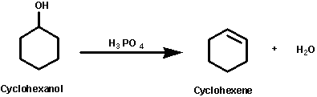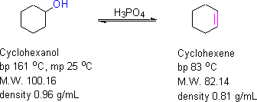

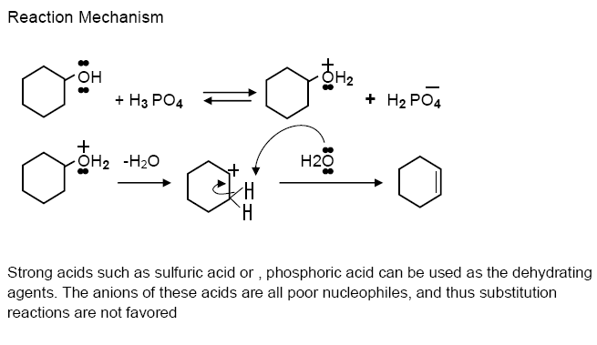

**Experimental Procedure:-**

| **Step** | **#** |
| --- | --- |
| 21.2ml of cyclohexanol are transferred to a 100ml round-bottomed flask, 5ml of 85% H3PO4 are added to the cyclohexanol. The solution is mixed thoroughly by swirling. | 1 |
| A few boiling chips are added, and the flask for simple distillation is assembled using a 50 mL Erlenmeyer flask in an ice-water bath as a receiver because cyclohexene is very volatile. | 2 |
| The reaction flask is heated slowly, so that the temperature of the distillate is no more than 95°C. The distillation is continued until about 5ml of solution remains in the flask. | 3 |
| The distillate is transferred in a small separatory funnel and wash with 10 ml of saturated salt solution once. The lower aqueous layer is discarded ,but the upper layer is kept. | 4 |
| The upper layer is washed with 20mL of 10% aqueous Na2CO3. The solution is swirled slowly at first and then the solution is shaken vigorously to neutralize. The layers are allowed to separate and the lower layer is drained and discarded. | 5 |
| The upper layer is transferred to a clean dry flask containing 3g of anhydrous calcium chloride(CaCl2) and let it stand for 10-15 min. Finally cyclohexene product is weighed and the total yield is calculated. | 6 |

| **Step** | **Observation(Positive results)** |
| --- | --- |
| **Test for unsaturation:-** Bromine test: **(Br2)**  0.5 ml of cyclohexene are placed into a test tube. A 2% solution of Br2/CCl4 are added drop wise.  Permanganate test: **(KMnO4)**  0.5 ml of cyclohexene are placed into a test tube. A 0.5% solution of Potassium Permanganate are added drop wise, the type is shaken. | **(Br2)**   Red----- Colorless   **(KMnO4)**  Purple----- Brown |

**Data, Calculations and Results:-**

**Weigh of Cyclohexene = 9.89g**

**Discussion & Comments:-**

The reaction mixture was heated since elimination reactions are favored by heat(2). For the dehydration of cyclohexanol reaction, the process is endothermic (i.e. ∆H is positive) and has more products than reactants.  
  
The percentage yield = 60.20% , this indicate that not all of the cyclohexene distillate from the solution . If the reactions take place for long time the percentage yield will increase.  
This decrease in the percentage yield indicate that there is an amount of cyclohexene volatile from the flask as the cyclohexene is very volatile.  
  
Why tests are used? To ensure that there is cyclohexene.  
  
When test with bromine(Red color) the convert from red to colorless indicate that there is cyclohexene.  
  
When test with Permanganate(Purple color) the convert from purple to brown, because of oxidation, indicate that there is cyclohexene.

**Questions:-**

**Q1.(2)**

**Q2.(5)** The product(Cyclohexene) is cooled, and Phosphoric acid need high temperature to act. So the reformation of Cyclohexanol would not obtain.

**Q3.(6)** Would get mixture of Cyclohexanol and Cyclohexene; because Cyclohexanol vaporized at high temperature, so this would get an error in result.

**References:-**  
  
(1) https://www.scribd.com/document/307467057/preparation-of-cyclohexene-from-cyclohexanol

(2) James. Elimination Reactions Are Favored By Heat.   
http://www.masterorganicchemistry.com/2012/09/10/elimination-reactions-are-favored-by-heat/ (accessed Oct 8, 2016)

**Good Luck**