**Abstract:-**The primary goal of plants is to grow and reproduce. Most of the metabolites produced by plants are polysaccharides and proteins that give the plants structure and function. Plants also produce very small amounts of secondary metabolites: compounds that are not directly related to growth or reproduction. Many of these secondary metabolites are very commercially valuable and some have very complex chemistry. Most of the plant compounds used in perfumes, flavors, and natural medicines are secondary metabolites.**(1)** The aims from this experiment are to learn how to set up steam distillation to separate the oils, and to show that the little amount of oil extracted from large amount of source.

**Chemicals:-**

| Aliquots of dichloromethane  CH2CL2 | Thymus serpyllum  (Spice) | Aliquots of saturated NaCl | Boiling chips | CaCl2 Drying agent |
| --- | --- | --- | --- | --- |

**Table 1: Chemicals Used**

**Glassware:-**

| Round bottom flask | Graduated Cylinder | Bunsen burner | Condenser | Beaker | Buchner Funnel | Filter Flask |
| --- | --- | --- | --- | --- | --- | --- |
| Thermometer | **Thermometer Adapter** | **Distillation head** | **Receiving adapter** | **Separotary funnel** |

**Table 2: Tools Used**

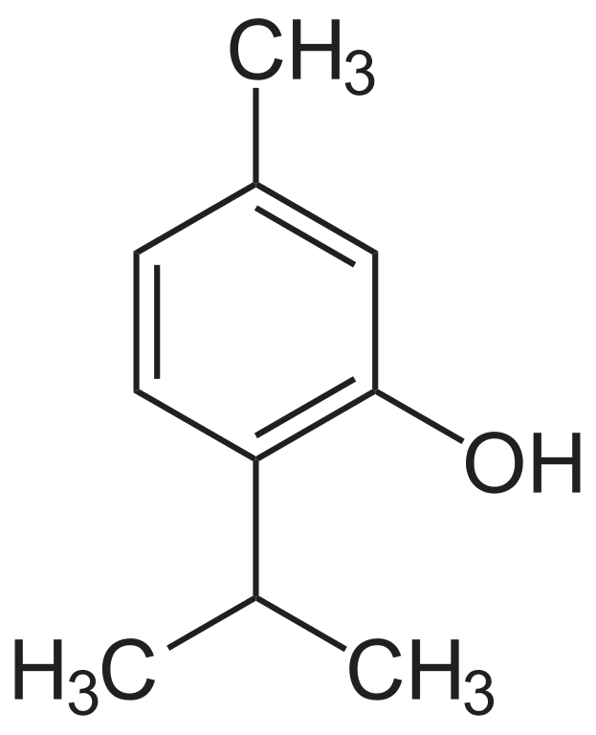

**Figure 1 :Thyme**

**Experimental Procedure:-**

| Step | # |
| --- | --- |
| Steam distillation is set**, 20 g thyme** is added to 500ml round bottom flask. | 1 |
| The flask if filled with distilled water, a couple of **boiling chips** is added. (Round bottom flask will be the distilling flask). | 2 |
| The distilling flask is **heated slowly** with Bunsen burner. The distillation is stopped after **2 hours**. The distillate is cooled with ice water. | 3 |
| The distillate is extracted twice with **15ml of CH2CL2** a- The distillate is added to separotary funnel. b- 15ml of CH2CL2 is added to separotary funnel, and shacked. c- The lower layer is drained d- Steps **b** are repeated through c | 4 |
| The organic layers are combined, then extracted twice with **15ml of NaCl solution** a- Organic solution is added to separotary funnel. b- 15ml of NaCl solution is added, and shacked c- Lower layer is drained and saved, discard upper layer. d- Steps **a** are repeated through **c** | 5 |
| **CaCl2**is used (Drying agent) to dry the organic layer. CaCl2 is filtered off. The filtrate is collected in a pre-weighed beaker. | 6 |
| The solvent is removed by heating over a hot water bath in the fume hood. The mass of product is obtained | 7 |

**Table 3 : Procedures**

**Data:-**   
1-Weight of Thyme(Spice) = 20 g  
2-Weight of Empty beaker(pre-weighed beaker) = 49.03 g  
3-Weight of beaker with extracted oil = 49.42 g  
4-Weight of extracted oil = Data 3 – Data 2 = 0.39 g

**Calculation and Results:-**

1-The smell of thyme oil is very strong.

2-The percentage yield =

**Discussion & Comments:**

The percentage yield = 1.95% , why is very small ?   
  
Because the extracted oil is evaporated and the use of stem distillation is not efficient like another methods like Clevenger distillation.  
  
**Reference:-**

1-http://www.engineering.iastate.edu/brl/files/2011/10/brl_essentialoils.pdf

**Good Luck**