

**Organic –Chem. 221 Lab**

**Instructor name: Imad Qamhiyeh Exp. date: 5-5-2021**

**Student Name: Ola Hammad** **Partner Name: Areej Hammoudeh**

**Student No:**  **1200725** **Partner No: 1201043**

**Experiment No: (**5)

**Experiment title:** Perfumes: The synthesis of Nerolin.

**Submission date:** 7-5-2021

**Abstract: (including objectives, chemical reactions, methods used and main results)**

Main Objectives:

1. Prepare nerolin through William’s ether reaction.

2. Using reflux distillation method.

3. Calculating the percentage yield of collected nerolin.

Methods used: distillation methods.

**Chemicals:**

Methanol, β-naphthol, Potassium hydroxide, Ethyl iodide, Ice cold water, Boiling chips, Grease.

**Glassware:**

Round bottom flask, Condenser, Beaker, Glass rod, Buchner funnel, Erlenmeyer flask, Graduated cylinder, Bunsen burner, Funnel, Filter paper, Thermometer, Capillary tube.

**Mechanisms or Reaction:**

Nerolin, chemically called 2-ethoxynaphthalene or ethyl β-naphthyl ether, is a synthetic perfume fixative. This means that it binds the other ingredients of perfume together to diminish the rate of evaporation of the more volatile components. Nerolin synthesis as shown in the following reaction:

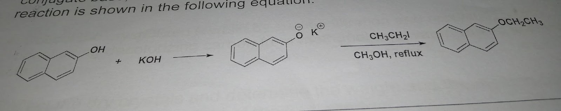

This experiment is done using the reflux distillation method. The purpose of this method is to thermally accelerate the reaction by conducting it at an elevated temperature which is the solvent boiling point. This method involves putting the liquid reaction mixture in a round bottom flask connected to a condenser. The round bottom flask is heated vigorously for the rest of the reaction. The condenser is open from the top and any vapors given off are cooled back to liquid form. The advantage of this technique is that there is no need to add more solvent considering the fact that any vapor is immediately condensed in the condenser and that the solvent will always boil at a certain temperature. This allows continuous mixing of the solution at constant temperature (controlled conditions).

**Data:**

Mass of filter paper = 0.33g

Table 1: properties of chemicals used

|  |  |  |  |
| --- | --- | --- | --- |
| **Name and structure** | **Density (g/cm3)** | **Weight** | **Molar Mass** |
| Methanol | 792 kg/m³ | ---- | 32.04 g/mol |
| B-naphthol | 1.22 g/cm³ | 5.30g | 144.17 g/mol |
| Potassium hydroxide | 2.12 g/cm³ | 3.28g | 56.1056 g/mol |
| Ethyl iodide | 1.94 g/cm³ | ---- | 155.97 g/mol |
|  | | | |

Table 2: results

|  |  |
| --- | --- |
| **Product** | **Mass** |
| **Nerolin** | 5.41 g |
| **Β-naphthol** | 5.30 g |
| **Potassium hydroxide** | 3.28 g |

**Calculation and results:**

# of moles of B-naphthol = mass / molar mass

= 5.30g / 144.17 g/mol

=0.036 mol

From the chemical equation:

1 mol of B-naphthol*1 mol of nerolin

0.036 mol * mol of nerolin

So # of moles of nerolin = 0.03 mol Mass of nerolin

= # of moles * molar mass

= 0.036 * 172.22

= 6.33g this is the theoretical yield

% yield= actual yield/ theoretical yield *100%

= 0.2 / 6.33*100 %

= 3.15

**Discussion & Comments:**

In this experiment, the method used was reflux distillation. this method is very useful for this experiment mostly due to the fact that it supplied energy to the reaction over a long period of time without needing to add more solvent since any vapors given off are cooled back as liquid into the flask. The main aim of this experiment was to calculate the percentage yield of the collected nerolin. The result was 3.15%, which is a very low yield. This can only be explained by many experimental errors. These include loss of the collected product by many ways such as residuals left over in the glassware. Also, the product on the paper did not dry well enough. On the other hand, the melting point found experimentally was very close to the theoretical melting point.

Questions:

**Q1.**

As it is an acid, it can be removed by washing it with KOH solution.

**Q3.**

When exposed to heat as well as when exposed to direct sunlight, the compounds in perfume may react to form undesired products and the perfume becomes impure and may become unfit for use.

If exposed to heat pressure may develop and the perfume bottle may burst out /explode.

**Q5.**

