**07.03.2018 Org-Chemistry -230 Section # 2**

**CHAPTER 3 (Key)**

**1.** a. Give the systematic name for the following compound.



b. How many primary carbons does it have? **3**

c. How many tertiary carbons does it have? **3**

**2.** Draw all the possible conformations as Newman projection of **pentane** for rotation about C2-C3 bond. Which one is the most stable?



**3.** List the following compounds in order of decreasing boiling point:

A) CH3CH2CH2CH2CH2CH3 B) 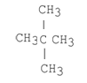

C) 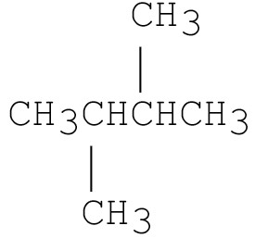 D) 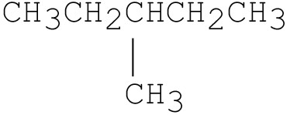

**A>D>C>B**

**Good Luck**