

**Analytical Chemistry**

**CHEM234**

**Sec 1**

**Student Name: Meran Nasser**

**Student ID: 1190803**

**Instructor: Dr. Diab Qadah**

Homework1

**The submission: 21\7\2021**

**Chapter 0:  
0.3:**

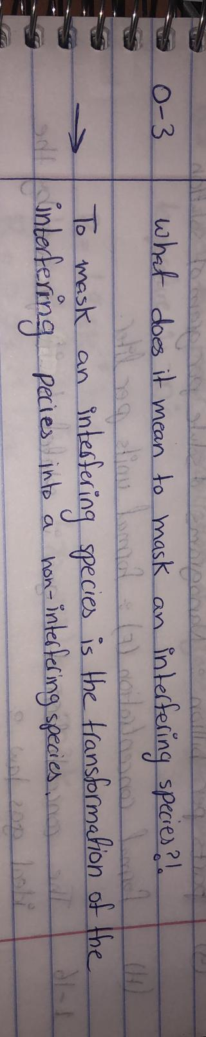

**0-4: What is the purpose of a calibration curve?**

* The response of an analytical method as a function of the known concentration of analyte in standard solutions is shown by a calibration curve. The concentration of an unknown can be inferred from a measured response after the calibration curve is known.

**0-6: The iodide (I-) content of a commercial mineral water was measured by two methods that produced wildy different results. Method A found 0.23 milligrams of I- per liter (mg/L) and method B found 0.009 mg/L. When Mn2+ was added to the water, the I- content found by method A increased each time more Mn2+ was added, but results from method B were unchanged. Which of the Terms to Understand describes what is occurring in these measurements?**

* Obviously, we observe the interference by Mn2+ in the I- analysis by method A. The presence of Mn2+ influences the outcome of the I- analysis. The higher the concentration of Mn2+ in mineral water, the larger the apparent concentration from I- found by method A. Method B isn’t subject to the same interference, so concentration It is I- low and independent of Mn2+ addition. There must be some Mn2+ in the original mineral water, which makes method A give a higher result than method B even if Mn2+ isn’t added intentionally**.**

**Chapter 1:**

**1-12:**

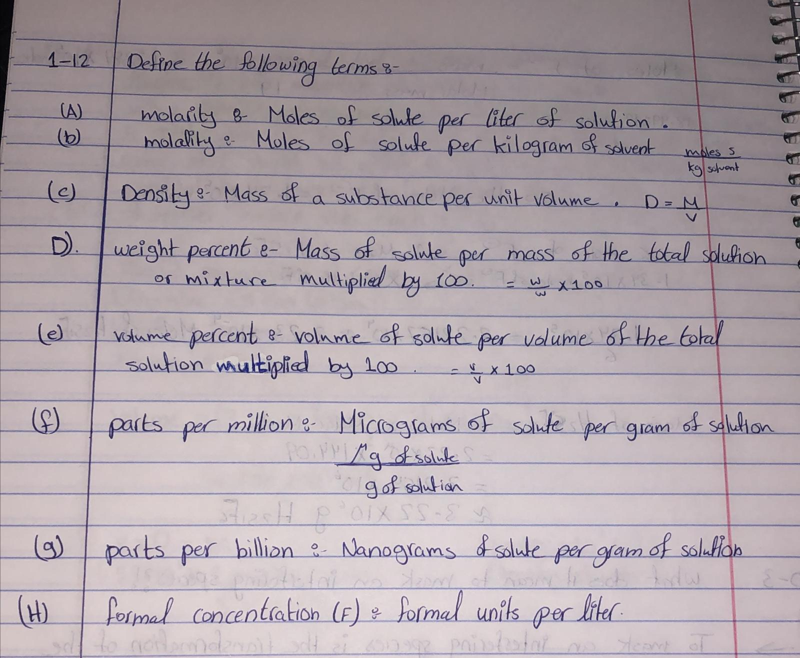

**1-13: Why is it more accurate to say that the concentration of a so-lution of acetic acid is 0.01 F rather than 0.01 M? (Despite this dis-tinction, we will usually write 0.01 M.)**

* **It is more correct to say that the concentration of the acetic acid solution is 0.01 Fahrenheit instead of 0.01 molar, due to the presence in the acetic acid solution a mixture of acetic acid and a separate acid or acetate ion. The use of F (formal) is therefore more accurate, because the combination of the concentration of acetic acid, i.e., CH3COOH, and the acetate ion, i.e. CH3C00" is 0.01 F. The partial dissociation of acetic acid in solution is:**

**CH3COO-(aq) CH3COO-(aq) + H+**

**1-14:**

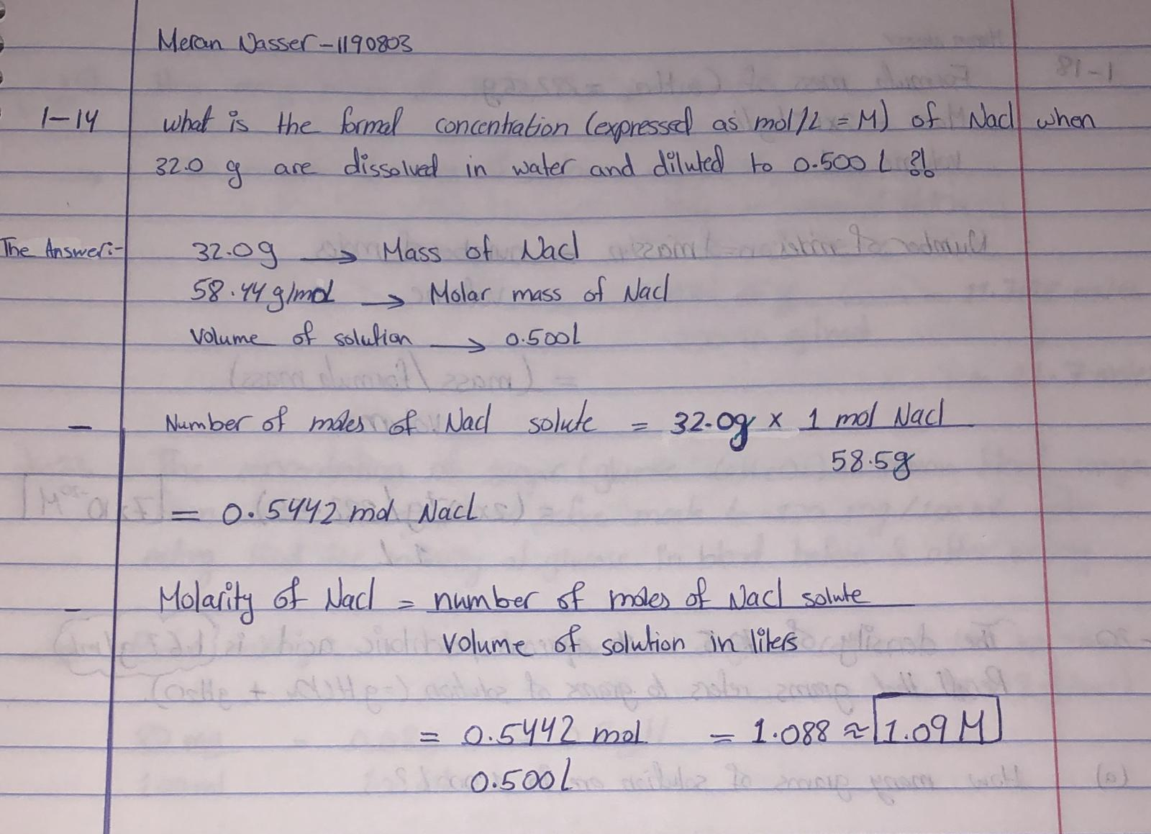

**1-16:   
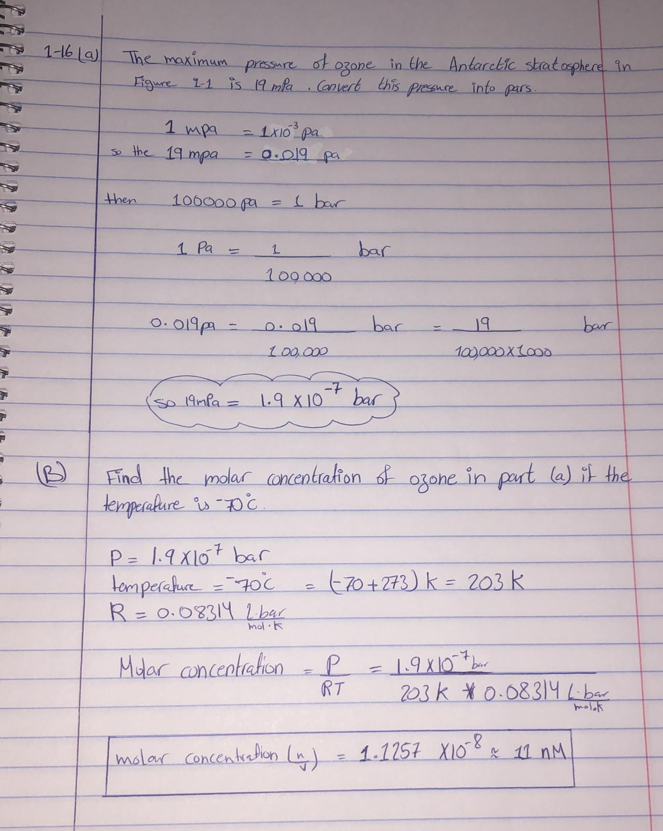**

**1-18:**

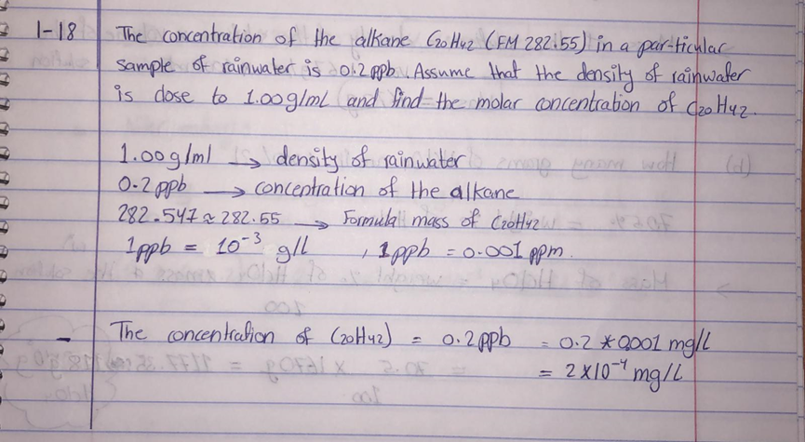

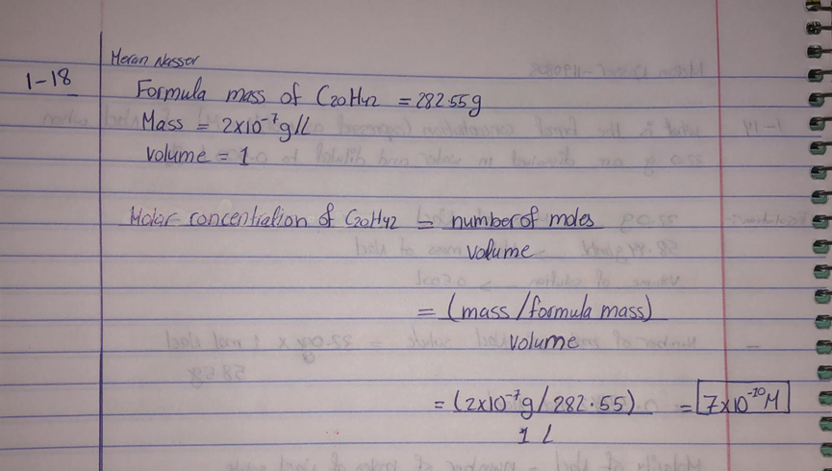

**1-20:**

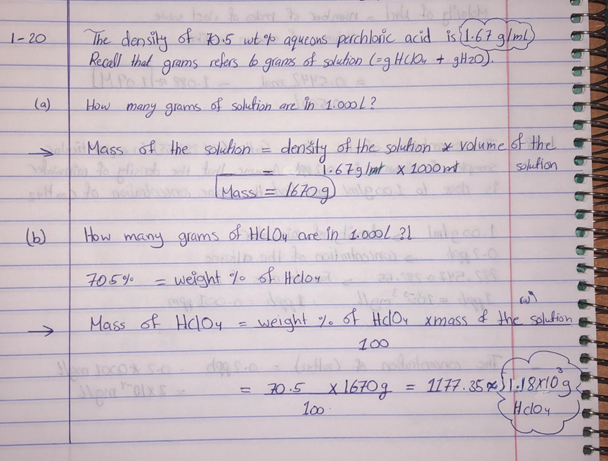

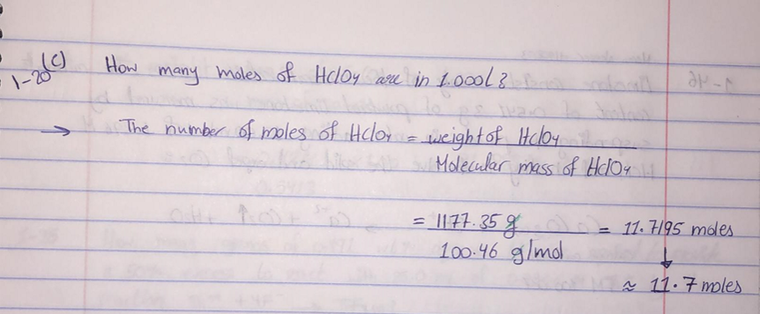

**1-23:**

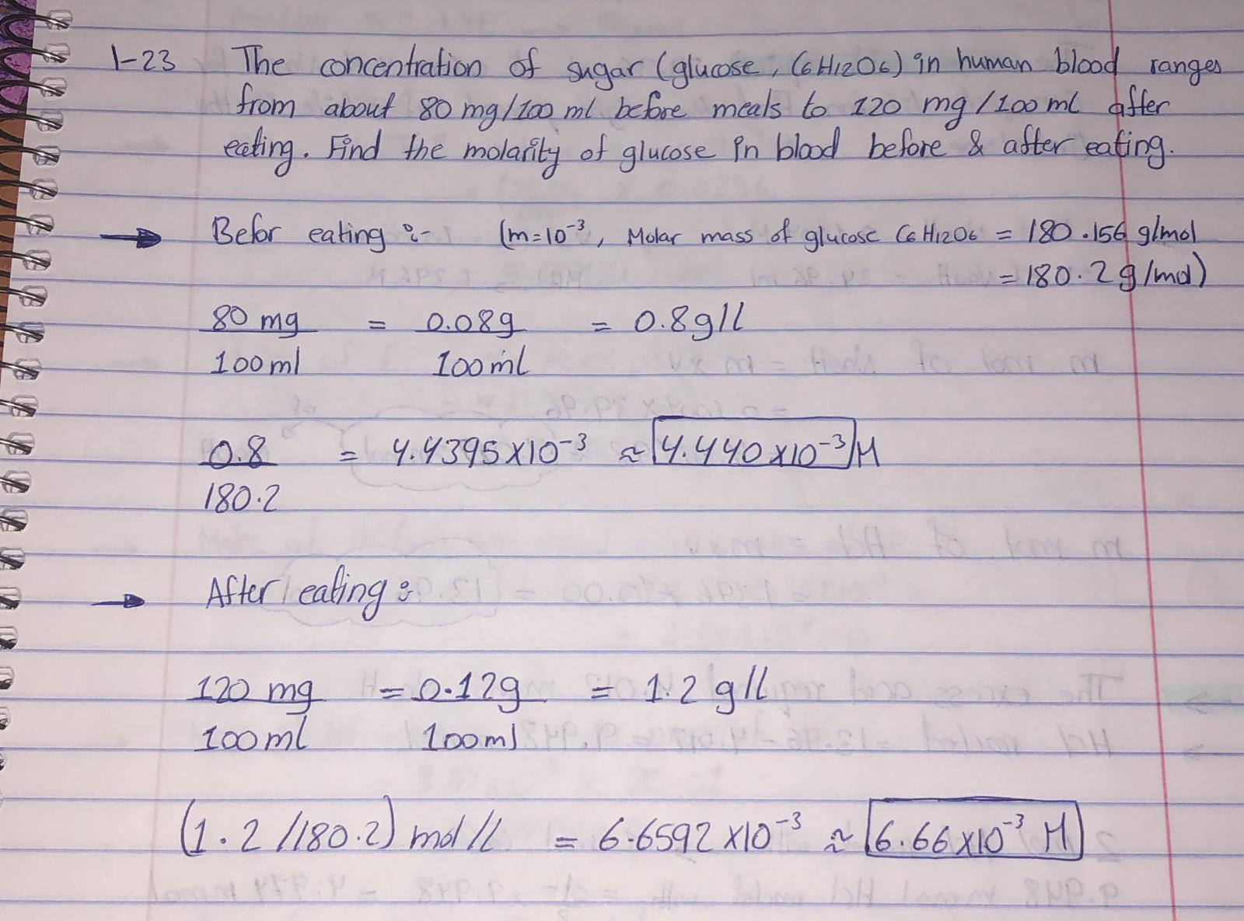

**1-24:** An aqueous solution of antifreeze contains 6.067 Methyl-ene glycol (HOCH2CH2OH, FM 62.07) and has a density of1.046 g/mL.

(a) Find the mass of 1.000 L of this solution and the number of grams of ethylene glycol per liter.

(b) Find the molality of ethylene glycol in this solution.

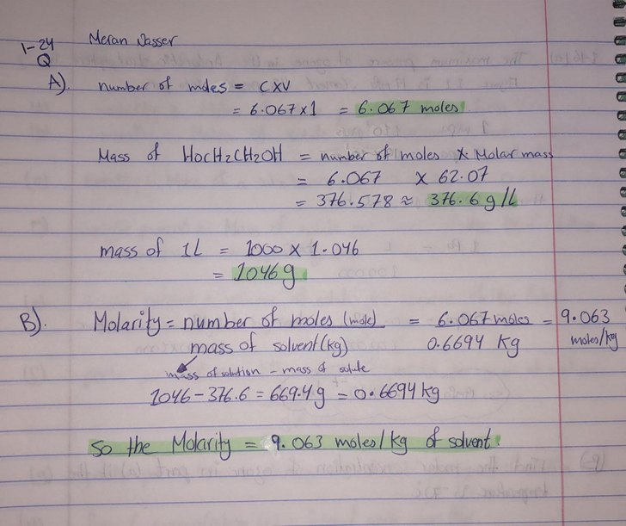

**1-26:**

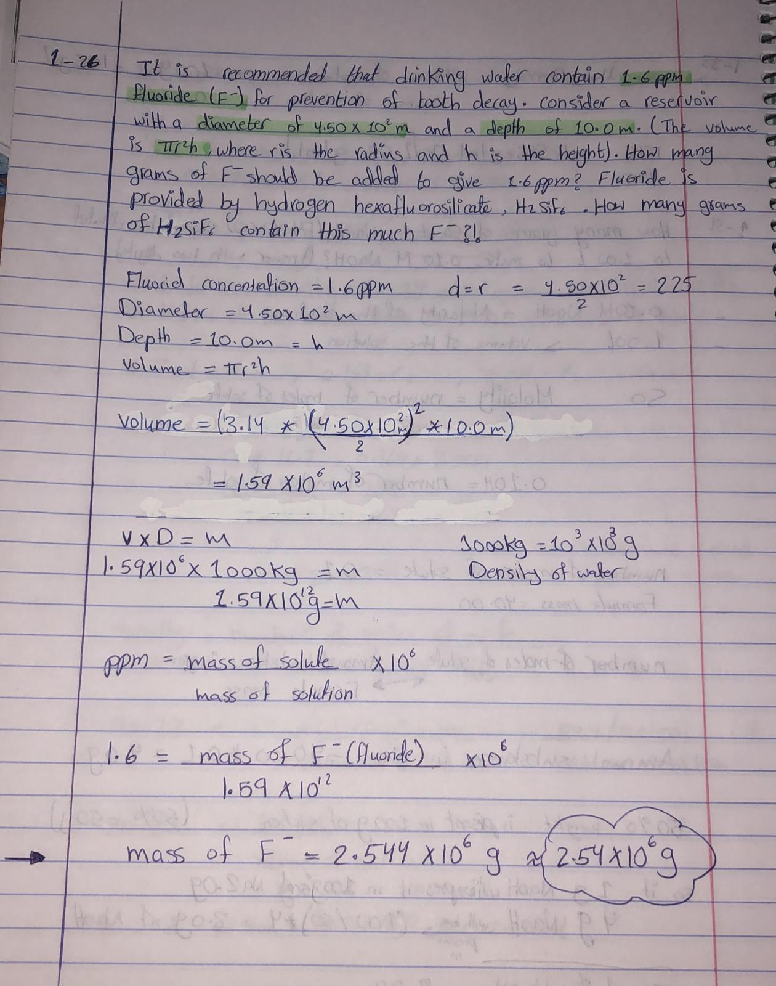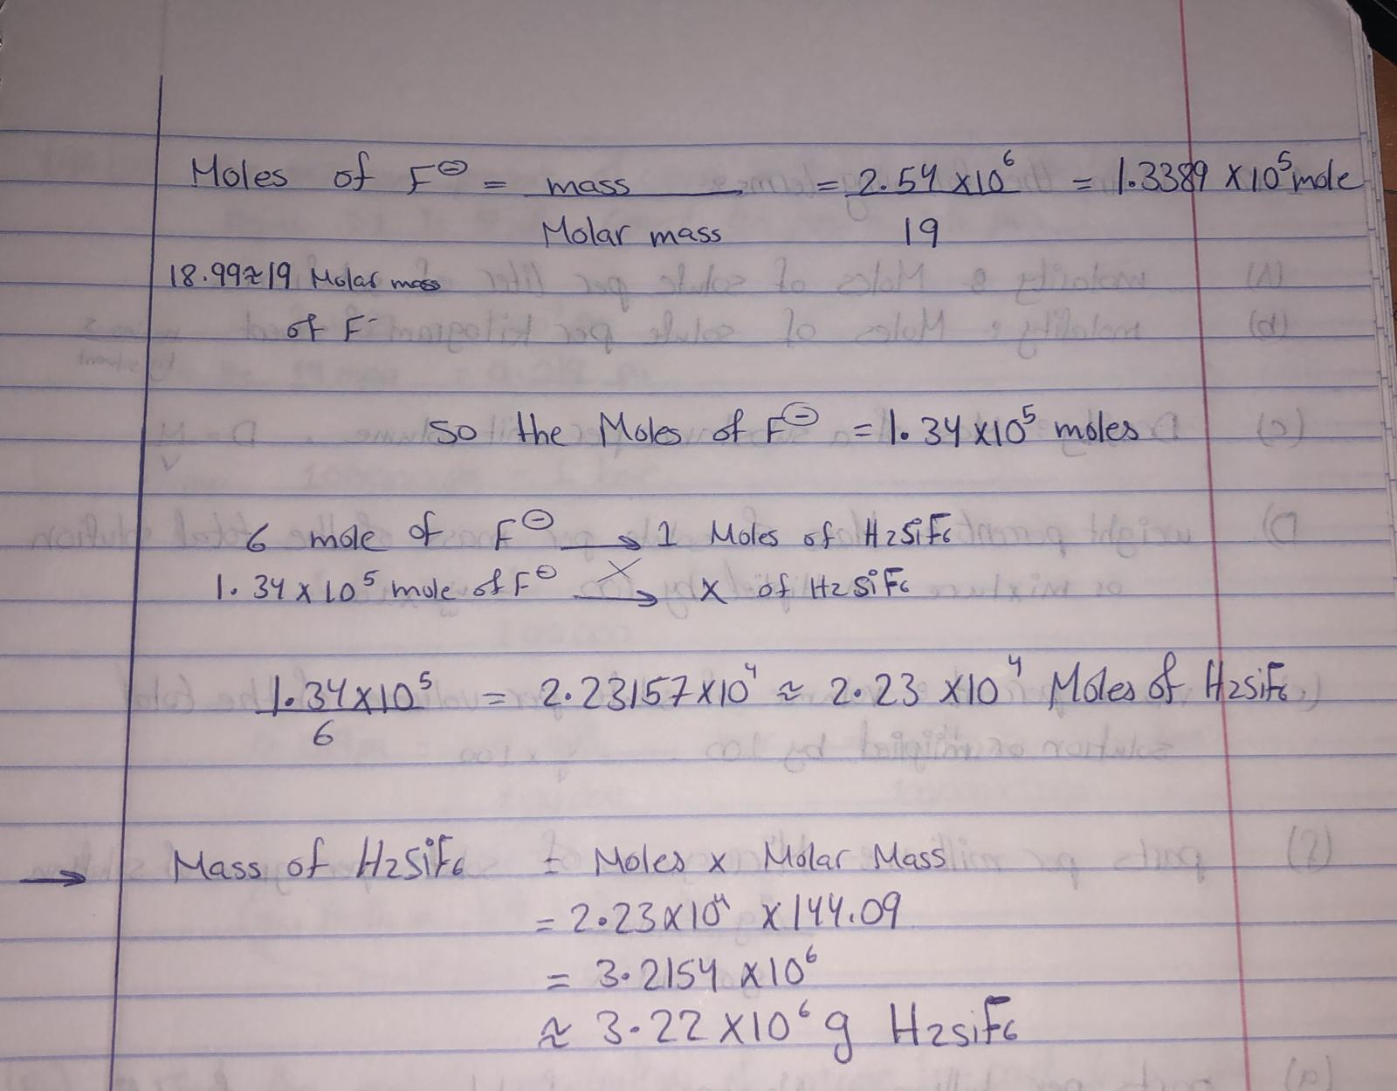

**1-27:**

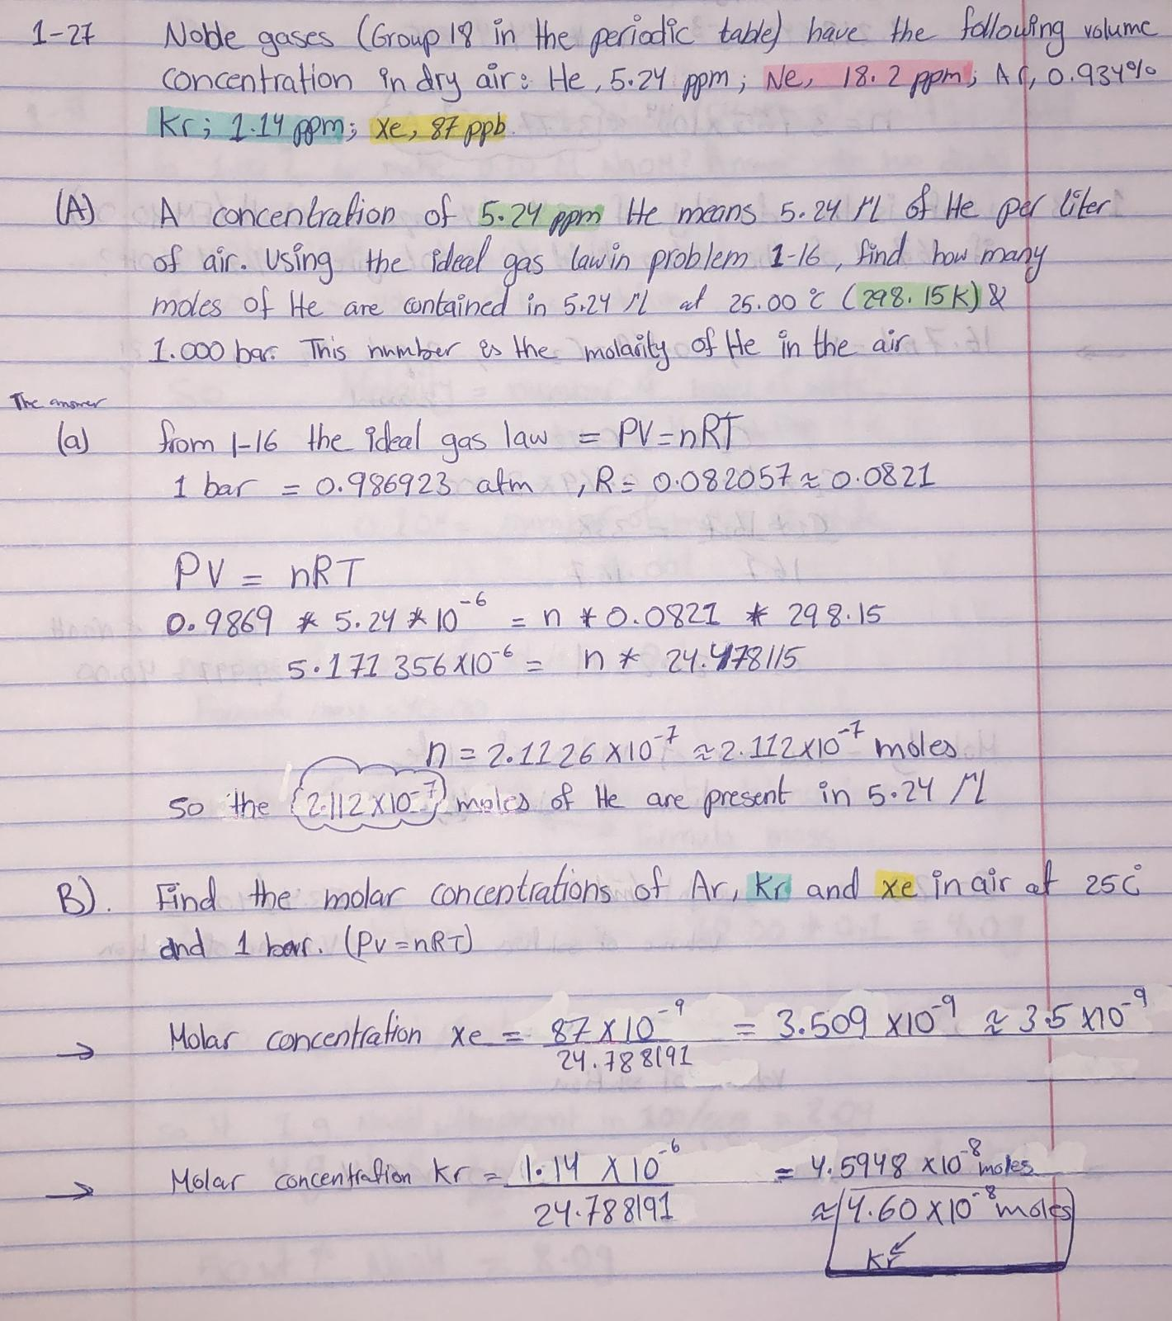

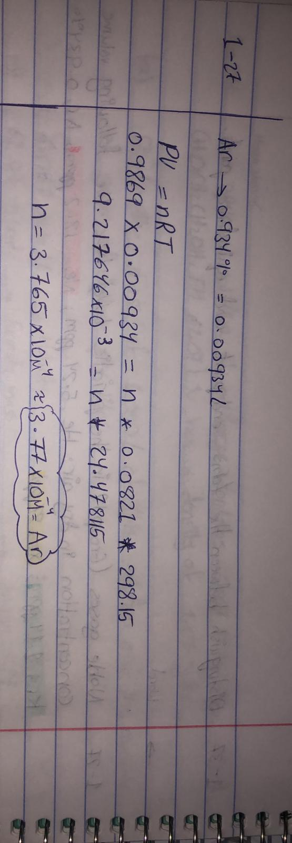

**1-31:**

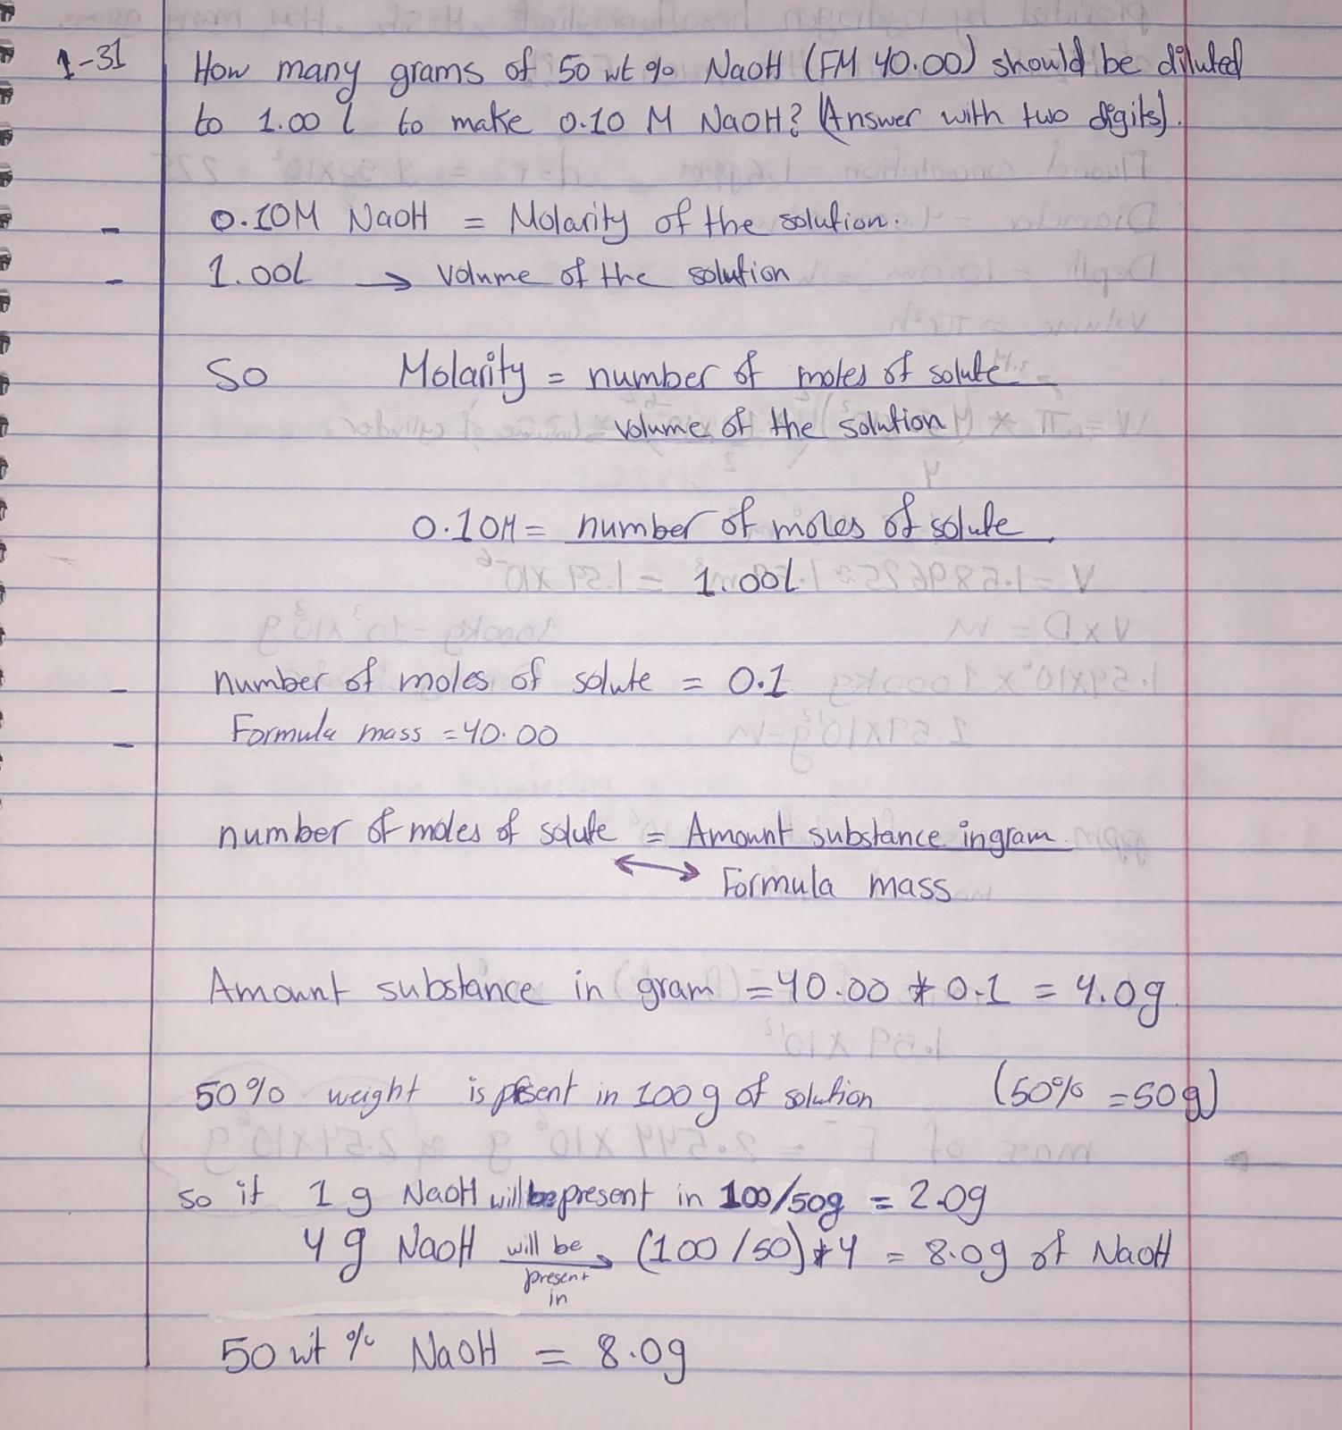

**1-33:**

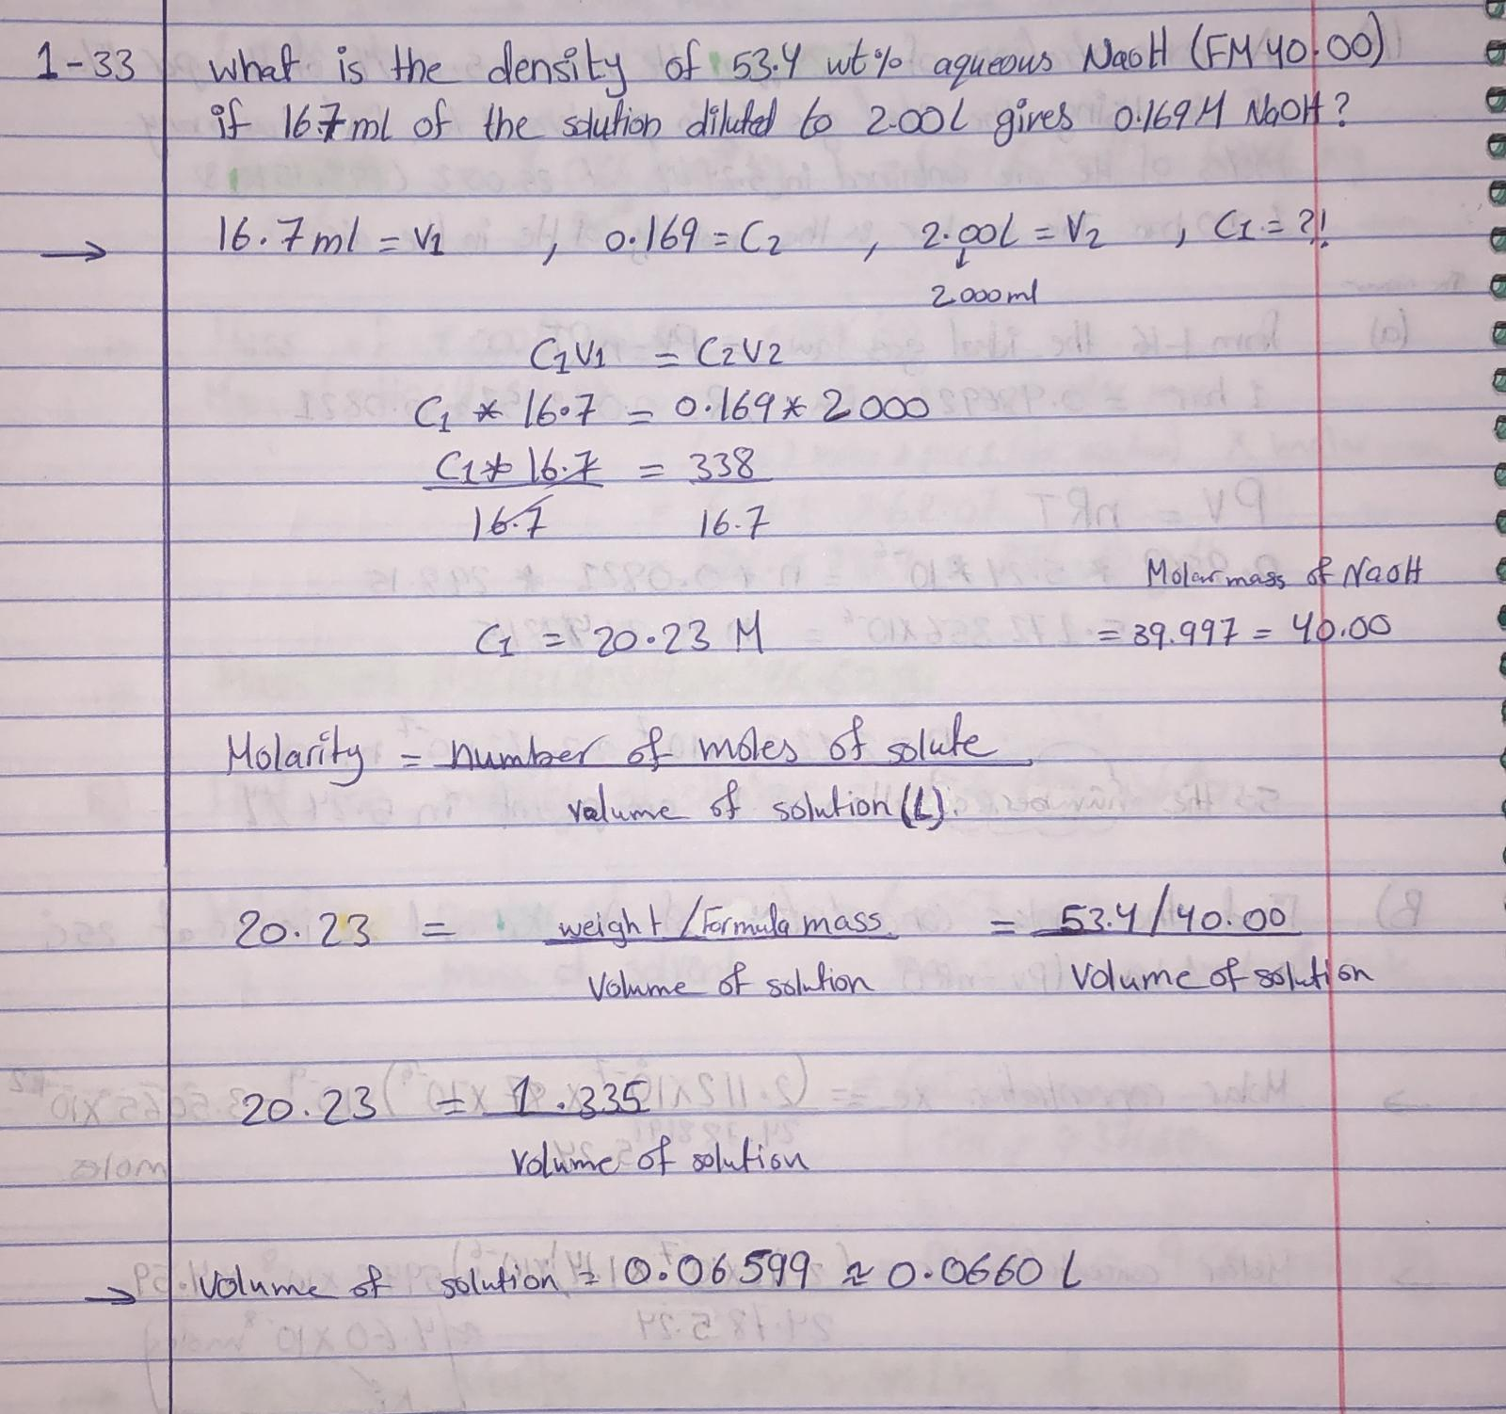

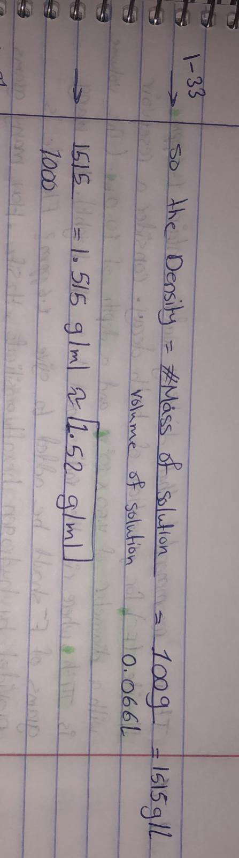

**1-35:**

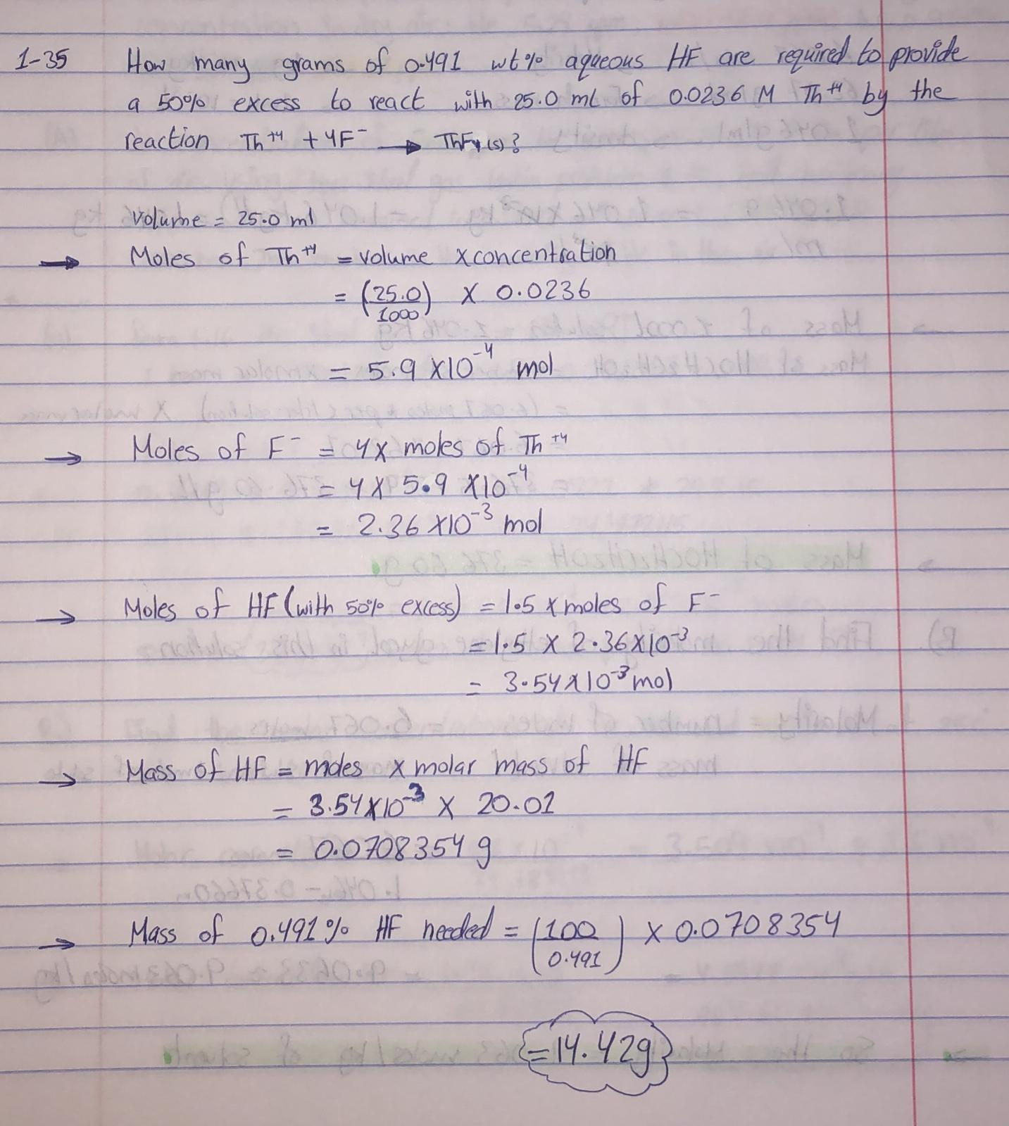

**1-37: Distinguish between the terms end point and equivalence point.**

* There are a number of distinctions between equivalence and end points, including the fact that the equivalence point occurs before the end point, which is the point at which the titrant is chemically equivalent to the analysis in the sample, and that many equivalence points can be obtained in weak acids. In contrast to the end point have just one end point, which happens after the equivalence point, when the color of the indicator appears in the solution.

**1-46:**

