

***Assignment2***

***ANALYTICAL CHEMISTRY - CHEM234***

***Sec:1***

***Student Name: Meran Nasser***

***Student ID: 1190803***

***Instructor: Dr. Diab Qadah***

**4-1: What is the relation between the standard deviation and the precision of a procedure? What is the relation between standard deviation and accuracy?**

* The precision increases as the standard deviation decreases. The connection between standard deviation and accuracy isn't required because the statistics we'll look at in this chapter are about precision rather than accuracy.

**4-2: Use Table 4-1 to state what fraction of a Gaussian population lies within the following intervals:**

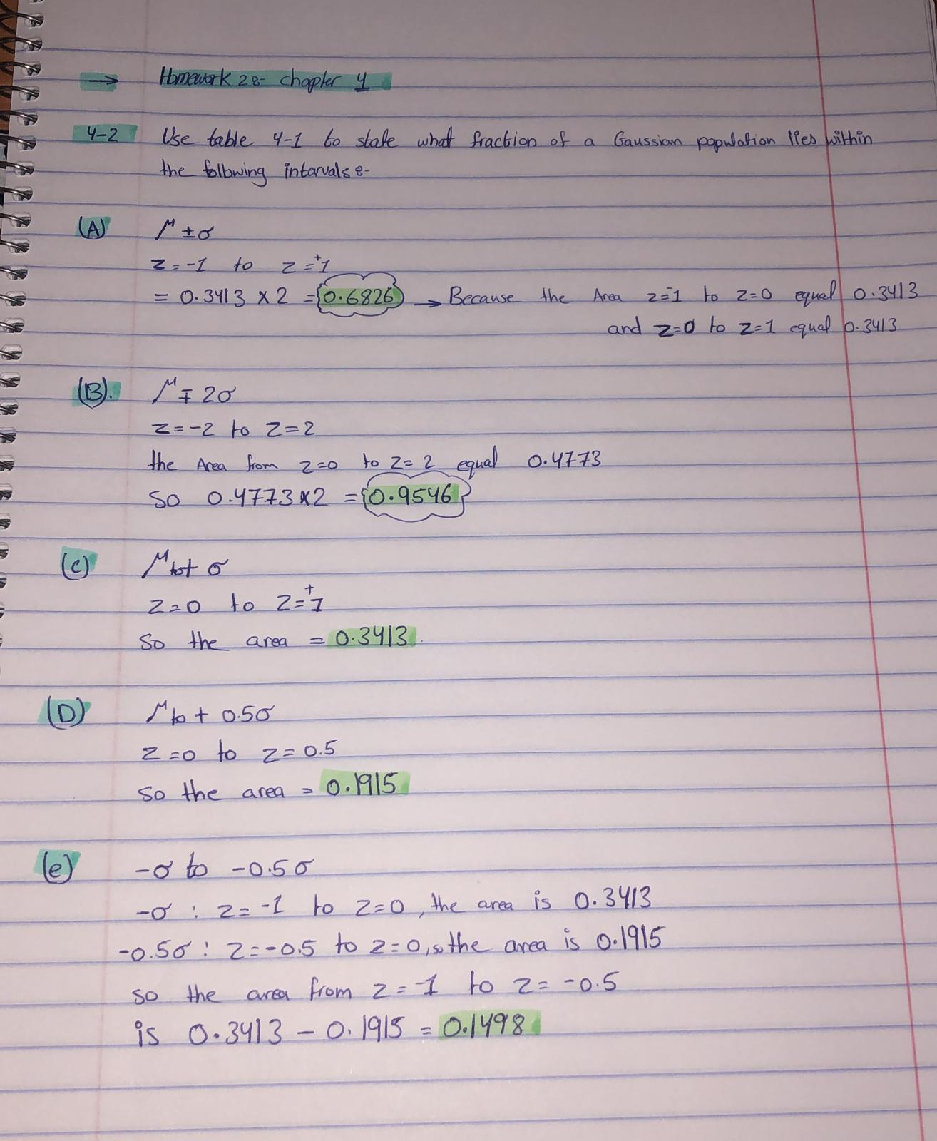

**4-8: What is the meaning of a conﬁdence interval?**

🡪 The confidence interval is the area around the measured mean where there is a probability that the true mean lies: if we repeat a set of measurements n more than once and calculate the mean and standard deviation for each group, then the 95% confidence interval will include the true population mean which we do not know the value of in 95% of the sets of n measurements.

**4-14: The CdSe content (g/L) of nanocrystals was measured by two methods for six different samples. Do the two methods differ significantly at the 95% conﬁdence level?**

|  |  |  |  |
| --- | --- | --- | --- |
| **Sample** | **Method 1** | **Method 2** | **Di(Method 1 – Method 2)** |
| **A** | 0.88 | 0.83 | 0.05 |
| **B** | 1.15 | 1.04 | 0.11 |
| **C** | 1.22 | 1.39 | - 0.17 |
| **D** | 0.93 | 0.91 | 0.02 |
| **E** | 1.17 | 1.08 | 0.09 |
| **F** | 1.51 | 1.31 | 0.20 |

So the average(xd) = ((0.05 + 0.11 – 0.17 + 0.02 + 0.09 + 0.20) \ (6)) = 0.05

The standard deviation:

(s) = $\frac{\sqrt{\sum{(}xi-x(mean))2}}{n-1}$

$=\frac{\sqrt{{\left(0.05-0.05\right)}^{2}}+{\left(0.11-0.05\right)}^{2}+{\left(-0.17-0.05\right)}^{2}+{\left(0.02-0.05\right)}^{2}+{\left(0.09-0.05\right)}^{2}+{\left(0.20-0.05\right)}^{2} }{6-1}=$

$$0.124$$

tCalculated = (0.050/0.124 ) $√6$* = 0.9876 ~ 0.988

ttable = n-1 = 6-1

So n=5, ttable = 2.571

* So the difference is not significant different because tcalculated < ttable (0.987 < 2.571)

**4-20:   
  
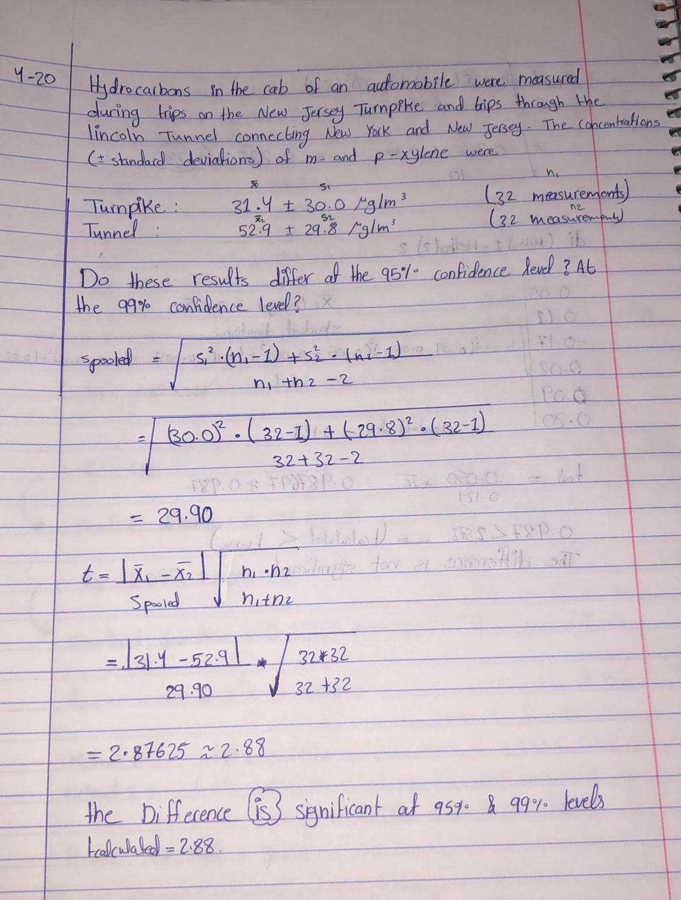**

**4-31:**

**A:**

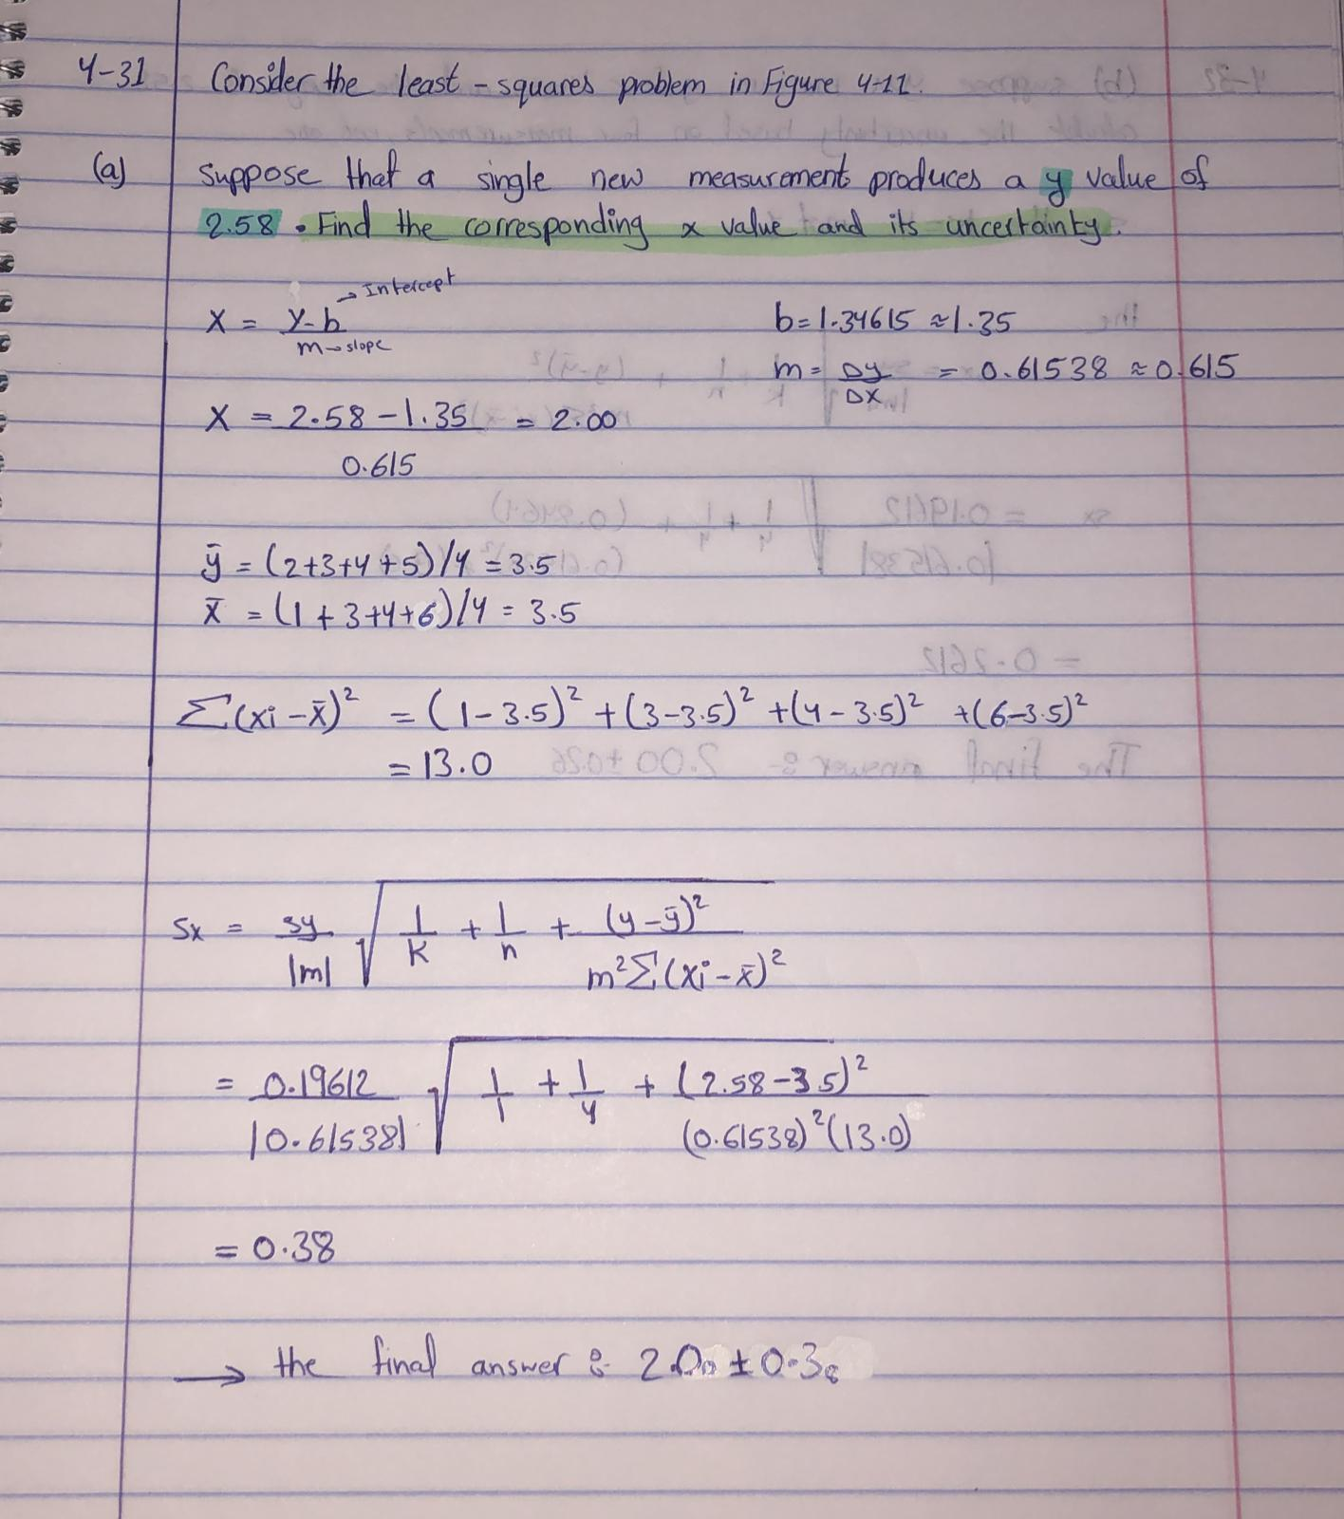

**B:**

