

***Analytical Chemistry***

***CHEM234***

***Sec 1***

***Exp4: Title***

***Determination of the Ka of a weak acid***

***Student Name: Meran Nasser***

***Student ID: 1190803***

***Partner’s name: Aya Daghra - 1190766***

***Instructor: Dr. Diab Qadah***

***Teacher Assistance: Sabreen***

***The submission: 2/8/2021***

**Abstract:**

Acids and bases are frequently classified as "weak" or "strong". The strength of an acid refers to its ability or tendency to lose a proton (H+). The acid dissociation constant (ka) is used to determine how strong an acid is. And it is determined by: [H+] *[the conjugate base of the acid]/ [ the acid] ([H+] [A- ] /[HA]) , as the general equation for the acid dissociation is: (the acid)HA 🡪 H+ + A-(conjugate base). As a result, this number is a characteristic that aids in the identification of an unknown acid.

Thus, the main objectives of this experiment are to determine the Ka value and the molar mass of a monoprotic weak acid by potentiometric titration. When an acid sample is titrated with NaOH and a titration curve is formed, the volume is half of the equivalence point's volume, and PH equals pKa.

Therefore, the main Reaction for this experiment:

**HA (aq) + NaOH(aq) NaA(aq) + H2O**

And after performing the experiment we manage to find the Ka and the molar mass by Determination of the Ka of a weak acid, the final results were:

Ka: 0.000193 ± 0.000144 %

Molar Mass: 87.99 ± 23.55 g\mol

Name of the unknown: Butyric acid

**Data:**

Unknown Number: (**J**)

Mass of unknown acid dissolved in 250 L: 1.26 g

Volume of sample titrated: 25.00 mL

Concentration of NaOH: 0.1218 M

**Table 1:** Volume of pH vs. Volume of NaOH consumed in potentiometric titration of NaOH & unknown acid solutions.

|  |  |  |  |  |  |
| --- | --- | --- | --- | --- | --- |
| **Trial 1** | | **Trial 2** | | **Trial 3** | |
| **V-NaOH** | **PH** | **V-NaOH** | **PH** | **V-NaOH** | **PH** |
| 0.00 | 2.59 | 0.00 | 2.59 | 0.00 | 2.52 |
| 2.00 | 2.99 | 4.10 | 3.36 | 4.10 | 3.39 |
| 4.00 | 3.31 | 6.10 | 3.62 | 6.00 | 3.70 |
| 6.00 | 3.60 | 8.00 | 3.88 | 8.00 | 4.00 |
| 8.00 | 3.89 | 10.00 | 4.21 | 10.10 | 4.30 |
| 9.00 | 4.05 | 10.50 | 4.30 | 12.00 | 5.69 |
| 9.50 | 4.14 | 11.20 | 4.48 | 13.00 | 7.42 |
| 10.00 | 4.26 | 12.30 | 5.42 | 13.90 | 8.00 |
| 10.20 | 4.31 | 13.00 | 6.42 | 14.40 | 8.84 |
| 10.40 | 4.35 | 13.30 | 9.57 | 14.90 | 10.59 |
| 10.68 | 4.43 | 16.00 | 11.61 | 15.80 | 11.30 |
| 10.90 | 4.49 | 16.45 | 11.67 | 16.00 | 11.49 |
| 11.10 | 4.56 | 17.40 | 11.76 | 16.30 | 11.62 |
| 11.30 | 4.65 | 19.10 | 11.88 | 21.10 | 11.80 |
| 11.50 | 4.74 | 21.20 | 11.98 | 23.10 | 11.86 |
| 11.80 | 4.88 | 23.20 | 12.05 | 24.20 | 11.88 |
| 12.10 | 5.05 | 24.80 | 12.10 |
| 12.50 | 5.77 |
| 12.78 | 7.30 |
| 12.90 | 8.80 |
| 13.10 | 8.82 |
| 13.40 | 10.60 |
| 14.72 | 11.04 |
| 14.90 | 11.10 |
| 15.50 | 11.20 |
| 16.40 | 11.32 |
| 18.00 | 11.47 |
| 20.00 | 11.59 |
| 24.50 | 11.78 |
| 26.50 | 11.84 |
| 28.50 | 11.90 |
| 30.50 | 11.94 |
| 32.10 | 11.98 |
| 33.50 | 11.99 |
| 35.50 | 12.02 |

* **Calculation:**
* Trial 1:

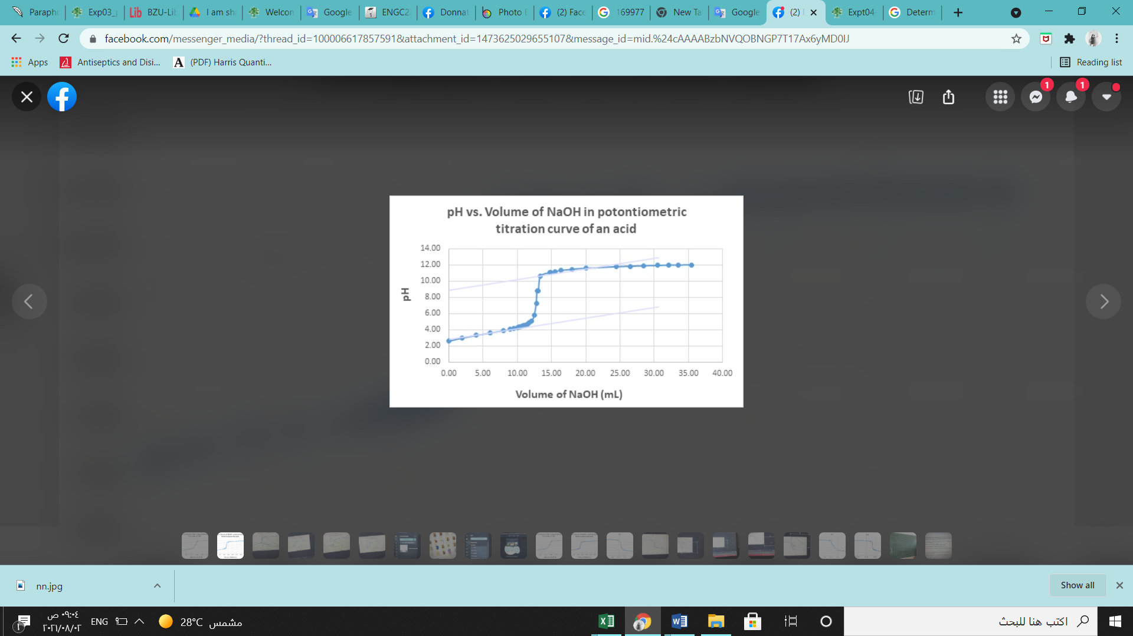

**Figure1: pH-metric titration curve of an unknown acid for trial 1.**

**Figure 2: First derivative plot of the pH metric titration curve obtained in trial 1.**

From the graphs, the equivalence point is at PH= 7.30, at which the volume is approximately 12.78 ml, so half the volume of the equivalence point is 6.39 ml at PH= 3.75, and as PH = pKa, Ka = 10-pKa = 10-3.75= 1.78 * 10-4.

And to calculate molar mass: (M*V) NaOH = number of moles of the acid = 0.1 mass of the acid/ molar mass of the acid

So, molar mass of the acid = ((1/10.00) *1.260 g)/ (10 * 0.1218 *12.78 *10-3) = 80.95 g/mol

* **Trial 2:**

**Figure3: pH-metric titration curve of an unknown acid for trial 2.**

**Figure 4: First derivative plot of the pH metric titration curve obtained in trial 2.**

From the graphs, the equivalence point is at pH= 6.42, at which the volume is approximately 13.00 ml, so half the volume of the equivalence point is 6.50 ml at pH= 3.70, and as pH = pKa, Ka = 10-pKa = 10-3.70= 1.9952 * 10-4 ~ **1.20 *10-4.**

And to calculate molar mass: (M*V) NaOH = number of moles of the acid = 0.1 mass of the acid/ molar mass of the acid

So, molar mass of the acid = ((1/10.00) *1.260 g)/ (0.1218 *13.00 *10-3) = 79.58 g/mol

* **Trial 3:**

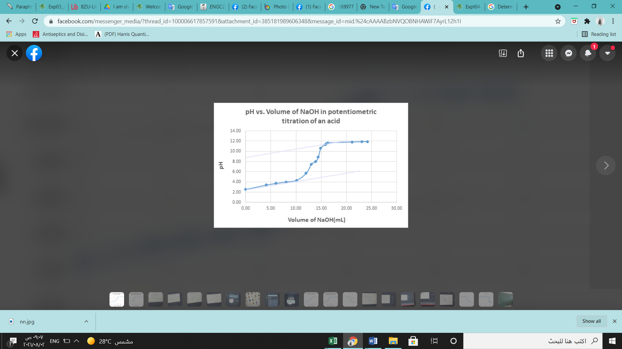

**Figure5: pH-metric titration curve of an unknown acid for trial 3.**

**Figure 6: First derivative plot of the pH metric titration curve obtained in trial 3.**

From the graphs, the volume is approximately 10.00 ml, so half the volume of the equivalence point is 5.00 ml at pH= 3.55, and as PH = pKa, Ka = 10-pKa = 10-3.55= 2.818 * 10-4 ~ **2.82 *10-4**.

And to calculate molar mass: (M*V) NaOH = number of moles of the acid = 0.1 mass of the acid/ molar mass of the acid

So, molar mass of the acid = ((1/10.00) *1.260 g)/ (0.1218 *10.00 *10-3) = 103.45 g/mol

* **Q test & Q table:**
* Tiral 3 (Ka):

= |suspension value – nearest neighbor value| / range   
= | 2.82 * 10-4 – 1.78* 10-4| / (2.82 * 10-4 – 1.20 * 10-4)

= 0.6420  
- The susp value isn’t outlier because the Q table > Q test   
- **The Q table** confidence level of 95% & n = 3 = **0.97**0. So the value is not an outlier.

* Trial 3 of molar mass:

= |suspension value – nearest neighbor value| / range   
= | 103.45 – 80.95| / (103.45 – 79.58)

= 0.94  
- The susp value is outlier because the Q test > Q table   
- **The Q table** confidence level of 95% & n = 3 = **0.97**0. So the value is an outlier

* **Average Ka:**

= (1.78*10-4  + 1.20*10-4 + 2.82*10-4) / 3

=1.933 *10-4

* **Average Molar Mass:**

= (80.95 + 79.58 + 103.45)/3

= 87.99 %

* **Standard deviation of Ka:**  
  (s) = $\frac{\sqrt{\sum{(}xi-x(mean))2}}{n-1}$

$=\frac{\sqrt{{\left(1.78*{10}^{-4}-1.93*{10}^{-4}\right)}^{2}}+{\left(1.20*{10}^{-4}-1.93*{10}^{-4}\right)}^{2}+{\left(2.82*{10}^{-4}-1.93*{10}^{-4}\right)}^{2}}{3-1}=$

$$0.000058$$

* **Standard deviation of Molar mass:**  
  (s) = $\frac{\sqrt{\sum{(}xi-x(mean))2}}{n-1}$

$=\frac{\sqrt{{\left(80.95-87.99\right)}^{2}}+{\left(79.58-87.99\right)}^{2}+{\left(103.45-87.99\right)}^{2}}{3-1}=$

$$9.4776$$

* **RSD% Ka:**

**Coefficient of variation = ((s\x) * 100)**

= (0.000058 / 1.933 * 10-4) * 100%

= 30.00%

* **RSD% of molar mass:**

**Coefficient of variation = ((s\x) * 100)**

= (9.4776 / 87.99 * 100%)

= 10.77 %

* **95 % confidence interval($μ)=x\frac{±ts}{\sqrt{n}}$** of Ka  
  = 0.000193 ± ((4.303 * 0.000058 ) / $\sqrt{3}$  
  = 0.000193 ± 0.000144
* **95 % confidence interval($μ)=x\frac{±ts}{\sqrt{n}}$** of molar mass  
  = 87.99 ± ((4.303 * 9.4776 ) / $\sqrt{3}$  
  = 87.99 ± 23.55
* **Discussion & Conclusion:**

According to the Q-test, none of the results of Ka in the three trials were rejected. As a result, the Ka has a mean of a Standard deviation = 0.000058. the 95% confidence interval: (0.000193 ± 0.000144) % the average 3.37*10-4 to 4.9 * 10-5, so we may conclude that we have good accuracy in our experiment because this range is not excessively large.

And applying the Q-test on the molar mass values, we got no rejected values. Then, the mean is 87.99 g/mol, with a standard deviation of 9.4776 g/mol. the 95% confidence interval: (87.99 ± 23.55) % the average 111.54 to 64.44 but we have no confidence good because this range is rather large.

However, some systematic errors may occur in this experiment that must be avoided, such as using an uncalibrated PH meter, not thoroughly stirring the solution while performing the titration, and not collecting enough data around the equivalence point, causing us to be unable to track the PH jump step by step, resulting in errors in drawing the calibration curve.

Random errors include the error associated with the volumetric glassware and tools used, such as: The pH meter so that it continues to read and jump and does not stop, which caused some errors, the buret and the method of reading from it.