

***Analytical Chemistry***

***CHEM234***

***Sec 1***

***Exp3: Title***

***pH-metric titration***

***determination of the strength of a given hydrochloric acid solution against a standard sodium hydroxide solution***

***Student Name: Meran Nasser***

***Student ID: 1190803***

***Partner’s name: Aya Daghra - 1190766***

***Instructor: Dr. Diab Qadah***

***Teacher Assistance: Sabreen***

***The submission: 31\7\2021***

* Abstract:

**The terms "weak" and "strong" are often used to characterize acids and bases. Neutralization reactions depend on reactions between certain analyte with a standard solution. The major objectives of this experiment, however, are to precisely identify the equivalency point of HCl-NaOH titration by creating a titration curve using data provided via PH-metric titration, and to calculate the molarity of NaOH using the precisely defined equivalency point. As a result, we utilized a PH meter to find the endpoint, which is an approximate value of the equivalency point, after neutralizing the hydrochloric acid solution with sodium hydroxide solution. To do so, we needed to create a titration curve, which is a plot of analyte or titrant concentration on the Y-axis against titrant volume on the x-axis.**

**The following was the major chemical reaction that occurred:**

**HCl + NaOH 🡪 NaCl + H2O**

**The molarity of NaOH solution is 0.1054 M and the molarity of HCl is 0.1199 M. The 95 % confidence interval of HCl is (0.1199 ± 0.0039) % and the RSD = 1.3007 %**

* Data:

|  |  |  |  |  |  |
| --- | --- | --- | --- | --- | --- |
| Trial 1 | | Trial 2 | | Trial 3 | |
| V-NaOH (mL) | PH | **V-NaOH (mL)** | PH | **V-NaOH (mL)** | PH |
| 0.45 | 1.15 | **0.00** | 1.24 | **0.00** | 1.40 |
| 2.20 | 1.18 | **10.00** | 1.43 | **11.10** | 1.51 |
| 6.20 | 1.24 | **15.10** | 1.59 | **18.00** | 1.70 |
| 8.20 | 1.33 | **20.00** | 1.79 | **20.00** | 1.80 |
| 10.30 | 1.40 | **22.00** | 1.94 | **22.10** | 1.91 |
| 12.20 | 1.46 | **24.00** | 2.10 | **24.00** | 2.06 |
| 15.10 | 1.57 | **25.10** | 2.25 | **26.00** | 2.35 |
| 19.00 | 1.70 | **25.70** | 2.34 | **28.00** | 3.20 |
| 21.00 | 1.82 | **26.10** | 2.43 | **28.80** | 5.56 |
| 23.00 | 1.97 | **26.50** | 2.51 | **31.30** | 11.20 |
| 25.02 | 2.15 | **27.10** | 2.67 | **33.00** | 11.44 |
| 26.10 | 2.28 | **28.00** | 3.33 | **35.00** | 11.57 |
| 27.00 | 2.43 | **28.30** | 5.21 | **36.00** | 11.62 |
| 27.50 | 2.53 | **28.40** | 6.78 | **37.00** | 11.63 |
| 28.00 | 2.66 | **30.00** | 10.98 | **38.00** | 11.65 |
| 28.50 | 2.89 | **32.00** | 11.33 | **39.00** | 11.66 |
| 29.00 | 3.27 | **33.00** | 11.43 | **40.00** | 11.67 |
| 29.40 | 9.45 | **34.00** | 11.51 | **41.00** | 11.68 |
| 32.00 | 11.26 | **35.00** | 11.55 | **42.00** | 11.68 |
| 34.00 | 11.51 | **36.01** | 11.58 |
| 36.00 | 11.62 | **37.50** | 11.62 |
| 37.00 | 11.65 | **38.50** | 11.63 |
| 38.10 | 11.67 | **39.00** | 11.64 |
| 39.10 | 11.70 | **40.00** | 11.66 |
| 39.50 | 11.70 | **41.00** | 11.67 |
| 41.00 | 11.70 | **42.00** | 11.67 |

* **Calculation:**

1. **For Trial 1:**

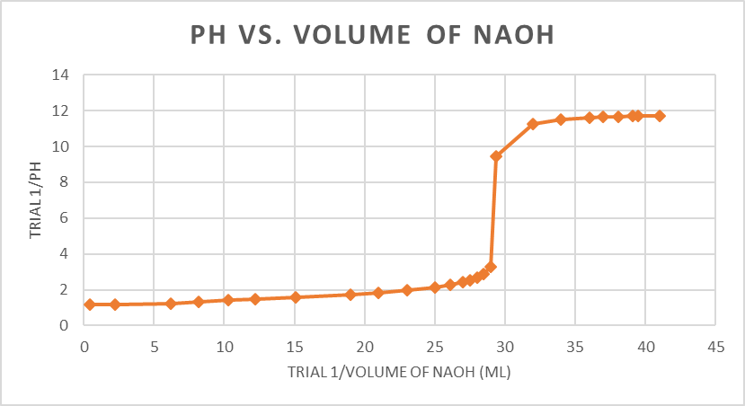

Figure1: Titration Curve of pH vs. volume of NaOH (mL) from trial 1

The volume of NaOH at equivalence point = 29.00 mL.

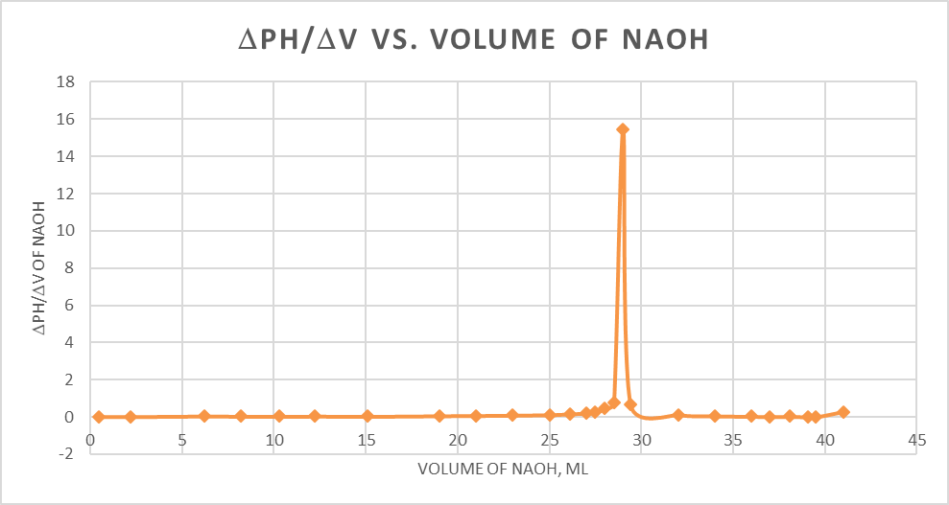

**Figure2: Equivalence point determination for acid HA using the first derivative method from trial 1**

First derivative plot:

At V=29.00 the peak of pH changing (at equivalence).

In trial 1, the volume of NaOH used was approximately 29.00 ml.

As a result, the molarity of HCl = ((Molarity of NaOH (M)* Volume of NaOH(mL))/ (Volume of HCl(mL)))

= (0.1054*29.00)/ (25.00) =0.12226 ~ 0.12223 M.

1. **For Trial 2:**

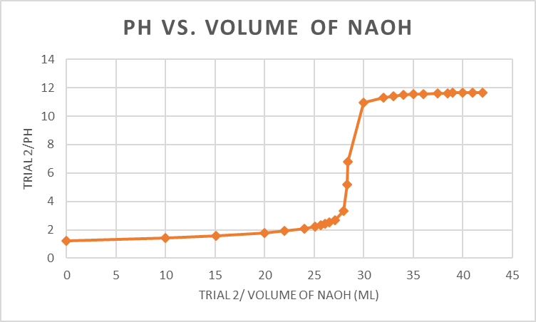

**Figure3: Titration curve of pH vs. volume of NaOH (mL) from trial 2**

The volume of NaOH at equivalence point= 28.30 mL.

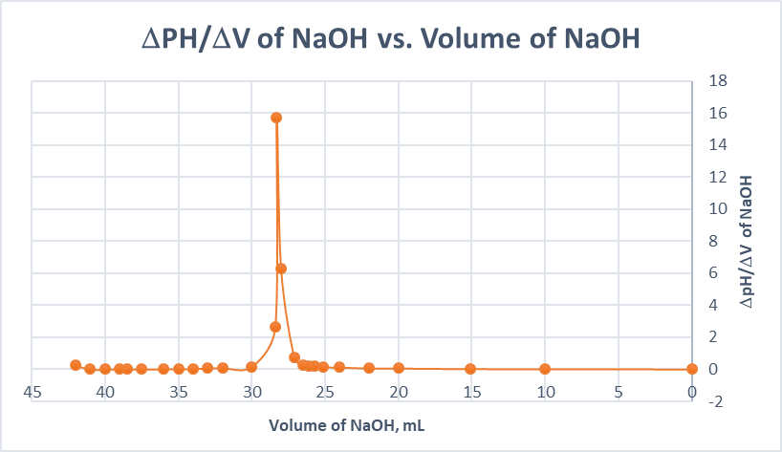

**Figure4: Equivalence point determination for acid HA using the first derivative method from trial 2**

First derivative plot:

At V=28.30 the peak of pH changing (at equivalence).

In trial 1, the volume of NaOH used was approximately 28.30 ml.

As a result, the molarity of HCl = ((Molarity of NaOH* Volume of NaOH)/ (Volume of HCl))

= (0.1054*28.30)/ (25.00) =0.1193 M.

1. For Trial 3:

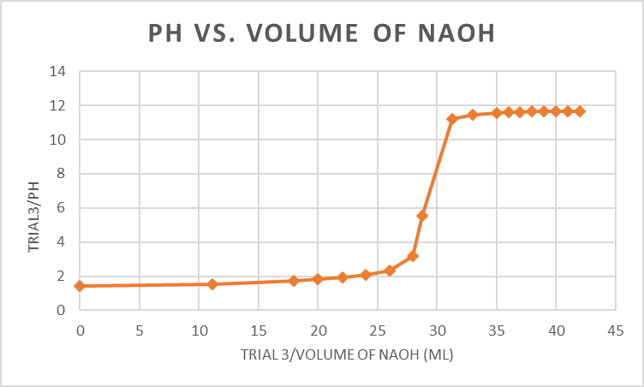  
**Figure5: Titration curve of pH vs. volume of NaOH (mL) from trial 3**

The volume of NaOH at equivalence point= 28.00 mL.

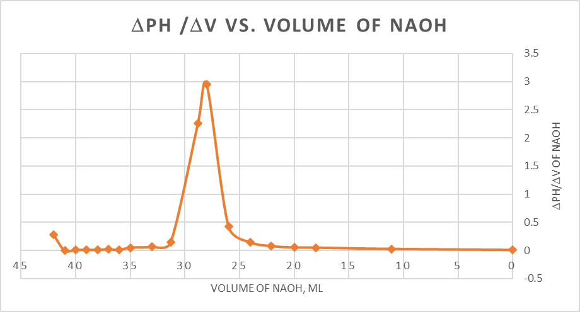

**Figure6: Equivalence point determination for acid HA using the first derivative method from trial 3**

First derivative plot:

At V=28.00 the peak of PH changing (at equivalence).

In trial 1, the volume of NaOH used was approximately 28.00 ml.

As a result, the molarity of HCl = ((Molarity of NaOH* Volume of NaOH)/ (Volume of HCl))

= (0.1054*28.00)/ (25.00) =0.1180 M.

1. **Q test & Q table**:

**Q testfor trial 1:**

= |suspension value – nearest neighbor value| / range  
= | 0.1223 – 0.1193| / (0.1223 - 0.1180)

= 0.6777 ~ **0.7**  
- The suspension value isn’t outlier because the Q table > Q test   
- **The Q table** confidence level of 95% & n = 3 = **0.97**0

1. **Average concentration of HCl Solution**:   
   = ((0.1223 + 0.1193 + 0.1180) / (3)) = 0.11986 ~ **0.1199 M**
2. **Standard deviation of HCl Molarity**   
   (s) =

* 10-3

1. **RSD %:**

**Coefficient of variation = ((s\x) * 100)**

= (1.5596 * 10-3 / 0.1199) * 100% = 1.3007 %

1. **95 % confidence interval($μ)=x\frac{±ts}{\sqrt{n}}$**  
   = 0.1199 ± ((4.303 * 1.5596 * 10-3 ) /   
   = (0.1199 ± 0.0039) %

* Discussion & Conclusion:

According to the Q-test, none of the results of the molarity of NaOH in the three trials were rejected. As a result, the HCl molarity has a mean of 0.1199 M and the Standard deviation in the HCL molarity = 1.03976 * 10-3.

The final result of 95% confidence interval for HCl = (0.1199 ± 0.0039) %, the average 0.1238 to 0.1160, so we may conclude that we have good accuracy in our experiment because this range is not excessively large.

However, some systematic errors may occur in this experiment that must be avoided, such as using an uncalibrated PH meter, not thoroughly stirring the solution while performing the titration, and not collecting enough data around the equivalence point, causing us to be unable to track the PH jump step by step, resulting in errors in drawing the calibration curve.

Random errors include the error associated with the volumetric glassware and tools used, such as: The pH meter so that it continues to read and jump and does not stop, which caused some errors, the buret and the method of reading from it.

* **Question:**

Q.2: The main flaw in this experiment is that carbon dioxide in the air works as an acid, lowering the PH of our titration system, which influences the PH measurements, especially around the equivalence point.

Q.3: Taking the first derivative plot of your data set will give you a clearer picture of where your equivalence point is. This is often done because determining your equivalence point by looking at your data is difficult, but by looking at the first derivative, the equivalence point should be where the first derivative of the data is at its maximum, indicating when the data is changing the most. Other method may suffer from drawing errors.