**13.11.2017 CHAPTER 7 Org-Chemistry -241**

**1. Which of the following structures have the correct common name?**

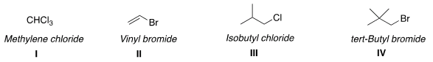

A) I and II B) II and IV **C) II and III** D) III and IV

**2. Which of the following statements about the reactions of alkyl halides is true?**

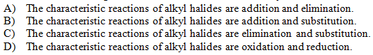

**Ans: C**

**3. Rank the following carbocations in order of decreasing stability, putting the most stable first.**

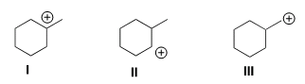

**A) I > II > III** B) II > I > III C) III > I > II D) III > II > I

**4. What is the product of the nucleophilic substitution reaction shown below?**

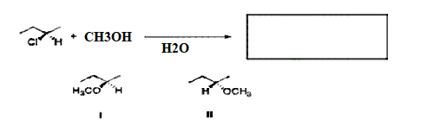

A) Only I B) Only II **C) I and II** D) None

**5. Given the following substitution reaction, what would the effect be of changing the solvent from CH3OH to (CH3)2S=O?**

CH3(CH2)5Br + NaOH → CH3(CH2)5OH + Br-

A) The rate would decrease because SN1 reactions are favored by polar protic solvents

**B) The rate would increase because SN2 reactions are favored by polar aprotic solvents.**

C) The rate would increase because SN1 reactions are favored by polar protic solvents.

D) The rate would decrease because SN2 reactions are favored by polar aprotic solvents.

**GOOD LUCK**