**13.01.2018 CHAPTERS 10 & 11 Org-Chemistry -241**

**1. What is the major product of the following reaction?**

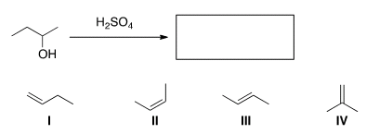

A) I B) II **C) III** D) IV

**2. Predict the product(s) of the following reaction.** 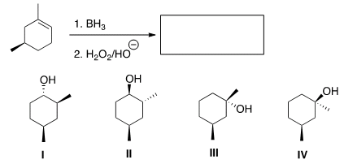

**A) Only I and II** B) Only I and III C) Only II and III D) Only III and IV

**3. In which of the following alkene addition reactions will carbocation rearrangements occur?**

A) Addition of Br2 and H2O B) Addition of Br2

C) Addition of Cl2 and H2O **D) Addition of H2O in the presence of H2SO4**

**4.** What is the best choice of reagent to accomplish the following transformation?

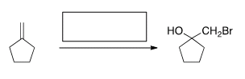

A) HBr **B) Br2, H2O** C) Br2 D) H2O2/Br2

**5. Which of the following compounds is a tautomer of 2-hexanone?**

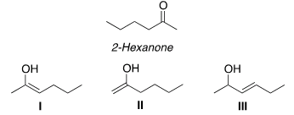

A) I B) II C) III **D) I and II** E) I and III F) II and III

**6. What is the major organic product of the following reaction?**

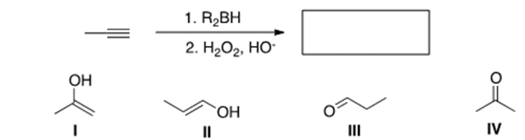

A) IB) II **C) III** D) IV

**7. What is the starting material in the following reaction?**

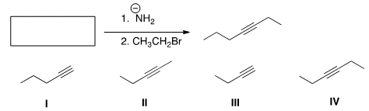

**A) I** B) II C) III D) IV

**GOOD LUCK**