**Mass spectrometry (MS)**

**Basics**

| Mass spectrometry is based on slightly different principles to the other spectroscopic methods.  The physics behind mass spectrometry is that a charged particle passing through a magnetic field is deflected along a circular path on a radius that is proportional to the mass to charge ratio, m/e.  In an **electron impact** mass spectrometer, a high energy beam of electrons is used to displace an electron from the organic molecule to form a ***radical cation***known as the ***molecular ion*.** If the molecular ion is too unstable then it can ***fragment*** to give other smaller ions.  The collection of ions is then focused into a beam and accelerated into the magnetic field and deflected along circular paths according to the masses of the ions. By adjusting the magnetic field, the ions can be focused on the detector and recorded.  Formations of ions in MS |  |
| --- | --- |

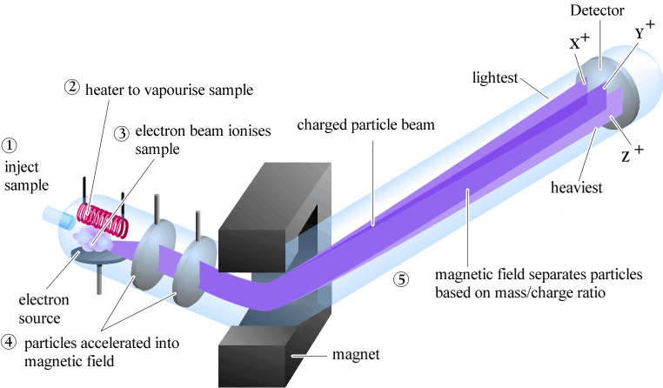

Probably the most useful information you should be able to obtain from a MS spectrum is the molecular weight of the sample.

This will often be the heaviest ion observed from the sample provided this ion is stable enough to be observed.

**Terminology**

| Molecular ion | The ion obtained by the loss of an electron from the molecule |
| --- | --- |
| Base peak | The most intense peak in the MS, assigned 100% intensity |
| M+ | Symbol often given to the molecular ion |
| Radical cation | +ve charged species with an odd number of electrons |
| Fragment ions | Lighter cations formed by the decomposition of the molecular ion.   These often correspond to stable carbcations. |

# Mass Spectroscopy: Fragmentation Patterns

**Spectra**

The MS of a typical hydrocarbon, n-decane is shown below. The molecular ion is seen as a small peak at m/z = 142.  Notice the series ions detected that correspond to fragments that differ by 14 mass units, formed by the cleaving of bonds at successive -CH2- units

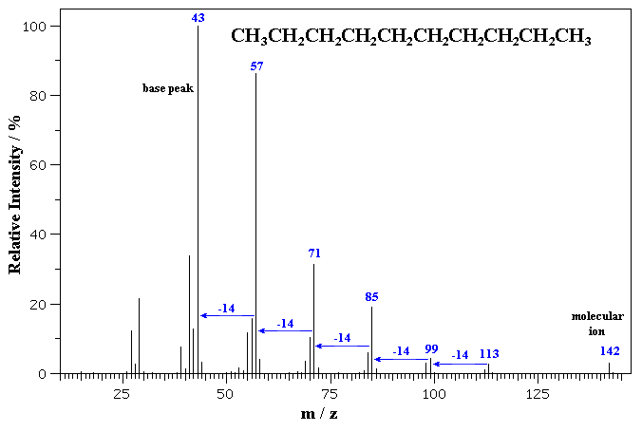

The MS of benzyl alcohol is shown below. The molecular ion is seen at m/z = 108.  Fragmentation via loss of 17 (-OH) gives a common fragment seen for alkyl benzenes at m/z = 91.  Loss of 31 (-CH2OH) from the molecular ion gives 77 corresponding to the phenyl cation. Note the small peaks at 109 and 110 which correspond to the presence of small amounts of 13C in the sample (which has about 1% natural abundance).

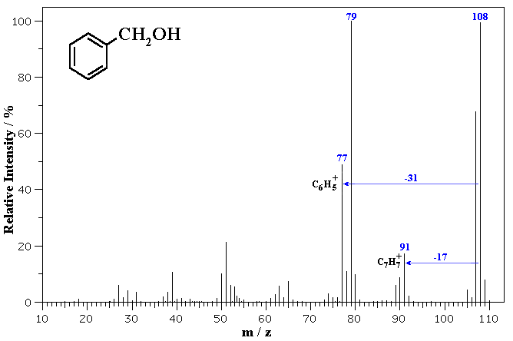

Isotope patterns

Mass spectrometers are capable of separating and detecting individual ions even those that only differ by a single atomic mass unit.

As a result molecules containing different isotopes can be distinguished.

This is most apparent when atoms such as bromine or chlorine are present (79Br : 81Br, intensity 1:1 and 35Cl : 37Cl, intensity 3:1) where peaks at "M" and "M+2" are obtained.

The intensity ratios in the isotope patterns are due to the natural abundance of the isotopes.

"M+1" peaks are seen due the presence of 13C in the sample.

The following two mass spectra show examples of haloalkanes with characteristic isotope patterns.

The first MS is of 2-chloropropane. Note the isotope pattern at 78 and 80 that represent the M and M+2 in a 3:1 ratio.   
Loss of 35Cl from 78 or 37Cl from 80 gives the base peak a m/z = 43, corresponding to the secondary propyl cation. Note that the peaks at m/z = 63 and 65 still contain Cl and therefore also show the 3:1 isotope pattern. 

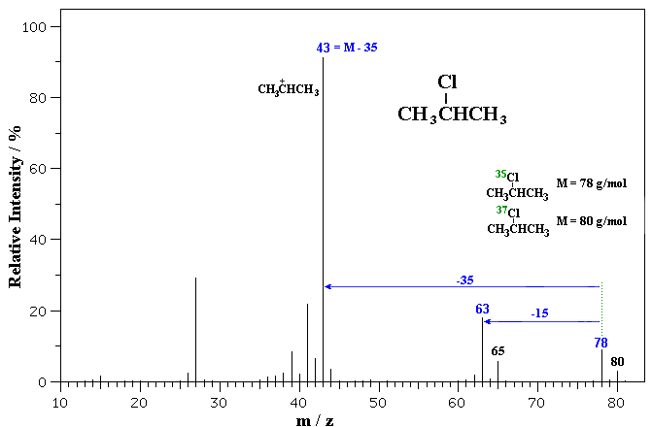

The second MS is of 1-bromopropane. Note the isotope pattern at 122 and 124 that represent the M and M+2 in a 1:1 ratio. Loss of 79Br from 122 or 81Br from 124 gives the base peak a m/z = 43, corresponding to the propyl cation. Note that other peaks, such as those at m/z = 107 and 109 still contain Br and therefore also show the 1:1 isotope pattern. 

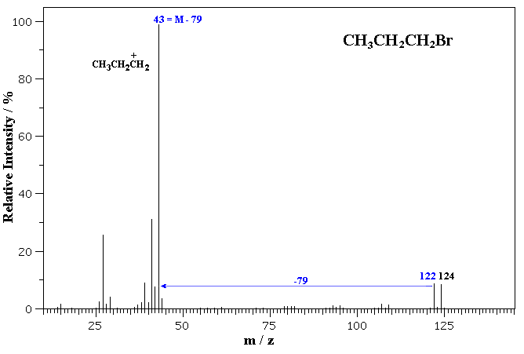

### Alcohol

An alcohol's molecular ion is small or non-existent. Cleavage of the C-C bond next to the oxygen usually occurs.  A loss of H2O may occur as in the spectra below.

3-Pentanol (C5H12O) with MW = 88.15

| http://chemwiki.ucdavis.edu/@api/deki/files/16697/alcohol.gif?size=bestfit&width=327&height=188&revision=1 | http://chemwiki.ucdavis.edu/@api/deki/files/16698/alcpic.gif?size=bestfit&width=237&height=106&revision=1 |
| --- | --- |

### Aldehyde

### Cleavage of bonds next to the carboxyl group results in the loss of hydrogen (molecular ion less 1) or the loss of CHO (molecular ion less 29).

### 3-Phenyl-2-propenal (C9H8O) with MW = 132.16

| http://chemwiki.ucdavis.edu/@api/deki/files/16699/aldehyde.gif?size=bestfit&width=323&height=188&revision=1 | http://chemwiki.ucdavis.edu/@api/deki/files/16700/aldpic.gif?size=bestfit&width=266&height=133&revision=1 |
| --- | --- |

### Alkane

Molecular ion peaks are present, possibly with low intensity.  The fragmentation pattern contains clusters of peaks 14 mass units apart (which represent loss of (CH2)nCH3).

Hexane (C6H14) with MW = 86.18

| http://chemwiki.ucdavis.edu/@api/deki/files/16701/alkane.gif?size=bestfit&width=324&height=190&revision=1 | http://chemwiki.ucdavis.edu/@api/deki/files/16702/alkpic.gif?size=bestfit&width=199&height=128&revision=1 |
| --- | --- |

### Amide

Primary amides show a base peak due to the McLafferty rearrangement.

3-Methylbutyramide (C5H11NO) with MW = 101.15

| http://chemwiki.ucdavis.edu/@api/deki/files/16703/amide.gif?size=bestfit&width=326&height=190&revision=1 | http://chemwiki.ucdavis.edu/@api/deki/files/16704/amidepic.gif?size=bestfit&width=178&height=137&revision=1 |
| --- | --- |

### Amine

Molecular ion peak is an odd number.  Alpha-cleavage dominates aliphatic amines.

n-Butylamine (C4H11N) with MW = 73.13

| http://chemwiki.ucdavis.edu/@api/deki/files/16705/amine.gif?size=bestfit&width=325&height=188&revision=1 | http://chemwiki.ucdavis.edu/@api/deki/files/16706/aminepic.gif?size=bestfit&width=188&height=82&revision=1 |
| --- | --- |

Another example is a secondary amine shown below.  Again, the molecular ion peak is an odd number.  The base peak is from the C-C cleavage adjacent to the C-N bond.

n-Methylbenzylamine (C8H11N) with MW = 121.18

| http://chemwiki.ucdavis.edu/@api/deki/files/16707/amine2.gif?size=bestfit&width=324&height=191&revision=1 | http://chemwiki.ucdavis.edu/@api/deki/files/16708/amine2pic.gif?size=bestfit&width=197&height=141&revision=1 |
| --- | --- |

### Aromatic

Molecular ion peaks are strong due to the stable structure.

Naphthalene (C10H8) with MW = 128.17

| http://chemwiki.ucdavis.edu/@api/deki/files/16709/aromatic.gif?size=bestfit&width=323&height=189&revision=1 | http://chemwiki.ucdavis.edu/@api/deki/files/16710/arompic.gif?size=bestfit&width=126&height=105&revision=1 |
| --- | --- |

### Carboxylic Acid

In short chain acids, peaks due to the loss of OH (molecular ion less 17) and COOH (molecular ion less 45) are prominent due to cleavage of bonds next to C=O.

2-Butenoic acid (C4H6O2) with MW = 86.09

| http://chemwiki.ucdavis.edu/@api/deki/files/16711/carboxylic.gif?size=bestfit&width=324&height=190&revision=1 | http://chemwiki.ucdavis.edu/@api/deki/files/16712/carbopic.gif?size=bestfit&width=157&height=133&revision=1 |
| --- | --- |

### Ester

Fragments appear due to bond cleavage next to C=O (alkoxy group loss, -OR) and hydrogen rearrangements.

Ethyl acetate (C~~4~~H8O2) with MW = 88.11

| http://chemwiki.ucdavis.edu/@api/deki/files/16713/ester.gif?size=bestfit&width=324&height=189&revision=1 | http://chemwiki.ucdavis.edu/@api/deki/files/16714/esterpic.gif?size=bestfit&width=163&height=152&revision=1 |
| --- | --- |

### Ether

Fragmentation tends to occur alpha to the oxygen atom (C-C bond next to the oxygen).

Ethyl methyl ether (C3H8O) with MW = 60.10

| http://chemwiki.ucdavis.edu/@api/deki/files/16715/ether2.gif?size=bestfit&width=326&height=193&revision=1 | http://chemwiki.ucdavis.edu/@api/deki/files/16716/ether2pic.gif?size=bestfit&width=144&height=86&revision=1 |
| --- | --- |

### Halide

The presence of chlorine or bromine atoms is usually recognizable from isotopic peaks.

1-Bromopropane (C3H7Br) with MW = 123.00

| http://chemwiki.ucdavis.edu/@api/deki/files/16719/halide.gif?size=bestfit&width=324&height=189&revision=1 | http://chemwiki.ucdavis.edu/@api/deki/files/16720/halpic.gif?size=bestfit&width=164&height=108&revision=1 |
| --- | --- |

### Ketone

Major fragmentation peaks result from cleavage of the C-C bonds adjacent to the carbonyl.

4-Heptanone (C7H14O) with MW = 114.19

| http://chemwiki.ucdavis.edu/@api/deki/files/16717/ketone.gif?size=bestfit&width=326&height=191&revision=1 | http://chemwiki.ucdavis.edu/@api/deki/files/16718/ketpic.gif?size=bestfit&width=222&height=123&revision=1 |
| --- | --- |