**11.04.2022 Chemistry -242**

**CHAPTER 15**

**Q1. Determine the product(s) of the following reactions.**

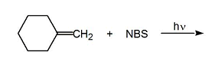

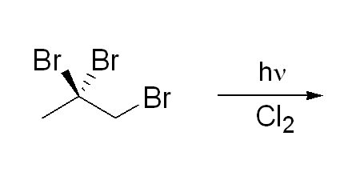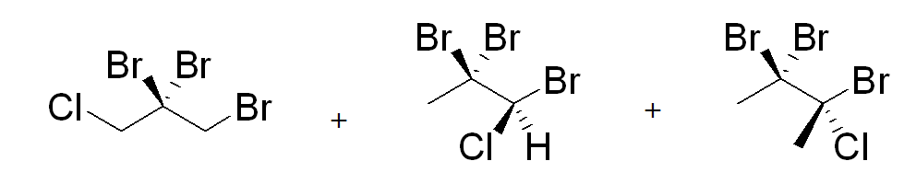

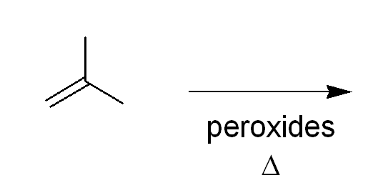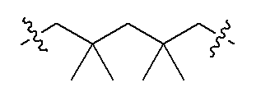

**excess**

**Q2. Arrange the following radicals in order of increasing stability:**

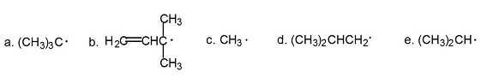 **C<d<e<a<b**

**Q3. Which of the labeled hydrogens is most readily abstracted in a free radical bromination reaction?**

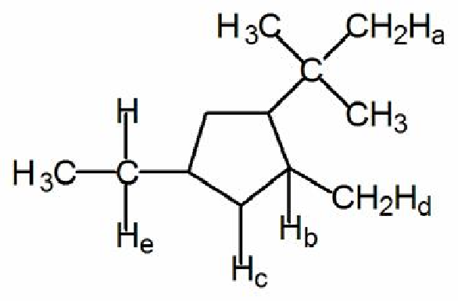

A) Ha **B) Hb** C) Hc D) Hd E) He

**Good Luck**