**21.04.2022 Chemistry 242**

**CHAPTER 16**

**Q1. Rank the following anions from most to least stable.**

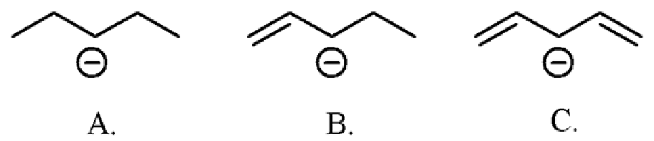

Ans: C> B> A

**Q2. Which of the following molecules is not conjugated?**

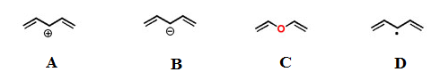

a. A b. B c. C d. D **e. none of these answers is correct**

**Q3. Rank the following in order of deceasing λmax (i.e. decrease in nm):**

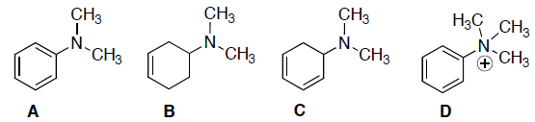

a. A>B>C>D b. D>A>B>C **c. A>D>C>B** d. B>C>D>A e. D>B>A>C

**Q4. What dienophile would react to give the product below?**

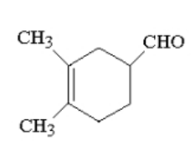

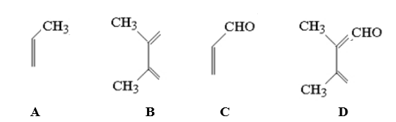

a. A b. B **c. C** d. D e. none of these answers is correct

**Good Luck**