**01.06.2022 Chemistry 242**

**CHAPTER 21**

|  |
| --- |
| **1. What is the cyclic hemiacetal product formed from intramolecular cyclization of the following hydroxy aldehyde?** |
| A) I **B) II** C) III D) IV |
| **2. What is the missing reagent in the reaction below?** |
| **A) I** B) II C) III D) IV |

**3. What is the product of the following reaction?**

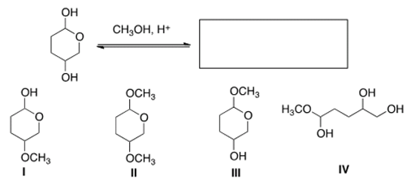

A) I B) II **C) III** D) IV

**4. Which combination of an aldehyde and an alcohol most readily forms a hemiacetal with base catalysis?**A) [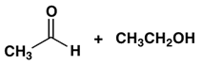](https://www.sanfoundry.com/wp-content/uploads/2018/08/organic-chemistry-questions-answers-acetals-q3a.png) B) [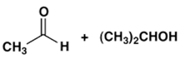](https://www.sanfoundry.com/wp-content/uploads/2018/08/organic-chemistry-questions-answers-acetals-q3b.png)   
**C)[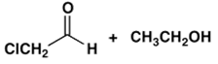](https://www.sanfoundry.com/wp-content/uploads/2018/08/organic-chemistry-questions-answers-acetals-q3c.png)** D) [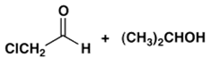](https://www.sanfoundry.com/wp-content/uploads/2018/08/organic-chemistry-questions-answers-acetals-q3d.png)

**Good Luck**