

SURVEYING LAB FOR ARCHITECTURE AND PLANNING ENGINEERING

ENCE317

Exp No.6

Measuring height of object using Stadia mehod

Group C

Hussam Abualrob 1180894

**Data :**

|  |  |  |  |  |  |  |  |
| --- | --- | --- | --- | --- | --- | --- | --- |
| **Position** | **Point** | **HCR** | **Staff Reading** | | | **ZA** | **HI** |
| **-** | **-** | **-** | **R1** | **R2** | **R3** | **-** | **-** |
| **A** | **BM** | **-** | **1.850 m** | **2.045 m** | **2.238 m** | **89**°68’04’’ | **1.60 m** |
| **A** | **B** | **0**°0’0’’ | **0.312 m** | **0.692 m** | **1.085 m** | **91**°52’19’’ | **1.60 m** |
| **-** | **C** | **54**°38’44’’ | **-** | **-** | **-** | **75**°56’49’’ | **1.60 m** |
| **B** | **C** | **0**°0’0’’ | **-** | **-** | **-** | **-** | **-** |
| **-** | **A** | **92**°34’17’’ | **-** | **-** | **-** | **-** | **-** |

**Equations :**

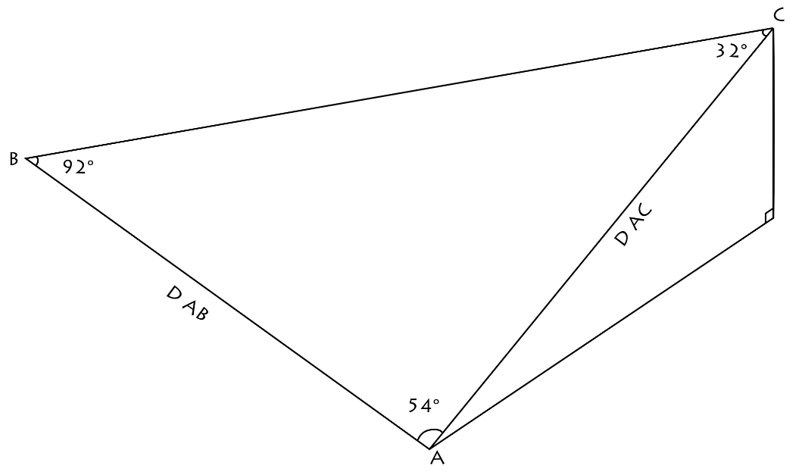

**H BM = HA + HI A + VA BM – R2 BM**

**V = (0.5) K R SIN (2 ZA)**

**D AB = K R SIN2 ZA**

**D AC \ SIN B = D AB \ SIN C**

**HC = HA + HI A + D AC / TAN ZA**

**Calculations :**

**Assuming H BM = 200, and knowing that K = 100 :**

**200 = HA + 1.60 + ( (0.5) (100) (2.238 – 1.850) (sin 178.268) ) – 2.238**

**HA = 200.052 m**

**D AB = (100) (0.388) (sin2 91.87194)**

**D AB = 38.75 m**

**D AC \ sin 92.57139 = 38.75 \ sin 32.78305**

**D AC = 71.49 m**

**HC = 200.052 + 1.60 + (71.49 / tan 75.94694)**

**HC = 219.54 = 19.54 m**