**Table of content:**

**Introduction ………………………………………………..2**

**Instrument …………………………………………………3**

**Procedures ………………………………………………….3**

**Data and Calculation ………………………………………4**

**Conclusion ………………………………………………….4**

**Literature citations ………………………………………..**

**1-introduction:**

As we know, concrete is one of the most important material these days. Concrete is any combination of four basic materials which are : cement, fine aggregate, coarse aggregate and water . It’s very important to assess the concrete after it hardened does it do it’s job or no, we have many tests applied on hardened concrete which can be divided into two main groups :

1. Destructive tests 2. Non-destructive tests.

In this experiment we concern destructive test (core test ).

The Core samples test **:** A test applied to hardened concrete to check many properties of hardened concrete such: the compression test, the tensile one, density and absorption so and so. The location of core depends on many factors from the aim of the core to the aesthetic considerations, it’s good to mention that the diameter of the core must be at least three times larger than the nominal maximum aggregate size. The results of the core could be influenced by two main things**:**

**a.** Concrete characteristics: the strength in the core would be 10-15% lower than the dry one also existing of void would also reduce the measured strength.

**b.** Testing variables: There are many variables would change the core result such:

(i) Length / diameter ratio of core.

(ii) Diameter of core.

(iii) Direction of drilling.

(iv) Method of capping.

(v) Reinforcement.

These previous tests have a considerable sense to engineering since they provide an ability to check if the concrete does it’s job or no and to check the whole situation of the concrete which can detect any problem before continue construction in our structure and also to check the validity of an old structure.

So we correct the error by this formula:

Estimated cube Compressive strength =1.25* corrected compressive strength (cylinder)

**2-Instuments:**

2. 1.

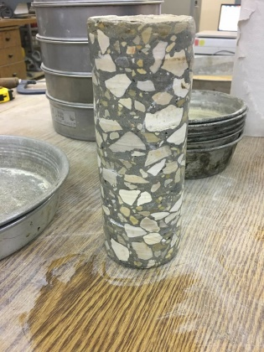 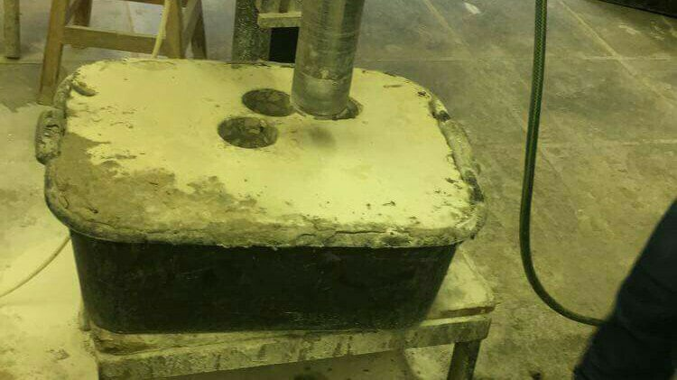

Fig(1): Fig(2):

3.

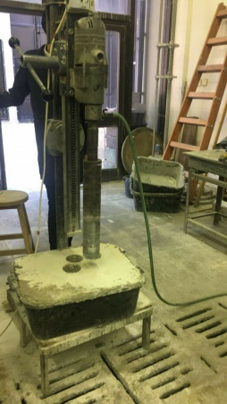

Fig(3):

**3-Procedure:**

1. The beam was inserted below the drill so that the region in which the cut will be made was directly under the drill’s cutting cylinder.

2. The drill was turned on and the water valve was opened so that water cooled and lubricated the cutter as it cut through the sample and the pressure must be constant .

3- We obtain a cylindrical specimen which may contain embedded reinforcement, and which will be removed by the insertion of a cold chisel down the side of the core, once a sufficient depth has been drilled.

4. The sample was submerged in water for 7 days.

5. The sample weight in air (saturated surface dry), and its submerged weight were measured.

7. The sample dimensions were measured with a caliper and the sample faces were rammed.

8. The sample was crushed and its strength was recorded.

**4-Data and Calculation:**

Data of Specimen

|  |  |
| --- | --- |
| Location of casting | Basement |
| Weight in air (Kg) | 1445 |
| Weight in water (Kg) | 830 |
| Volume | 615 |
| Density |  |
| Length of SP | 146 |
| Diameter (mm) | 73.5 |
| Area | 4240.76 |
| Excess void age ratio | 1.5% |
| Max. size of voids (mm) | 4.5 |
| Max size of aggregate (mm) | ​​32.7 |
| Load | 77.7 KN |
| Strength | 18.32MPa |
| Cylinder strength | 18MPa |
| Cube strength | 22.8MPa |

*Note that allowable thickness of sulpher is less than 10 mm, which is acceptable*

**5-The result:**

In this experiment if the strength sample gives 85%from required strength or more then the concrete is success. The examination and compression testing of cores cut from hardened concrete is a well - established method, enabling visual inspection of the interior regions of a member to be coupled with strength estimation. The core test is a very reliable test for determining the strength of hardened concrete. The standard cylinder has a ratio of length: diameter equals 2:1, the lower this ratio for the taken sample, the higher the strength, and thus the strength of lower ratios is multiplied by a factor lower than one and the strength of higher ratios is multiplied by a factor higher than one determined from tables. The reason for this is that higher L/D ratios make samples less stable and increases the possibility of buckling (such as 2:1 ratio). The diameter of the cylinder should be at least 3 times the maximum aggregate size, the larger the sample, the more accurate the results would be.