Table of content:

Introduction ………………………………………………..2
Instrument …………………………………………………4
Procedures ………………………………………………….5
Data and Calculation ………………………………………6
Conclusion ………………………………………………….7
Literature citations ………………………………………..8

1.Introduction:
Background Information
Withstanding heavy traffic loading under changing climatic conditions when designing asphalt mixes for paving jobs is the main concern for engineers. Thus, a study of the mixtures’ constituents is important since the mixtures’ quality is majorly affected by the type and grading of the aggregates used as well as the type of the bituminous material. As a result, a test called Marshall Method was developed. This test seeks to select the asphalt binder content at a desired density that satisfies minimum stability and range of flow values. Conversely, the test is applicable to hot mix designs having a maximum aggregate size of 25mm and attempts to get the optimum binder content for the aggregate mix type and traffic intensity. This is the test which helps us to draw Marshall Stability vs. % bitumen graph.
Furthermore, the stability of the mix is defined as “the maximum load carried by a compacted cylindrical specimen at a standard test temperature of 60 ͦ C.” ( The Constructor,2013). This value reflects the strength of the asphalt mix and the temperature at which this test is performed refers to the weakest condition of a bituminous pavement under compressive loads. Also, during the loading, an attached dial gauge measures the specimen's plastic flow (deformation) due to the loading and is recognized as the Marshall flow test which reflects the flexibility of the mix and is measured as “the deformation in units of 0.25 mm between no load and maximum load carried by the specimen during stability test.” (The Constructor,2013).
**$Stability \left(corrected\right)=Dial gauge reading ×25.45$ .
**$Flow \left( corrected\right)= flow gauge reading ×0.001×25.4$ .
Consequently, the volumetric properties of the mixture are used in the density- void analysis. This analysis helps in designing the mix, which determines the volume of bitumen binder and aggregates necessary to produce a mixture with the specific properties such as the theoretical maximum density, the bulk specific density of the mix, percentage of air voids, and percentage volume of bitumen, percentage void of aggregate and percentage voids filled with bitumen.
It is worth mentioning that the Percentage of air voids in the asphalt mixture is very crucial in the mixtures’ durability, stability and permeability. This percentage is defined as “the total volume occupied by air in the compacted paving mixture” (Highway,2010).
**Percentage of air voids (V_{m}):V_{m} = $\frac{theoritical density-actual density}{theoritical density}$ X100%.
**Where, the theoretical density = $\frac{100}{\frac{100-bitumen percentage}{2.779}+\frac{bitumen percentage}{1.02}}$ .
**And the actual density =$\frac{weight in air}{volume}$.
Moreover, the percentage of aggregate voids (V_{a}) is “ the total volume of voids in the aggregate mix (when there is no bitumen)” ( Highway,2010). When the percentage of aggregate voids is too low there will be no enough room for adding sufficient bitumen binder to coat aggregates properly. Thus, the mixture will be too sensitive to small changes of binder content. On the contrary, excessive aggregate void percentage causes low mixture stability. Moreover, this quantity represents the volume of the effective bitumen content.
**Aggregate void percentage ( V_{a} ) = V_{m} + $\frac{bitumen percentage×actual density}{1.02}$.
The filled void percentage (V_{f} ) is inversely related to air voids; as air voids decreases, the percentage of filled voids increases.
**Filled voids percentage (V_{f}) = $\frac{bitumen persentage×actual density}{1.02×aggregate voids}$.

2.Instruments :

2- Oven  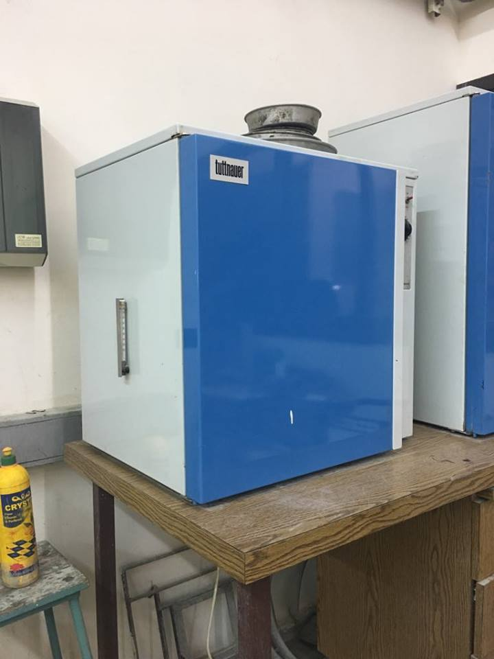 | - Sample of hot bitumen  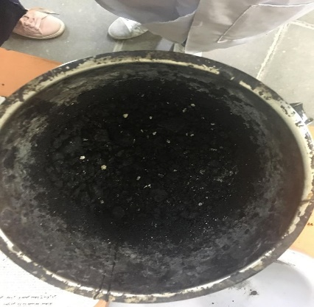
4- Laboratory Bench Mixer  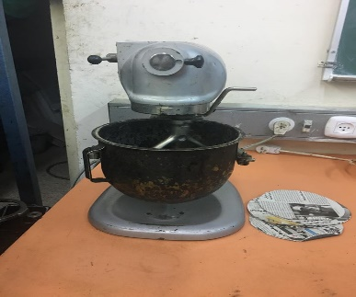 | 3- Balance  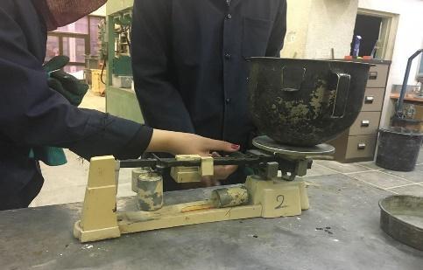
6- Molds  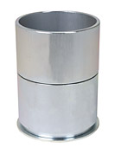 | 5- Finger Guard and Paper Disks  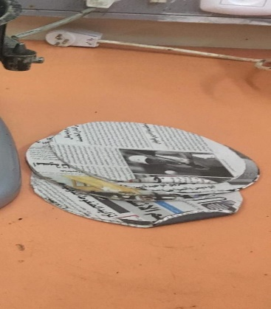.
7- Hand Compaction Hammer

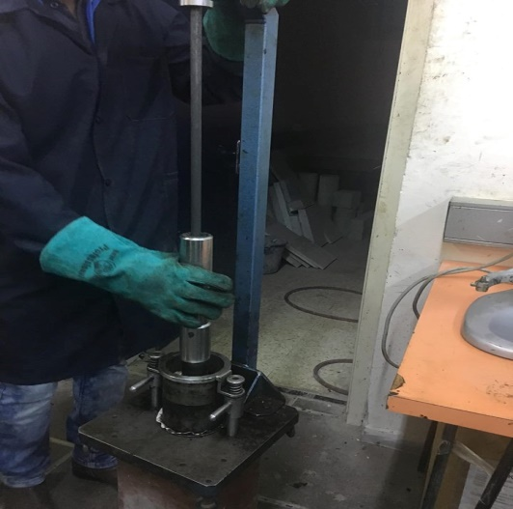

3.Procedure :-
1.Three samples of coarse aggregate, fine aggregate and the filler material were proportioned so to fulfill the requirements of the relevant standards.
2.The 1128 gr of aggregate proportions were blended and dried in oven at a temperature of 110C.
3.The compaction would assembly and rammer were cleaned and kept pre-heated to a temperature of 100C to 145C.
4.A 6% of the aggregate weight was calculated, and the result was used as bitumen weight; the bitumen was heated to at temperature of 121C to 138C and added to the hot aggregate mixture.
5.After that the bitumen was added to the aggregate mixture, the sample was mixed using blinder machine.
6.Then the sample was mixed again by heated mixing hand; to make sure that the bitumen covers the whole sample.
7.The mixture was placed in the marshal apparatus in an oiled mould and a piece of filter paper was fitted in the bottom of the mould, and then a 75 times free fallings was made from top to bottom.
8.The mold was inverted again and another 75 times of free falling were made on the other side of the sample.
9.With collar on the bottom, the base was removed and the sample was extracted to push it out the extractor.
10.The same procedure was repeated on the other two samples.
11.Then the three samples were put oven.
12. The specimen is measured and weighed in air and water (for volume determination).
13. The specimen is then marked and stored for stability and flow measurements.
4. Data & Calculation:
Table (1) below shows the data collected to determine stability and flow of asphaltic mix.
Table (1): Data collected for Stability and Flow
Specimen # | 1 | 2 | 3
Binder % | 6 | 6 | 6
Height  (mm) | 70.5 | 70.7 | 67.5
Mass in air W  (gm) | 8989.1 | 1200.5 | 15  6.2
Mass in water Ww  (gm) | 680 | 675 | 635
Volume (B)  (ml) | 509.9 | 525.5 | 521.2
Actual Density (SM)  (gm/ml) | 2.33 | 2.2 8 | 2.22
Theoritical Density (STH) (gm/ml) | 2.5 | 2. 5 | 2.5
Total mix voids (Vm )% | 6.8 | 8.8 | 11.2
Aggregates voids (Va )% | 20.64 | 22.34 | 24.38
Filled with bitumen (Vl )% | 67.06 | 60.63 | 54.1
Compacted asphalt density (SA) (gm/cm3) | 2.19 | 2.14 | 2.08
Dial gauge reading  (S) | 509 | 298 | 364
Converted N | 25.45 | 25.45 | 25.45
Corrected(N) | 12959.05 | 7584.1 | 9263.8
Dial gauge reading(F) | 150 | 164 | 160

Sample Calculation
Chosen Sample: Specimen No.1
• Volume (B) = W – Ww = 509.9
• Actual Density (SM) 2.33
• Theoretical Density (STH) = 100/ ( (94/2.779)+(6/1.02))= 2.5
• Total mix voids% (Vm) = ((STH-SM) /STM ) = 6.8%
• Aggregates voids% (Va) 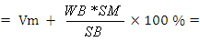 20.64%
• Voids with bitumen% (Vl) 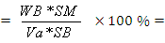 67.06
• Compacted Asphalt Density =2.33*((100-WB)/100)= 2.19
• Corrected stability = converted gauge reading
• Corrected reading for the 1st gauge = 25.45 509= 12959.05N.
• Corrected reading for the 2nd gauge = 0.002 150 = 0.3mm.

5. Conclusion:
To judge the way Marshall asphalt concrete mixtures must be prepared 3 specimens for each percentage of bitumen is made and determine the appropriate rate of bitumen between these mixtures in terms of density, stability, and flow and the proportion of the blanks.
From the results obtained from the experiment it found that the density of the mixture is less than the limits of the density according to international standards are up to 2.35 g / cm³, and the results between (2.25-2.27) g / cm³.
The void ratio is acceptable also, because in asphalt mixtures void ratio shouldn’t be high because it if the percentage of spaces was few, it will lead to the withdrawal of bitumen to the surface by the pressure and expansion of the heat. In terms of stability, the stability of the mixture is reasonable because the standard refers to the percentage stability up to 9100 Newton and the results is 12959.05 Newton.

6. References :
1. "Pervious Concrete and Freeze-Thaw". Concrete Technology E-Newsletter. PCA.
Retrieved 30 September2012.
2. Concrete technology (A.M. NEVILLE, J.J. BROOKS; second edition).
3. IS: 4031(Part 4):1988-Methods of physical tests for hydraulic cement.
4. M.S. Mamlouk and J.P. Zaniewski, 1999, Materials for Civil and Construction
Engineers, Addison-Wesley, Menlo Park CA, 231.

