**Table of content:**

**Introduction ……………………………………………..…..2**

**Instrument ………………………………………………..…4**

**Procedures ……………………………………………….….6**

**Data and Calculation ………………………………….……8**

**Conclusion ………………………………………………….10**

**Reference …………………………………………………..12**

**1-Introduction**:

Asphalts mixture of  aggregates and a black binder which is also known as bitumen. is a sticky, black and highly viscous liquid or semi-solid form of petroleum. It may be found in natural deposits or may be a refined product; it is a substance classed as a pitch.

The primary use of asphalt is in road construction, where bitumen is used as the glue or binder that holds the aggregate particles to create asphalt concrete bitumen’s other main use is for bituminous isolating waterproofing products and for sealing flat roofs.

Part A: Penetration test:

Based on this famous test of bitumen the asphalt is classified into different categories which represent the consistency of the sample. Determining the penetration value of bitumen is widely needed in diverse construction sectors. For this, a molten sample of bitumen in firstly poured into a standard mold, which is allowed to be cooled at room temperature. This is placed in a water bath for allowing the specimen to be at an exact temperature before mounting it in the testing machine.

Penetration value is: a measure of hardness or consistency of bituminous material. It is the vertical distance traversed or penetrated by the point of a standard needle into the bituminous material under specific conditions of load, time and temperature. This distance is measured in parts of millimeters. This test is used for evaluating consistency of bitumen. It is not regarded as suitable for use in connection with the testing of road tar because of the high surface tension exhibited by these materials.

Part B: Flash point and fire point.

This test is done to determine the flash point and the fire point of asphaltic bitumen and fluxed native asphalt, cutback bitumen and blown type bitumen as per IS: 1209 – 1978. The principle behind this test is given below:

Flash point: The flash point of a material is the lowest temperature at which the application of test flame causes the vapors from the material to momentarily catch fire in the form of a flash under specified conditions of the test and never sustain fire.

Fire Point: The fire point is the lowest temperature at which the application of test flame causes the material to ignite and burn at least for 5 seconds under specified conditions of the test.

Part C: Ductility test

Ductility is one of the important properties of bitumen, which controls the workability of bitumen and its suitability with the place it will be used in, such as in cold areas the ductility will be higher than the hot areas.

Ductility is the property of bitumen that allows it to undergo great deformation or elongation. Ductility is defined as the distance in cm, which a standard sample of the material will be elongated without breaking. The bitumen sample is heated and poured in the mould assembly placed on a plate. These samples with moulds are cooled in the air and then they were submerged in water bath at 25c temperature. Then the mould with assembly containing sample is kept in water bath of the ductility machine for about 90 minutes. The sides of the moulds are removed, the clips are hooked on the machine and the machine is operated. The distance up to the point of breaking of thread is the ductility value which is reported in cm. The ductility value gets affected by factors such as pouring temperature, test temperature and rate of pulling

Part D: Viscosity test

To calculate the actual percentage of bitumen in the mixture we must make a separation between aggregates and bitumen, and first we must disconnect the ponds in the mixture by adding the gasoline which react with it and destroyed the ponds between molecules then we but the bituminous mixture in the Centrifuge machine which make the wanted separation.

Purpose:

1.To determine the bitumen's resistance to penetration.

2. To determine the consistency of a bituminous material. and to know the tendency of the sample to form a flammable mixture with air under controlled laboratory conditions.

3.Tocalculate the viscosity of the bitumen.

**2- Instruments:**

1.Bitumen water bath.

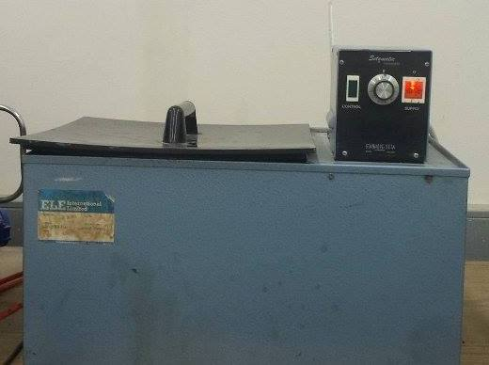

     Fig 1: Bitumen water bath

2. Penetration device.

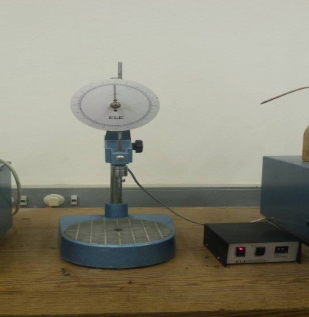  
Fig 2: Penetration device

3. Bitumen samples.

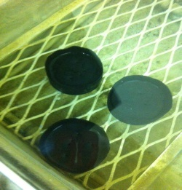

 Fig 3: Bitumen samples.

4. Heat plate.

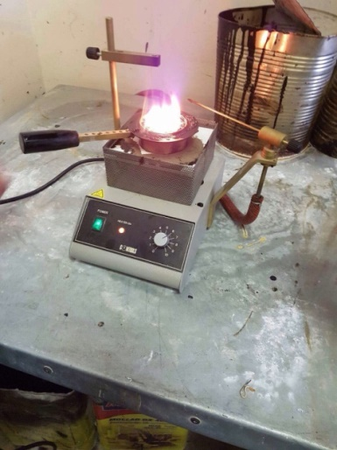  
        Fig 4: Heat plate.

5. Thermometer.  
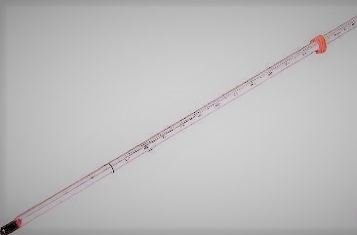

       Fig 5: Thermometer.

6.ductlity machine

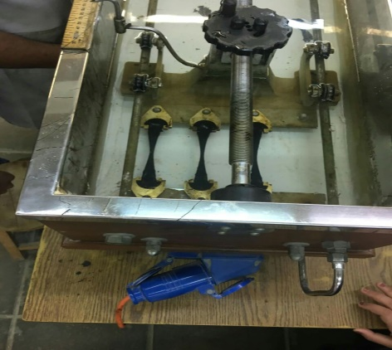

Fig 6: ductility machine

**3-procedure:**

**For ductility test**:

1) The bitumen sample was heated and poured in the mould assembly placed on a plate. These samples with moulds were cooled in the air and then in water bath at 27o C temperature.

2) The excess bitumen was cut and the surface was leveled using a hot knife.

3) The mould with assembly containing sample was kept in water bath of the ductility machine for about 90 minutes.

4) The sides of the moulds were removed, the clips were hooked on the machine and the machine was operated.

5) The distance up to the point of breaking of thread was the ductility value which was reported in cm.

**For Centrifuge Extraction Test:-**

1) A sample of asphalt was taken and we determine its weight.

2) The sample of asphalt was placed in the centrifuge extractor. Then we covered the sample with benzene, and the filter paper was put on it with the cover plate tightly fitted on the bowl.

3) The centrifuge extractor was started, revolving slowly and the speed was gradually increased until the solvent ceases flow from the outlet.

4) The centrifuge extractor was stopped. Benzene was added again and the procedure was repeated.

5) The procedure was repeated so that the extract was clear and not darker than the light straw color and the volume of total extract in the graduated vessel was recorded.

6) The filter paper was removed from the bowl and the sample dried in the oven at 110 + 5oC.

7) After 24hours, the weight of the extracted sample was taken.

**For Penetration test:**

1- A sample was taken from the container and tested by a standard needle of a total load of 100 g that was applied until it made contact with the surface of the bitumen sample at a temperature of 25 Cofor 5 seconds.

2- The indicator was on (0) on the gradual disk of machine.

3- The machine was run, the needle penetrated a distance of the sample.

4- After the machine automatically stopped, the penetration percentage (distance of penetration) was reported from the gradual disk.

5- The previous procedure was repeated for several times on the other two samples.

**Flash point and fire point.**

A) Flash point:

1. Bitumen was softened between 75 and 100 ° C. To remove air bubbles and water.

2. The cup is filled with the material to be tested until the packing mark. Put on the bathroom. The open section was repaired. Then the thermometer was inserted and moved by the instigator.

3. The flame test was lit and adjusted. And provided with heat bearing not to exceed 5 ° C or more than 6 ° C per minute. By a thermometer about 5 ° C or more than 6 ° C per minute.

4. The open flash point is taken as the temperature when the flash first appears at any point on the surface of the material in the cup. Be aware that the bluish halo that sometimes surrounds the test torch is not confused with the real flash. Stop stirring while applying the test

flame.

5. The flash point should be taken as the read temperature on the thermometer at the time the flash occurs.

B) Fire Point:

1. After the flash point, the heating shall continue at such a rate that the temperature recorded by the thermometer shall not be less than 5 ° C and not more than 6 ° C per minute.

2. The torch must be lit test and adjusted so that the bead size is 4mm in Dia.

**4- Data and Calculations:** above 75

Part A: Penetration test:

Table (1): Data of Penetration test

|  |  |  |  |  |  |
| --- | --- | --- | --- | --- | --- |
| Sample No. | Penetration values (mm) | | | | Average (mm) |
|  | 1 | 2 | 3 | 4 |  |
| 1 | 3.9 | 4.6 | 3.0 | - | 3.83 |
| 2 | 2.3 | 3.5 | 3.5 | 2.9 | 3.05 |
| 3 | 2.0 | 3.0 | 1.6 | - | 2.20 |

Part B: Ductility test:

Table (2): Data of Ductility test

|  |  |
| --- | --- |
| Sample No. | Distance  (mm) |
| 1 | above 75 |

Part C: Viscosity test:

Table (3): Data of Viscosity test

|  |  |  |
| --- | --- | --- |
| Trial No. | Time needed to fill the flask (sec) | Viscosity  (mm2/sec) |
| 1 | 87 |  |
| 2 | 117 |  |

Temperature = 81°C

Sample Calculation

Chosen Sample 1:

=Ct+ 

C1(constant)=0.222mm2/sec2

C2(conctant)=-182.528mm2

v =0.222 (87) +  =17.21mm2/sec

Average viscosity = mm2\sec

Part D: Flash point and Fire point tests:

Temperature of bitumen at the flash point (Co) =294°

Temperature of bitumen at the fire point (Co) =300°

**5-Results and conclusions:**

* Penetration test

The needle penetrated the three samples about 2.95, 2.4 and 3.5 mm respectively from the surface of the sample. This result indicates that the three bitumen samples are solid, since the penetration did not exceed 8 mm.

Penetration test is a commonly adopted test on bitumen to grade the material in terms of its hardness. Grading of bitumen helps to assess its suitability in different climatic conditions and types of construction. It is clear that in warmer regions, lower penetration grades are preferred to avoid any softening whereas higher penetration grades are used in colder regions to prevent the occurrence of any excessive brittleness.

The penetration test is used also as a measure of consistency. Higher values of penetration indicate softer consistency. Whereas lower values of penetration indicate harder consistency. The result obtained from this test concludes that the sample of bitumen has high consistency due to the low value of penetration.

While experimenting, there were some errors that may have an effect on the result. For example, the surface of bitumen sample was not seen because it was under water; therefore it was difficult to set the needle exactly on the top surface of the sample. Another source of error is that the procedure of this experiment was done by different students with different skills.

* Viscosity test

The result obtained for this test was 22.3 mm2/sec. The value of viscosity of bitumen obtained experimentally is far from the theoretical value (around 43 mm2/sec) that is stated in the standard table in the manual within the experimental errors.

The viscosity test measures the viscosity of asphalt. The viscosity test and the penetration test both measure the consistency of asphalt at some specified temperatures and are used to designate grades of asphalts. The advantage of using the viscosity test as compared with the penetration test is that the viscosity test measures a fundamental physical property rather than an empirical value.

Knowing the viscosity of bitumen can give an idea about the penetration value of the bitumen. Penetration grading basic assumptions is that the less viscous the asphalt, the deeper the needle will penetrate.  This penetration depth is empirically correlated with asphalt binder performance.

The mixing temperature of bitumen is vital to determine the well mixing of the bitumen with the aggregate. Temperature affects the viscosity of bitumen, low temperature will result in bitumen with high viscosity which unable to mix well with aggregate to provide sufficient bonding between those two materials, which in the end affects the quality of the road surface layer laid with the material. So Viscosity is inversely proportional with temperature.

* Ductility

The previous samples are consistent and show an accepted ductile behavior of the bituminous sample, which indicates that the samples have passed because none of them have exceeded the maximum of 1000mm; over ductile bituminous samples tend to make the asphaltic mix flexible, more vulnerable to deformations and thus unstable for pavement structures or any other application of asphalt which requires stability. Misreading the length of the elongated bitumen sample may be a source of error

* Flash and Fire Points

Temperature of bitumen at the flash point (Co) =294 Celsius

Temperature of bitumen at the fire point (Co) =300 Celsius

This indicates the temperatures at which the bitumen is no longer usable and dangerous in order to avoid ever reaching such temperatures. Errors in this test might have happened due to slow or fast reading of the temperature of the thermometer.

**6-References:**

* Mustafa Abedmosa, 2009, Construction Materials Laboratory.