**Table of content**

**Introduction …………………………………………………………..2**

**Instruments …………………………………………………………...2**

**Procedure ……………………………………………………………..4**

**Data and calculation ………………………………………………….5**

**Result and conclusion ………………………………………………... 6**

**Literature citation …………………………………………………… 7**

**1- Introduction:**

Aggregate is one of important materials that use in preparing concrete for building construction, also used in roads (base coarse). So it is very important to know, how the aggregate behave under the pressure agents and abrasion in order to provide the safety for the structure for a long time.

Los Angeles abrasion test on aggregates is the measure of aggregate toughness and abrasion resistance. The standard los angeles abrasion test subjects a coarse aggregate sample (retained on the No. 12 sieve) to abrasion in a los angeles machine grinding a rotating steel drum containing a specified number of steel spheres(11 balls of steel) .After being subjected to the rotating drum, the weight of aggregate that is retained on a No.12 sieve is subtracted from the original weight to obtain a percentage of the total aggregate weight that has broken down and passed through the No. 12sieve.

The percentage of abrasion of the aggregate can be calculated by:

$Percentage of abrasion=\frac{Original weight 0f aggregate - weight of aggregate remaining on sieve \#12 }{Original weight 0f aggregate} ×100\%$

**Purpose**:

The Los Angeles abrasion test on aggregates are done for following purposes:

1. To determine the Los Angeles abrasion percentage.
2. To find the suitability of aggregates for use in road construction and other uses of it .

**2- Instruments:**

Los Angeles machine

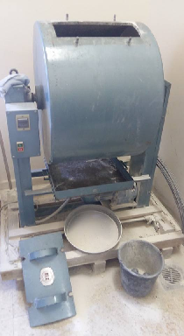

Fig (1) : los Angeles Machine

A mechanical shaker.

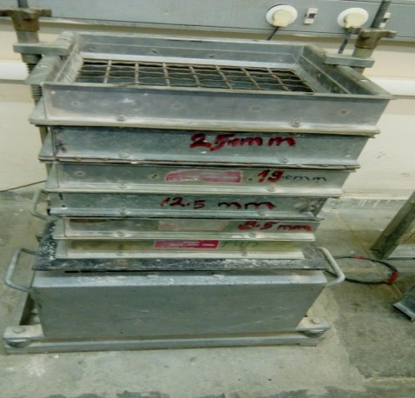

Fig(2) :mechanical shaker

Sieve #12.

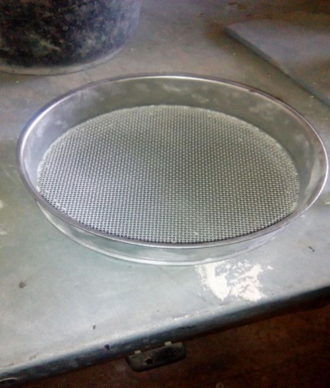

Fig (3) : Sieve #12

Eleven steel spheres.

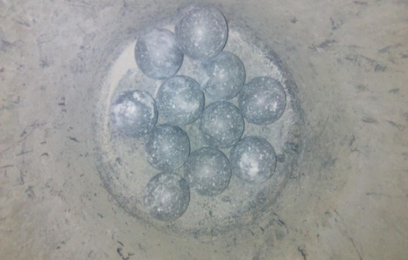

Fig (4) : 11 steel spheres

Digital Balance.

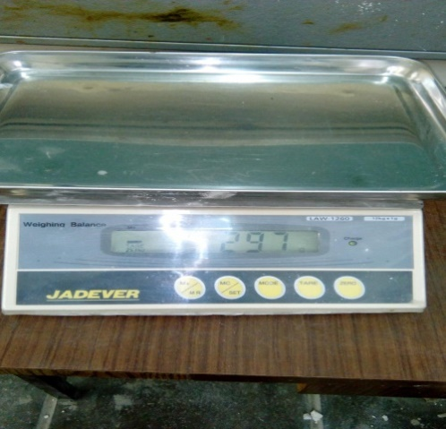  Fig (5) : Digital Balance

Sample of Aggregate.

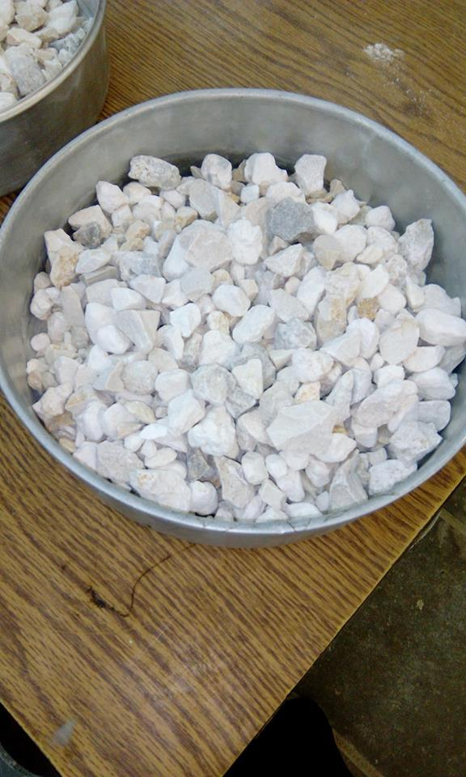

Fig (5) : sample of Aggregate

**3- Procedures:**

Los Angeles is the most important experiment to determine toughness and abrasion characteristics for aggregate ,it is important because the aggregate must resist crushing degradation and disintegration .

1. The coarse aggregate Was segregated by A mechanical shaker .
2. Two and a half kg from aggregate was taken from the size 9.5 mm and 2.5 kg from 12.5 mm .
3. But the both size but in the Los Angeles Machine with 11 steel sphere and rotate the machine for 15 min .
4. After that the mixture ( coarse and fine aggregate ) was taken and sieved it by 12 mm sieve .
5. Then the Remaining aggregate was taken and Weighted .
6. The percentage calculated by Divide the difference between the original weight and remaining weight on the sieve on the original weight ((Woriginal –Wnew) / Woriginal) *100% .

Then you can notice the percentage if it more than 40% that’s main this aggregate is able to Smoothing because of that you cannot use it in the road and Airports because the Friction is the main aim to building it .

**4- Data and calculation:**

The mass of retained aggregates on the two sieves :

|  |  |
| --- | --- |
| **Sieve size  (mm)** | **Retained mass  ( gram)** |
| 12.5 | 2500 |
| 9.5 | 2500 |

* Total mass = 5000 gram
* Number of balls = 11
* Retained mass on sieve number 12 (1.7 mm ) = 3120 gram
* The number of rotations on Los Angeles are about 500 revolution  
   (rotates for 15 minutes at 33 rpm)

|  |
| --- |
| Original mass – retained mass on sieve #12 |
| Original mass |

Percentage of abrasion = * 100%

|  |
| --- |
| 5000- 3120 |
| 5000 |

* 100% = 37.6 %

**5- Result and conclusion:**

The percentage of abrasion that founded in this experiment is ( 37.6%) , and it is accepted according to the American properties because it doesn’t exceed the higher ratio (45%). Errors may be occurred during doing the experiment such as loss of an amount of the sample during sieving or during using Los Angeles machine .

**6- Literature citations:**

**Reference used:**

**https://ar.scribd.com/doc/86556617/Los-Angeles-Abrasion-Test**