Table of content:

Introduction ……………………………………………..2
Instrument ………………………………………………3
Procedures ……………………………………………….4
Data and Calculation ……………………………………4
Result and Conclusion ………………………………….5
Referances ……………………………………………....6

1-Introduction:
Mortar is a workable paste used to bind building blocks such as stones, bricks, and concrete masonry units together, fill and seal the irregular gaps between them, and sometimes add decorative colors or patterns in masonry walls.
Cement mortar becomes hard when it cures, resulting in a rigid aggregate structure; however the mortar is intended to be weaker than the building blocks and the sacrificial element in the masonry, because the mortar is easier and less expensive to repair than the building blocks. Mortars are typically made from a mixture of sand, a binder, and water.
“In order to use cement as a building material it’s important to make several tests on it, the most important tests are the compressive and tensile strength test, which determine the workability of the cement as a linking material and how much the mixture is hard and strong to resist the erosion and destructive forces like earthquake.
* Compressive Strength
Compressive strength of cement indicates the compressive strength of cement mortar cubes of 1:3 proportion, using standard sand as specified by IS: 650 as fine aggregate, tested under compression (Grade of cement indicates their compressive strength at the end of 28 days of curing). Many other properties of mortar concrete are related to compressive strength of cement, because cement is used in structure in the form of mortar or concrete.
*purpose
The aim of the experiment is to test the pressure resistance of cement, where this identifies to us the extent of resistance of cement for different loads and stresses that face it, and thus identify the possibility of its using in various construction works. For that reason also the tensile strength that is not necessary because the toughness of concrete to the tension is (0.1-0.15) of the cement resistance to compression.

2-Instuments:

1.Water.  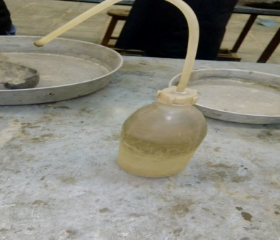 | 2.vibration machine  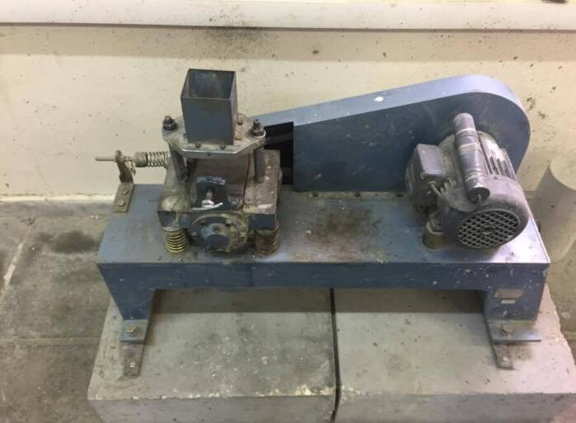
3.cube moulds  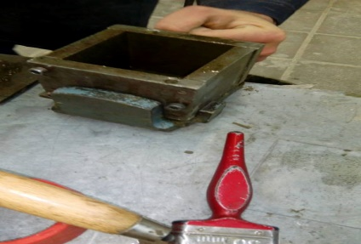 | 4.cement  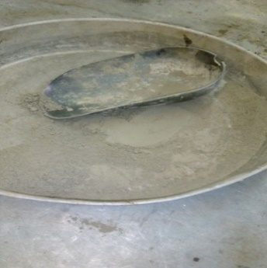
5.compressi ve testing machine.  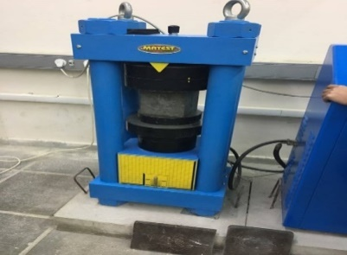 | 6.cone  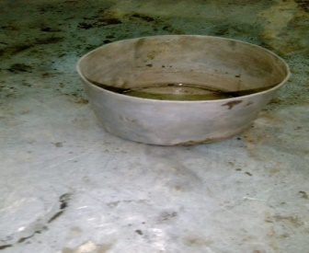
7.balance  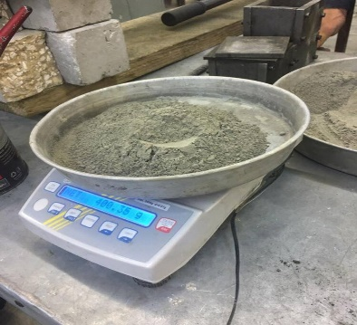 | 8.sand  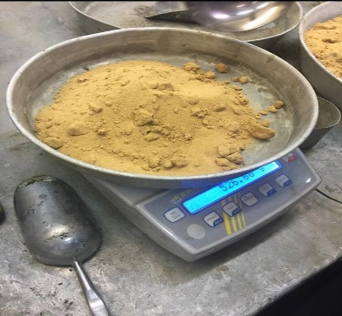
3-Procedure:
- One hundred and eighty five grams of cement was weighted to make a specimen for compressive test.
- Five hundred and twenty three grams of sand was weighted too.
- Cement and sand was mixed in the dry condition first about 2 minutes.
- One hundred and eight milliliters of water (equal to 108 grams) was adding to the mixture and mixing was kept for 2 minutes.
- The interior faces of the Cube molds and were covered with oil.
- The cube molds were filled with motor which prepped in the first step, the mold is placed on an iron plate.
- Filled mold was put on the vibration machine for 2 minutes.
- After that, the mold was taken out from the vibration machine and it was put on the table to harden.
- The last 8 steps were repeated 3 times to get 3 specimens for compressive test.
- The specimens were submerged in water after they were hardened.
- After week of mixing the specimens, the dimensions of each specimen were taken and the compressive test were done on the specimens by special machine for test.
- Finally the measurements of maximum compressive forces could the specimens support were taken.

4-Data and Calculations:
Compressive strength:

Table (1): data for compression test.
Cube # | Length (mm) | Width (mm) | Comp.force (KN)
1 | 69.50 | 71.50 | 91.00
2 | 64.00 | 66.00 | 48.70
3 | 64.00 | 67.00 | 41.80

compressive strength :
Surface area = length * width
Compressive strength = compression. force / surface area.

Cube 1:-
Surface area= 69.50* 71.50= 4969.25mm²
Compressive strength = 91000.00/ 4969.25= 18.31N/mm² (Mpa)
Cube 2:-
Surface area = 64.00 * 66.00= 4224.00 mm²
Compressive strength = 48700.00/ 4224.0 = 11.52N/mm² (Mpa)
Cube 3:-
Surface area = 64.00*67.00= 4288.00mm²
Compressive strength = 41800.00/ 4288.00= 9.75N/mm² (Mpa)
We will refuse the sample 1 because it's value not logical for sample 2 and 3.
The AVG. of 2,3 sample :( 11.52 + 9.75 )/2 = 10.63(MPa).

• Result:
compressive strength
Table (2): result for compressive test.
Cube | Compressive force(KN) | Surface area (mm²) | Compressive strength (N/mm²)
1 | 91.00 | 4969.25 | 18.31
2 | 48.70 | 4224.00 | 11.52
3 | 41.80 | 4288.00 | 9.75

5-Result and conclusion:

6-Referance:

1.

