**Table of content:**

**Introduction …………………………………………………………..2**

**Instruments …………………………………………………………...3**

**Procedure ……………………………………………………………..6**

**Data and calculation ………………………………………………….7**

**conclusion ……………………………………………….................... 14**

**Literature citation …………………………………………………… 9**

**1-Introduction:**

Aggregates contain different sizes of particles therefore we must know if all sizes present in the aggregate or if there is omitted sizes in aggregate because this will help us to find out the quality of aggregate which is very important because aggregate has many different uses in project for example it is the basic element in concrete and asphalt.

Sieve Analysis

We can know if the aggregate is well graded or poor graded by procedure which called sieve analysis ,we can use this procedure for the aggregate that is greater than 0.075mm therefore we must wash the sample in sieve number 200 to get rid of fine particles . Sieve analysis consists of many sieves ranked above each other and the sieve consist of many sieve openings and the size of sieve opening become smaller whenever we go down until we arrive the pan which the aggregate cannot pass from it. After we put the sample in the procedure we must calculate the weight retained in each sieve then we should make some calculations then we can make a relationship between sieve size and percent passing and from this relationship we can know the classification of aggregate.

“If we need to know gradation size, take a sample of aggregate and put it on a group of sieves after that determined the type of gradation about this classification :

• If the aggregate contain all sizes (coarse, fine, medium) and the curve is distributed in all graph the grade is called well graded.

• Gap graded: If the aggregate missing any size particle it lead to find voids so it not efficient, the curve in these type should have a horizontal line .

• Uniform graded: also called narrow graded so the sample have nearly same size the curve in these sample is a vertical curve.” (Donald Mcglinchey, 2005)



A:well graded B:gap graded C:narrow graded

“The data of sieve analysis can be used to compute the fineness modulus (FM) which defines as the sum of the cumulative percentages retained on the sieves of the standard series, dividing by 100. It is used to detect slight variations in the aggregate from the same source and usually computed for fine aggregate .

**2-Instrument:**

Balance scale

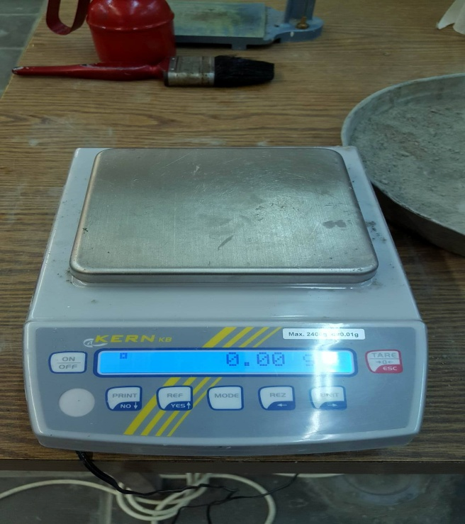

Fig (1) : Balance scale

Sieve shaker (Electronic vibrator ) .

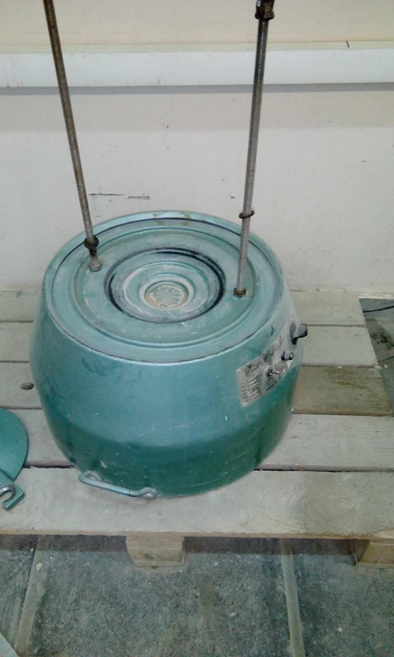

Fig (2) : Sieve shaker

Set of sieves (for fine aggregate)

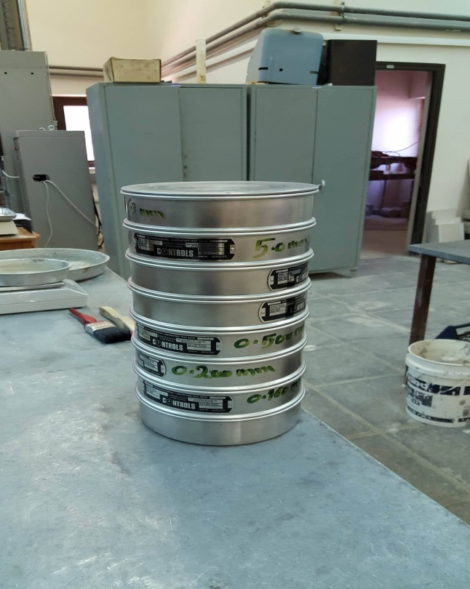

fig(3):set of sieves

set of sieves (for coarse aggregate)

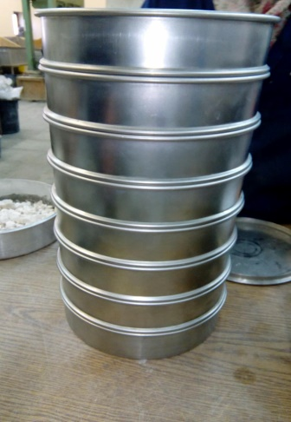

Fig (4) : Set of sieves

sample of coarse aggregate:

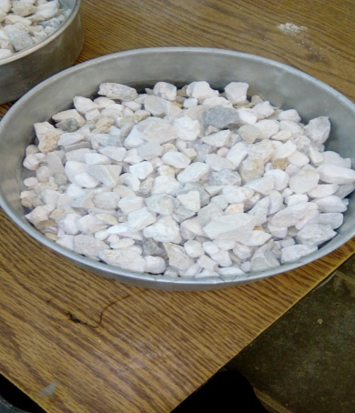

Fig(5):coarse aggregate

sample of fine aggregate:

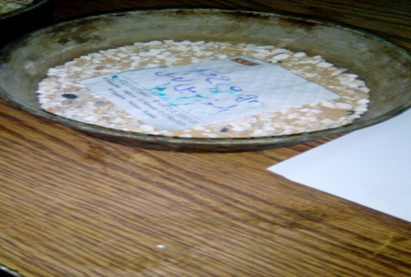

Fig(6):fine aggregate

**3-Procedure:**

For Coarse Material:

the trays were assured to be clean.

The course aggregate sample were weighted using the digital balance.

The weight of the sample before the sieving process was recorded

The aggregates were poured into the Coarse Stack of Sieves that was ordered from (4.75- 25.0) mm

The stack was put on the electrical shaker for 3 minutes.

The stack was removed from the electrical shaker, & the sieves were separated.

The aggregates retained on each sieve were tapped and brushed by wire brush.

After that each retained amount was weighted using the digital balance.

The pan was weighted.

The weight of the sample was taken aftar sieving.

the procedure was repeated for another Sample

For Fine Material:

The trays were assured to be clean

A sample of fine aggregate was weighted using the tared digital balance. Then, it was washed on sieve #200 until the washing water became clear and then it was dried.

The weight of the sample before the sieving process was recorded

The aggregates were poured in the Fine Stack of Sieves that was ordered from (0.160- 6.3) mm and then sent to the shaker for 5 minutes

The stack was removed from the electrical shaker, the sieves were separated.

The aggregates retained on each sieve were tapped and brushed by the hair brush

The retained masses of aggregates in each sieve were weighted

The pan was weighted

The weight of the sample was taken aftar sieving.

the procedure was repeated for another Sample.

**4-Data and calculation :**

Table(1): Gradation on coarse aggregate( sample1)

|  |  |  |  |  |  |  |  |  |
| --- | --- | --- | --- | --- | --- | --- | --- | --- |
| sieve size  (mm) | | Individual  Mass Retained  (gm) | | Corrected  Mass  retained | Individual percent  Retained  (%) | Cumulative  Percent  retained  (%) | cumulative  percent  passing  (%) | Reported  Percent Passing (%) |
| 25.0 | | 0.00 | | 0.00 | 0.00 | 0.00 | 100.00 | 100.00 |
| 19.0 | | 61.10 | | 61.11 | 2.94 | 2.94 | 97.06 | 97.00 |
| 12.5 | | 860.10 | | 860.26 | 41.99 | 44.93 | 55.07 | 55.00 |
| 9.5 | | 534.90 | | 535.00 | 26.12 | 71.05 | 28.95 | 29.00 |
| 6.3 | | 386.10 | | 386.17 | 18.85 | 89.90 | 10.10 | 10.00 |
| 4.75 | | 92.60 | | 92.61 | 4.52 | 94.24 | 5.58 | 6.00 |
| Pan | | 139.60 | | 139.26 | 6.81 | 101.23 | 1.23 | 1.00 |
| ∑ | 2074.40 | | 2074.41 | |

Sample of calculation :

Sample1:

mass before sieving=2074.9

mass after sieving=2074.5

error = (mass before sieving – mass after sieving) gm

= 2074.9 – 2074.5 = 0.4 gm .

the corrected mass retained is obtained with the equation.

= Individual mass retained * error +Individual mass retained .

Weight before sieving

Such that ( 61.10 * 0.4) + 61.10 = 61.11 gm .

2074.9

Individual percent Retained= Individual Mass Retained * 100 .

Mass before sieving

Such that : 61.11 * 100 = 2.94 % .

2074.9

Table(2):Graduation on coarse aggregate (sample2):

|  |  |  |  |  |  |  |  |  |
| --- | --- | --- | --- | --- | --- | --- | --- | --- |
| sieve size  (mm) | | Individual  Mass Retained  (gm) | | Corrected  Mass  retained | Individual percent  Retained  (%) | Cumulative  retained percent  (%) | cumulative  passing percent  (%) | Reported  Percent Passing (%) |
| 25.0 | | 0.00 | | 0.00 | 0.00 | 0.00 | 100.00 | 100.00 |
| 19.0 | | 40.10 | | 40.11 | 3.77 | 3.77 | 96.23 | 96.00 |
| 12.5 | | 412.70 | | 412.77 | 38.82 | 42.59 | 57.41 | 57.00 |
| 9.5 | | 258.20 | | 258.25 | 24.28 | 66.87 | 33.13 | 33.00 |
| 6.3 | | 177.30 | | 177.33 | 16.67 | 83.54 | 16.46 | 16.00 |
| 4.75 | | 50.20 | | 50.21 | 4.72 | 88.26 | 11.74 | 12.00 |
| Pan | | 124.70 | | 124.72 | 4.73 | 99.99 | 0.01 | 0.00 |
| ∑ | 1063.20 | | 1063.40 | |

Sample of calculation :

Sample2:

mass before sieving=1063.2

mass after sieving=1063.0

error = (mass before sieving – mass after sieving) gm

= 1063.2 – 1063.0 = 0.2gm .

the corrected mass retained is obtained with the equation :

= Individual mass retained * error +Individual mass retained .

Weight before sieving

Such that ( 40.1 * 0.2) + 40.10 = 40.11 gm .

1063.2

Individual percent Retained= Individual Mass Retained * 100 .

Mass before sieving

Such that : 40.11 * 100 = 3.77 % .

1063.2

Fig.7

Table(3): Gradation on fine aggregate(sample1):

|  |  |  |  |  |  |  |  |  |  |
| --- | --- | --- | --- | --- | --- | --- | --- | --- | --- |
| sieve size  (mm) | | Individual  Mass Retained  (gm) | | Corrected  Mass  retained | | Individual percent  Retained  (%) | cumulative  percent  retained  (%) | Cumulative passing percent  (%) | Reported  Percent Passing (%) |
| 6.30 | | 0.00 | | 0.00 | | 0.00 | 0.00 | 100.00 | 100.00 |
| 5.00 | | 41.50 | | 41.63 | | 8.68 | 8.68 | 91.32 | 91.00 |
| 2.00 | | 138.70 | | 139.13 | | 29.02 | 37.70 | 62.30 | 62.00 |
| 1.60 | | 3.57 | | 3.58 | | 0.75 | 38.45 | 61.55 | 61.00 |
| 0.50 | | 13.00 | | 13.04 | | 2.72 | 41.17 | 58.83 | 59.00 |
| 0.20 | | 112.80 | | 113.15 | | 23.60 | 64.77 | 35.23 | 35.00 |
| 0.16 | | 87.00 | | 87.27 | | 18.20 | 82.97 | 17.03 | 17.00 |
| Pan | | 45.00 | | 81.84 | | 17.07 | 100.04 | 0.04 | 0.00 |
| ∑ | 441.57 | | 479.28 | |

Sample of calculation :

Sample1:

Mass before washing=479.4

mass before sieving=443.06

mass after sieving=441.9

Pan = ( Weighted before washing - Weighted before sieving )

= (479.4 - 443.06) = 36.34gm

error = (mass before washing – (sum of individual mass retained+ pan)

= 479.4– 477.91 = 1.49 gm .

the corrected mass retained is obtained with the equation

= Individual mass retained * error +Individual mass retained .

Weight before sieving

Such that ( 41.5 * 1.49) + 41.5= 41.63 gm

479.4

Individual percent Retained= Individual Mass Retained * 100 .

Mass before sieving

Such that : 41.63 * 100 = 8.68 % .

479.4

Table(4): Gradation on fine aggregate(sample2):

|  |  |  |  |  |  |  |  |  |
| --- | --- | --- | --- | --- | --- | --- | --- | --- |
| sieve size  (mm) | | Individual  Mass Retained  (gm) | | Corrected  Mass  retained | Individual percent  Retained  (%) | Cumulative  retained percent  (%) | cumulative  passing percent  (%) | Reported  Percent Passing (%) |
| 6.30 | | 0.00 | | 0.00 | 0.00 | 0 | 100.00 | 100.00 |
| 5.00 | | 47.60 | | 47.78 | 9.50 | 9.50 | 90.50 | 90.00 |
| 2.00 | | 144.40 | | 144.94 | 28.85 | 38.35 | 61.65 | 62.00 |
| 1.60 | | 4.10 | | 4.11 | 0.82 | 39.16 | 60.84 | 61.00 |
| 0.50 | | 12.40 | | 12.45 | 2.47 | 41.63 | 58.37 | 58.00 |
| 0.20 | | 141.60 | | 142.13 | 28.26 | 69.89 | 30.11 | 30.00 |
| 0.16 | | 78.20 | | 78.49 | 15.61 | 85.50 | 14.50 | 14.00 |
| Pan | | 35.50 | | 72.83 | 14.48 | 99.98 | 0.02 | 0.00 |
| ∑ | 463.80 | | 502.73 | |

Sample of calculation :

Sample1:

Mass before washing=502.9

mass before sieving=465.7

mass after sieving=463.7

Pan = ( Weighted before washing - Weighted before sieving )

= (502.9 - 465.7) = 37.2gm

error = (mass before washing – (sum of individual mass retained+ pan) gm

= 502.9– 501 = 1.9 gm .

the corrected mass retained is obtained with the equation

= Individual mass retained * error +Individual mass retained .

Weight before sieving

Such that ( 47.6 * 1.9) + 47.6= 47.78 gm

502.9

Individual percent Retained= Individual Mass Retained * 100 .

Mass before sieving

Such that : 47.78 * 100 = 9.5 % .

502.9

Fig.8

**5**-**Results and conclusion**:

Fineness modulus (coarse aggregate) = 8.03

Fineness modulus (coarse aggregate) = 7.85

Fineness modulus (fine aggregate) = 2.74

Fineness modulus (fine aggregate) = 2.84

Gragh1: show that it uniformly graded aggregate

Graph 2 : show that it gap graded aggregate

Some of the errors that may have caused lack of accuracy in our results and graphs are:

1- Inaccuracy in weighing the samples before shaking them and after shaking.

2- Shaking the samples for more than the needed time which causes aggregates to break or even for less than the needed time and so it won’t be shook properly

3- Some of the material may have been left in the sieves and due to not cleaning the sieves properly with the brush.

Sieve analysis allows the determination of the distribution of particles sizes in granular materials. Since many separation processes and reactions depend on the amount of surface area relative to mass and that ratio increases as particle size decreases, knowing the distribution of sizes can be very important especially in mix concrete.

6-Literature and citation:

Construction materials laboratory manual (2016).