Table of content:

Introduction ………………………………………………..2
Instrument …………………………………………………3
Procedures ………………………………………………….4
Data and Calculation ………………………………………6
Conclusion ………………………………………………….7
Literature citations ………………………………………..8

1.Introduction:
o Back ground
Bend and re-bend and axial tension tests(for steel):
Steel is the basic material in structure and building operations, so it is treated to many examinations & tests, these tests determinate its properties about its standard range.
The first test was about bend-re-bend test, and this test was performed to make sure that a steel rod is good for use in various construction projects, specially the parts that affected by moment, so while bending and re-bending if any cracks start to appear in the bending zone, the steel rod would not pass the test and so that it is acceptable to be used.
The second part was about axial tension test using axial tension machine, this machine subject a steel bar by an axial force in the direction of its centroid increased gradually from zero until the steel breaks, also it prints a stress strain diagram using a plotter ,the graph represents the conclusion of the test, so from it many things can be noticed, first of all, the curve is divided into two regions, elastic and plastic behavior, the elastic region represent a linear relationship between the stress and strain, and the slope is equal to the modulus of elasticity, the zone where the elastic ends and the plastic starts is called proportional limit, after that the plastic region begins, it contains three parts, yielding, strain hardening and necking, the relation between stress and strain in this region is not linear and the deformation is permanent, the highest point in the curve is called ultimate stress, the point where the curve ends is called fracture stress.
The elastic region: The region where the deformation is not permanent and the material retains to its original shape.
The yielding region: The region where the material does an appreciable deformation where is no increase in load or stress.
The strain-hardening region: The region where the relation between stress & strain is non linear & the deformation is preeminent.
The necking region: The region where the radius of the bar starts to decrease untill the rod fractures.

o Purpose:
The aim of bend-re-bend test is to determine the strain that happens to a steel rod and the strength of this rod. The axial tension test determines the properties of steel; its behavior, and strength according to the stress-strain diagram..

2. Instruments
Table (1): Materials & Equipment
1. Steel Rod 16mm | 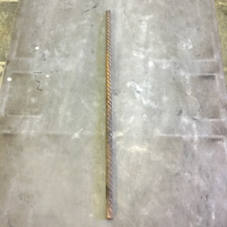  Figure 1
2. Axial Tensile Test Machine | 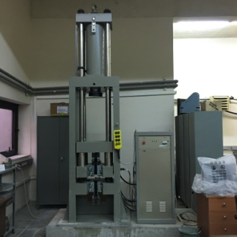  Figure 2
3. Bend & Rebend Machine | 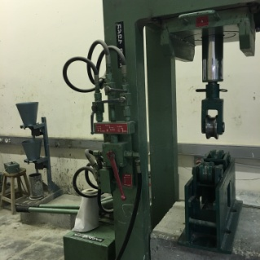  Figure 3
4. Roll No. 48 | 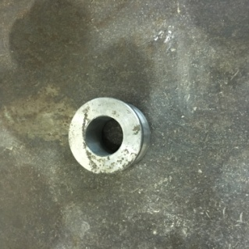  Figure 4
5. Roll No. 63 | 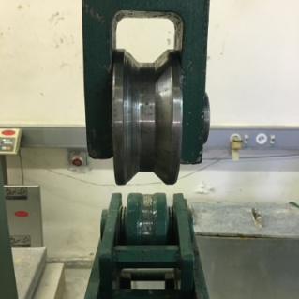  Figure 5
6. Boiling Water Container | 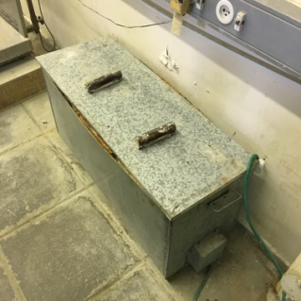  Figure 6
7. Gloves | 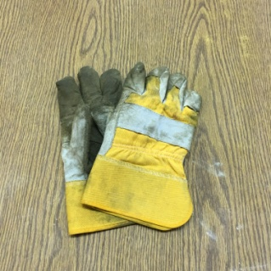  Figure 7
8. Stick | 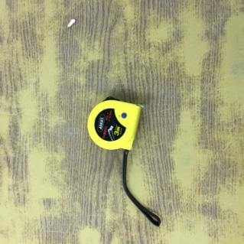  Figure 8

3.Procedure:
Bending and Re-bending Test :
1. A steel rod was taken and its length was measured and divided to the half.
2. A roll no. 48 was put in the bend-re-bend apparatus and the steel rod was bended to a 90 degree .
3. The steel rod was put them in an oven at 100 C for an hour.
4. It was taken out after time passed by gloves with high care.
5. A roll no. 63 was put in the bend-re-bend apparatus and the steel was then re-bended again nearly to 135 degree.
Tensile Test :
1. A steel rod of a 18 mm diameter was taken.
2. The length, mass & initial length were measured.
3. The rod was restrained in the axial tension apparatus.
4. A variable axial tension force was applied upon it until it fractured.
5. The stress & strain diagram was plotted.

4.Data & Calculations:
Table (2): Data Obtained
Description | Steel Rod 1
dn Nominal diameter (mm) | 16
Length (mm) | 572
Weight (g) | 904.1
Unit weight | 1.58
Initial length (mm) | 272
Elongated length (mm) | 325
Ultimate strain | 19.4

Unit Weight = W/L
= 1.58 gm/mm
Equivalent Diameter = 12.74 [(W/L) ^0.5]
= 12.74[(904.1/572)^0.5]
=16.02 mm
Ultimate Strain = [(Lu-Lo)/Lo]
= 0.194mm
Percent of elongation = ((Lu – L0)/ L0)*100% = ((325-272)/272)*100% = 19.4%

Table (3): Data Obtained from Tensile Test Machine
Length (mm) | 325.0
Unit Weight (kg/m) | 1.58
Area (mm^2) | 201.3
Diameter (mm) | 16.02
Maximum Force (kN) | 117.9
Upper yield stress (N/mm^2) | 407.9
Lower yield stress (N/mm^2) | 411.2
Ultimate stress (N/mm^2) | 585.7
Modulus of elasticity (N/mm^2) | 9702.5
Elongation percent (%) | 19.4

Table (4): Tensile Test Results
Maximum Force (kN) | 87.9
Upper yield stress (N/mm^2) | 407.9
Lower yield stress (N/mm^2) | 411.2
Ultimate stress (N/mm^2) | 585.7
Modulus of elasticity (N/mm^2) | 9702.5
Maximum force the bar can afford = ultimate stress * area = 585.7 * 201.3= 11816.31 N = 11.8KN
Elongation=L1–L0=325-272=53mm
Strain(theoretically)=(L1–L0)/L0=((325-272)/272)*100% = 19.4%

5.Results and conclusions:
The aim for the bend and re-bend test was to figure out if the steel used is effective to use in the desired construction or not. According to the results obtained from this test, we can realize that the steel sample passed the test since there were no cracking marks or fractures at the bent zone, therefore it is considered acceptable for engineering use. Temperature is also an important agent affecting the steel’s risk to fracture as steel has lower toughness at lower temperatures. Moreover, the results obtained from the axial tension test shows that using steel in structural works can be very useful. It prolongs the durability of the structure because of its ability to elongate, undergo tensile loading and bending forces without fracture, which means that steel is a ductile material. The Steel sample showed a very rapid transition between the decreased area and the rest of its length, this is a property of ductile materials which is called necking. And the percent strain of the steel bar is equal to 19.4%.
Sources of errors are due to:
- The weight and the length of the two samples were estimated.
- The steel bar cannot be bent at exactly 90 degrees with the given machines.
- Placing the sample in a wrong way in the tension machine.

6.References:
- Mustafa Abedmosa, 2009, Construction Materials Laboratory.

