**Table of content:**

**Introduction ………………………………………………..2**

**Instrument …………………………………………………3**

**Procedures ………………………………………………….6**

**Data and Calculation ………………………………………8**

**Conclusion ………………………………………………….9**

**Literature citations ………………………………………..10**

1. **Introduction:**

* Back ground:

Concrete components are cement, coarse aggregates, fine aggregates and water. There are many tests which are conducted to check the quality and workability of fresh concrete.. The word "workability" or workable concrete signifies much wider and deeper meaning than the other terminology consistency often used loosely for workability. Consistency is a general term to indicate the degree of fluidity or the degree of mobility. The factors helping concrete to have more lubricating effect to reduce internal friction for helping easy compaction are given below:

(a) Water Content (b) Mix Proportions (c) Size of Aggregates (d) Shape of Aggregates (e) Surface Texture of Aggregate (f) Grading of Aggregate (g) Use of Admixtures

The following tests are commonly employed to measure workability of fresh concrete. First test, the slump test is the most commonly used method of measuring consistency of concrete which can be employed either in laboratory or at site of work. . It indicates the characteristic of concrete in addition to the slump value. If the concrete slumps evenly it is called true slump. If one half of the cone slides down, it is called shear slump. Another form is called collapse slump. Second test, the vee bee test. The main objective of Vee-bee test is to determine the workability of the freshly mixed concrete. The Vee-Bee test gives an indication about the mobilityand the compactibility aspect of the freshly mixed concrete. Third test, compacting factor test is also use to study the workability of concrete by Compacting Factor apparatus.

* Purpose:

The purpose of all these tests is to measure the workability of concrete and study the effect of different w/c ratios on the mix concrete.

**2- Instruments:**

* **Balance:**  to measure weight of the concrete component as shown in the picture.

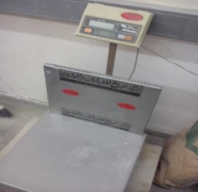

Fig 1:balance

* **Concrete Mixer** :This machine use to mix the concrete component ( fine and coarse aggregate ,sand ,and water with cement) and make homogeneous concrete mixturewhich we need to test as shown in the picture.

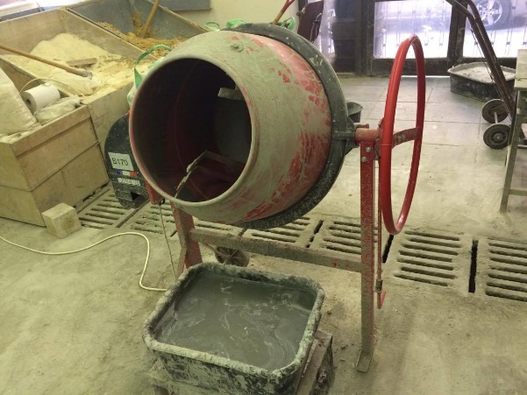

Fig 2 : concrete mixer

* **Trowel**

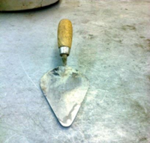

Fig 3: trowel

* **Mixing bowl:** use to put the concrete mixture on it as shown in the picture.

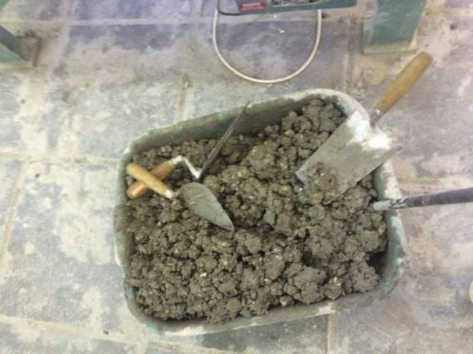

Fig 4: Mixing bowl

* **Round metallic cylinder :** to put concrete specimen in.

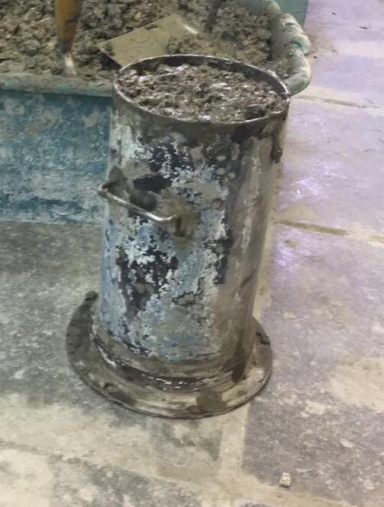

Fig 5: Round metallic cylinder

* **Slump Cone:**

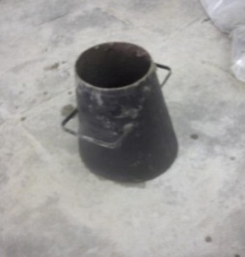

Fig 6: Slump Cone

* **Compacting factor machine**

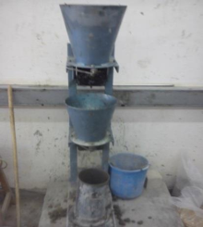

Fig 7: compacting factor machine

* **Tamping Rod**

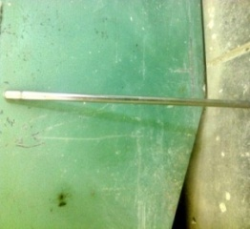

Fig 8: tamping rod

* **Vee-Bee test machine**

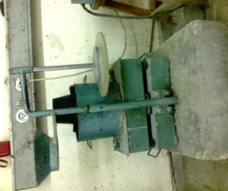

Fig 9: Vee -Bee test machine

* **Meter**

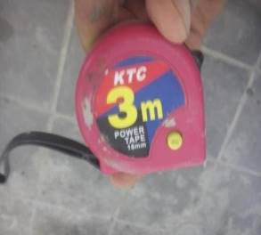

Fig10: meter

**3- Procedures:**

ــ The components of concrete was prepared in the specific weight

ــThen the components were put in the concrete mixer

ــ After that the specimen was checked by 3 tests

* **Slump test:**

1. the oil was put inside the slump cone.
2. the slump cone was put in flat surface and installed it.
3. the concrete was filled in 3 stages ,in each concrete layer was compacted by rod 25 times.
4. the excess concrete was removed.
5. the slump cone was pulled vertically in slow motion
6. The slump cone was placed in an inverted position next to the concrete and measured the distance to the top of the original center of the specimen

* **Compaction Factor Test:**

1. The concrete specimen was placed gently in the upper hopper using the trowel.
2. The trap door was opened to filled the lower upper and the concrete was allowed to fall into the empty cylinder.
3. The excess concrete in the cylinder was removed by hand scoop
4. The outside of cylinder was cleaned then the cylinder weight was taken (this weight is known as the weight of partially compacted concrete).
5. The cylinder was emptied after that the concrete specimen was filled in cylinder in 3 stage on vibrating table
6. Then the cylinder weight was taken again.( This weight is known as the weight of fully compacted concrete).

* **Vee-Bee test :**

1. the slump cone was placed in the cylinder
2. The mixed concrete was placed in the slump cone on 3 stages, in each stage the concrete was compacted by a uniformly rod for 25 times all over the surface, Till the slump cone was filled to its top.
3. The glass disc attached to the swivel arm was turned and placed on the top of the concrete in the pot.
4. The electrical vibrator was switched on and a stop-watch was started, at the same time.
5. Vibration was continued till the conical shape of the concrete converted to cylindrical shape.
6. When the concrete fully converted to a cylindrical shape, the stop-watch was switched off immediately. The time was noted and scored.

* **Preparing the molds:**

After all tests been done, The concrete with different W\C ratios was filled in molds with different shapes and sizes as follows (for each mix) : 10cubic molds with dimensions of ( 10*10*10), and one prism mold, were filled in 2 layers, 3 cubic molds with dimension of (35*35*35), and 3 cylinders were filled in 3 layers, each layer was vibrated using the vibrating table for a specific time, till all voids filled with concrete. Again, these steps were repeated for each concrete mix.

While treating the mix with higher W\C ratio (0.60), the vibrator never been used, instead a rod with 16 mm radius and 600 mm length was used to compact the concrete for each: the cylinders and the (35*35*35) dimensional cubes, in 3 layers, but cylinders were compacted 25 times each layer, and cubes were compacted 35 each. And a rod with dimensions (25*25) and 200 mm length was used to compact each layer of the (10*10*10) dimensioned cubes, and prisms in 2 layers After all molds been filled they were lifted in the normal weather for 24 hours, then all of molds were opened and all hardened concrete were put in water to be ready for the crushing test to indicate strength.

**4- Data and Calculation**

|  |  |  |  |  |  |  |
| --- | --- | --- | --- | --- | --- | --- |
| W/C | Water  (liter) | Cement  (Kg) | Sand  (Kg) | Aggregate  (20mm)  (Kg) | Aggregate  (15mm)  (Kg) | Aggregate  (5mm)  (Kg) |
| **0.50** | **11.7** | **23** | **27** | **39** | **14** | **13** |
| **0.55** | **13** | **23** | **27** | **39** | **14** | **13** |
| **0.60** | **14.1** | **23** | **27** | **39** | **14** | **13** |
| **0.65** | **15.3** | **23** | **27** | **39** | **14** | **13** |

Table(1): the amount of samples

**calculations & results**

**Slump test:**

Table(2): results of slump test

|  |  |
| --- | --- |
| **Ratio** | **Slump (mm)** |
| **0.50** | **30** |
| **0.55** | **50** |
| **0.60** | **155** |
| **0.65** | **150** |

w/c(.50):true slump

w/c(.55):true slump

w/c(.60):shear slump

w/c(.65):shear slump

**Vee-Bee time test:**

Table(3):Vee-Bee test result

|  |  |
| --- | --- |
| **Ratio** | **Time (s)** |
| **0.50** | **3.17** |
| **0.55** | **3.34** |
| **0.60** | **-** |
| **0.65** | **-** |

**Compacting Factor test :**

Table(4): compacting factor test result

|  |  |  |  |
| --- | --- | --- | --- |
| **Ratio** | **Partially compacted weight**  **(Kg)** | **Fully compacted weight**  **(Kg)** | **Compacting Factor**  **(Kg/Kg)** |
| **0.50** | **15.45** | **17.15** | **0.90** |
| **0.55** | **10.3** | **11.35** | **0.90** |
| **0.60** | **-** | **-** | **-** |
| **0.65** | **-** | **-** | **-** |

**Sample calculation of compacting factor**

Compacting factor = (partially compacted weight/fully compacted weight)

= (15.45/17.15) = 0.90

**5- Conclusion:**

ــ The mixture which have w/c = 0.50 describes to have stiff workability according to slump test and compacting factor, its stiff plastic according vee-bee test.

ـــThe mixture which have w/c = 0.55 describes to have stiff plastic workability according to slump test and compacting factor and vee-bee test

ـــ The mixture which have w/c = 0.60 describes to have stiff plastic according to slump test and its flowing according to compacting factor, too moist according to vee-bee test.

ـــ The mixture which have w/c = 0.65 describes as flowing according to all tests.

**6- Literature citations:**

**Reference used:**

**1- Concrete laboratory manual, pages 33-52.**

**2-** [**https://theconstructor.org/concrete/vee-bee-test-concrete-consistometer/17815/**](https://theconstructor.org/concrete/vee-bee-test-concrete-consistometer/17815/)